**June 2020 Challenge**

Introduction

This Challenge is beginner-friendly and available to both Premium and non-Premium users. It consists of 30 daily problems over the month of June. A problem is added here each day, and you have 24 hours to make a valid submission for it in order to be eligible for rewards.

Rules

In order to be eligible for prizes, you must comply with all the Challenge rules.

1. **Valid submission:**only problems where a valid submission is made will be eligible for rewards. This means the submission was:
   1. within the **valid time period** for that problem; this is before 23:59 PM PDT on the day it appeared.
   2. made **within this Explore Card**. If you have completed the question previously, you will need to re-submit an answer within this Explore Card.
   3. given the judgement **"Accepted"** when submitted. Please note that if your submission receives a different judgement, including, but not limited to, Wrong Answer or Time Limit Exceeded, you are allowed to resubmit, as long as it's still within the valid time period.

After making a valid submission for a problem, a **blue checkmark** will appear next to that problem in the left bar. A grey cross means that a valid submission was not made on time for that problem, and so, unfortunately, you're no longer eligible for prizes for that problem.  


1. **Late or invalid submissions:**will not be accepted under **any** circumstances. It is ***your responsibility*** to make a valid submission for a problem within its valid time period, and to confirm that the blue checkmark has appeared.

1. **Rewards:**only valid submissions will be eligible for rewards. For more information about the rewards, [check out the Discuss post](https://leetcode.com/discuss/general-discussion/655704/June-LeetCoding-Challenge).

1. **Disclaimer:** LeetCode reserves the right, in our sole discretion, to disqualify any entries where we believe a user undermines the fairness of this June's LeetCoding Challenge event, which includes, but is not limited to, copying and pasting solutions from other places directly into your submission.

[](https://leetcode.com/subscribe/?ref=ex_dc)

Week 1: June 1st–June 7th

~~+10~~

**Invert Binary Tree**

~~+10~~

 Delete Node in a Linked List

~~+10~~

**Two City Scheduling**

~~+10~~

 Reverse String

~~+10~~

 Random Pick with Weight

~~+10~~

 Queue Reconstruction by Height

~~+10~~

**Coin Change 2**

Week 2: June 8th–June 14th

~~+10~~

**Power of Two**

~~+10~~

**Is Subsequence**

~~+10~~

 Search Insert Position

~~+10~~

 Sort Colors

~~+10~~

 Insert Delete GetRandom O(1)

~~+10~~

**Largest Divisible Subset**

~~+10~~

**Cheapest Flights Within K Stops**

Week 3: June 15th–June 21st

~~+10~~

 Search in a Binary Search Tree

~~+10~~

 Validate IP Address

~~+10~~

**Surrounded Regions**

~~+10~~

**H-Index II**

~~+10~~

**Longest Duplicate Substring**

~~+10~~

**Permutation Sequence**

~~+10~~

**Dungeon Game**

Week 4: June 22nd–June 28th

~~+10~~

**Single Number II**

~~+10~~

 Count Complete Tree Nodes

~~+10~~

**Unique Binary Search Trees**

~~+10~~

 Find the Duplicate Number

~~+10~~

**Sum Root to Leaf Numbers**

~~+10~~

 Perfect Squares

~~+10~~

 Reconstruct Itinerary

Week 5: June 29th–June 30th

~~+10~~

 Unique Paths

~~+10~~

 Word Search II

**Invert Binary Tree**

Invert a binary tree.

**Example:**

Input:

4

/ \

2 7

/ \ / \

1 3 6 9

Output:

4

/ \

7 2

/ \ / \

9 6 3 1

**Trivia:**  
This problem was inspired by [this original tweet](https://twitter.com/mxcl/status/608682016205344768) by [Max Howell](https://twitter.com/mxcl):

Google: 90% of our engineers use the software you wrote (Homebrew), but you can’t invert a binary tree on a whiteboard so f*** off.

## Solution

#### **Approach #1 (Recursive) [Accepted]**

This is a classic tree problem that is best-suited for a recursive approach.

**Algorithm**

The inverse of an empty tree is the empty tree. The inverse of a tree with root r*r*, and subtrees \mbox{right} and \mbox{left}, is a tree with root r*r*, whose right subtree is the inverse of \mbox{left}, and whose left subtree is the inverse of \mbox{right}.

**Java**

public TreeNode invertTree(TreeNode root) {

if (root == null) {

return null;

}

TreeNode right = invertTree(root.right);

TreeNode left = invertTree(root.left);

root.left = right;

root.right = left;

return root;

}

**Complexity Analysis**

Since each node in the tree is visited only once, the time complexity is O(n)*O*(*n*), where n*n* is the number of nodes in the tree. We cannot do better than that, since at the very least we have to visit each node to invert it.

Because of recursion, O(h)*O*(*h*) function calls will be placed on the stack in the worst case, where h*h* is the height of the tree. Because h\in O(n)*h*∈*O*(*n*), the space complexity is O(n)*O*(*n*).

#### **Approach #2 (Iterative) [Accepted]**

Alternatively, we can solve the problem iteratively, in a manner similar to breadth-first search.

**Algorithm**

The idea is that we need to swap the left and right child of all nodes in the tree. So we create a queue to store nodes whose left and right child have not been swapped yet. Initially, only the root is in the queue. As long as the queue is not empty, remove the next node from the queue, swap its children, and add the children to the queue. Null nodes are not added to the queue. Eventually, the queue will be empty and all the children swapped, and we return the original root.

**Java**

public TreeNode invertTree(TreeNode root) {

if (root == null) return null;

Queue<TreeNode> queue = new LinkedList<TreeNode>();

queue.add(root);

while (!queue.isEmpty()) {

TreeNode current = queue.poll();

TreeNode temp = current.left;

current.left = current.right;

current.right = temp;

if (current.left != null) queue.add(current.left);

if (current.right != null) queue.add(current.right);

}

return root;

}

**Complexity Analysis**

Since each node in the tree is visited / added to the queue only once, the time complexity is O(n)*O*(*n*), where n*n* is the number of nodes in the tree.

Space complexity is O(n)*O*(*n*), since in the worst case, the queue will contain all nodes in one level of the binary tree. For a full binary tree, the leaf level has \lceil \frac{n}{2}\rceil=O(n)⌈2*n*​⌉=*O*(*n*) leaves.

**Two City Scheduling**

A company is planning to interview 2n people. Given the array costs where costs[i] = [aCosti, bCosti], the cost of flying the ith person to city a is aCosti, and the cost of flying the ith person to city b is bCosti.

Return *the minimum cost to fly every person to a city* such that exactly n people arrive in each city.

**Example 1:**

**Input:** costs = [[10,20],[30,200],[400,50],[30,20]]

**Output:** 110

**Explanation:**

The first person goes to city A for a cost of 10.

The second person goes to city A for a cost of 30.

The third person goes to city B for a cost of 50.

The fourth person goes to city B for a cost of 20.

The total minimum cost is 10 + 30 + 50 + 20 = 110 to have half the people interviewing in each city.

**Example 2:**

**Input:** costs = [[259,770],[448,54],[926,667],[184,139],[840,118],[577,469]]

**Output:** 1859

**Example 3:**

**Input:** costs = [[515,563],[451,713],[537,709],[343,819],[855,779],[457,60],[650,359],[631,42]]

**Output:** 3086

**Constraints:**

* 2 * n == costs.length
* 2 <= costs.length <= 100
* costs.length is even.
* 1 <= aCosti, bCosti <= 1000

## Solution

#### **Approach 1: Greedy.**

**Greedy algorithms**

Greedy problems usually look like "Find minimum number of something to do something" or "Find maximum number of something to fit in some conditions", and typically propose an unsorted input.

The idea of greedy algorithm is to pick the locally optimal move at each step, that will lead to the globally optimal solution.

The standard solution has \mathcal{O}(N \log N)O(*N*log*N*) time complexity and consists of two parts:

* Figure out how to sort the input data (\mathcal{O}(N \log N)O(*N*log*N*) time). That could be done directly by a sorting or indirectly by a heap usage. Typically sort is better than the heap usage because of gain in space.
* Parse the sorted input to have a solution (\mathcal{O}(N)O(*N*) time).

Please notice that in case of well-sorted input one doesn't need the first part and the greedy solution could have \mathcal{O}(N)O(*N*) time complexity, [here is an example](https://leetcode.com/articles/gas-station/).

How to prove that your greedy algorithm provides globally optimal solution?

Usually you could use the [proof by contradiction](https://en.wikipedia.org/wiki/Proof_by_contradiction).

**Intuition**

Let's figure out how to sort the input here. The input should be sorted by a parameter which indicates a money lost for the company.

The company would pay anyway : price_A to send a person to the city A, or price_B to send a person to the city B. By sending the person to the city A, the company would lose price_A - price_B, which could negative or positive.

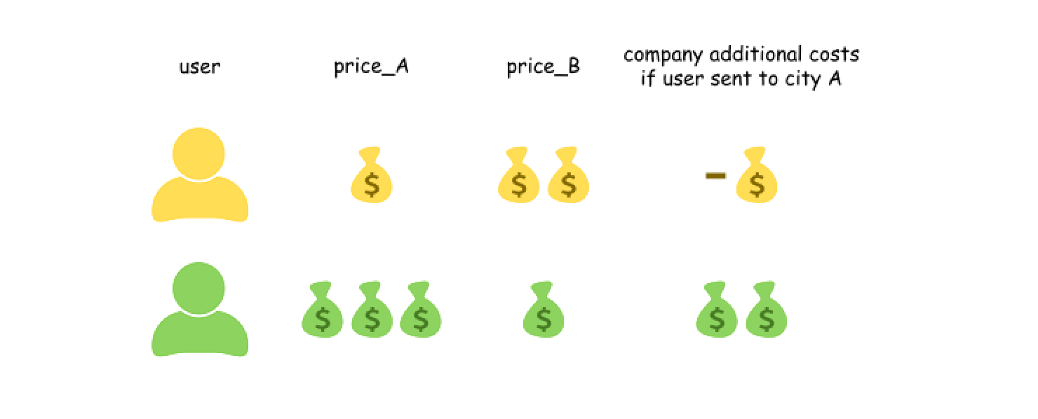

To optimize the total costs, let's sort the persons by price_A - price_B and then send the first n persons to the city A, and the others to the city B, because this way the company costs are minimal.

**Algorithm**

Now the algorithm is straightforward :

* Sort the persons in the ascending order by price_A - price_B parameter, which indicates the company additional costs.
* To minimise the costs, send n persons with the smallest price_A - price_B to the city A, and the others to the city B.

**Implementation**

|  |
| --- |
| class Solution {  public int twoCitySchedCost(int[][] costs) {  // Sort by a gain which company has  // by sending a person to city A and not to city B  Arrays.sort(costs, new Comparator<int[]>() {  @Override  public int compare(int[] o1, int[] o2) {  return o1[0] - o1[1] - (o2[0] - o2[1]);  }  });  int total = 0;  int n = costs.length / 2;  // To optimize the company expenses,  // send the first n persons to the city A  // and the others to the city B  for (int i = 0; i < n; ++i) total += costs[i][0] + costs[i + n][1];  return total;  }  } |

**Complexity Analysis**

* Time complexity : \mathcal{O}(N \log N)O(*N*log*N*) because of sorting of input data.
* Space complexity : \mathcal{O}(1)O(1) since it's a constant space solution.

**Coin Change 2**

You are given coins of different denominations and a total amount of money. Write a function to compute the number of combinations that make up that amount. You may assume that you have infinite number of each kind of coin.

**Example 1:**

**Input:** amount = 5, coins = [1, 2, 5]

**Output:** 4

**Explanation:** there are four ways to make up the amount:

5=5

5=2+2+1

5=2+1+1+1

5=1+1+1+1+1

**Example 2:**

**Input:** amount = 3, coins = [2]

**Output:** 0

**Explanation:** the amount of 3 cannot be made up just with coins of 2.

**Example 3:**

**Input:** amount = 10, coins = [10]

**Output:** 1

**Note:**

You can assume that

* 0 <= amount <= 5000
* 1 <= coin <= 5000
* the number of coins is less than 500
* the answer is guaranteed to fit into signed 32-bit integer

## Solution

#### **Approach 1: Dynamic Programming**

**Template**

This is a classical dynamic programming problem.

Here is a template one could use:

* Define the base cases for which the answer is obvious.
* Develop the strategy to compute more complex case from more simple one.
* Link the answer to base cases with this strategy.

**Example**

Let's pic up an example: amount = 11, available coins - 2 cent, 5 cent and 10 cent. Note, that coins are unlimited.



**Base Cases: No Coins or Amount = 0**

If the total amount of money is zero, there is only one combination: to take zero coins.

Another base case is no coins: zero combinations for amount > 0 and one combination for amount == 0.

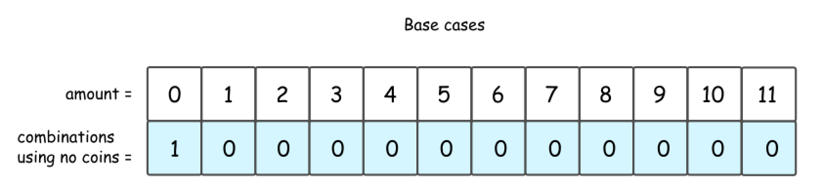

**2 Cent Coins**

Let's do one step further and consider the situation with one kind of available coins: 2 cent.

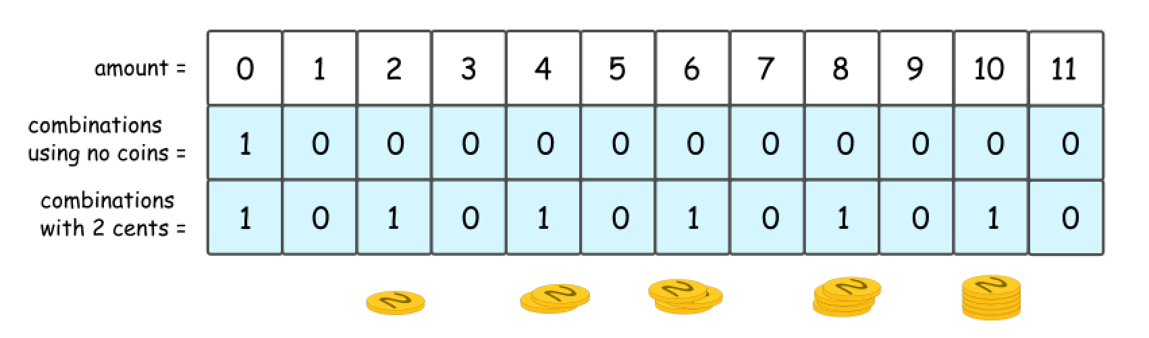

It's quite evident that there could be 1 or 0 combinations here, 1 combination for even amount and 0 combinations for the odd one.

The same answer could be received in a recursive way, by computing the number of combinations for all amounts of money, from 0 to 11.

First, that's quite obvious that all amounts less than 2 are not impacted by the presence of 2 cent coins. Hence for amount = 0 and for amount = 1 one could reuse the results from the figure 2.

Starting from amount = 2, one could use 2 cent coins in the combinations. Since the amounts are considered gradually from 2 to 11, at each given moment one could be sure to add not more than one coin to the previously known combinations.

So let's pick up 2 cent coin, and use it to make up amount = 2. The number of combinations with this 2 cent coin is a number combinations for amount = 0, i.e. 1.

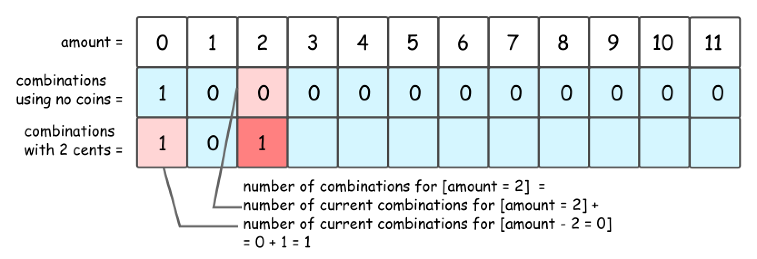

Now let's pick up 2 cent coin, and use it to make up amount = 3. The number of combinations with this 2 cent coin is a number combinations for amount = 1, i.e. 0.

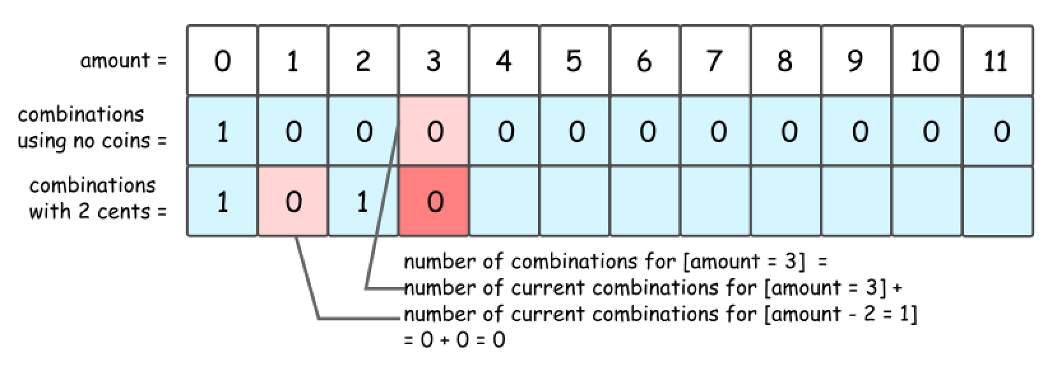

That leads to DP formula for number of combinations to make up the amount = x: dp[x] = dp[x] + dp[x - coin], where coin = 2 cents is a value of coins we're currently adding.

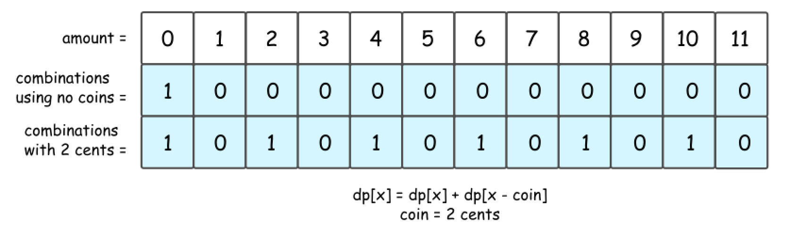

**2 Cent Coins + 5 Cent Coins + 10 Cent Coins**

Now let's add 5 cent coins. The formula is the same, but do not forget to add dp[x], number of combinations with 2 cent coins.

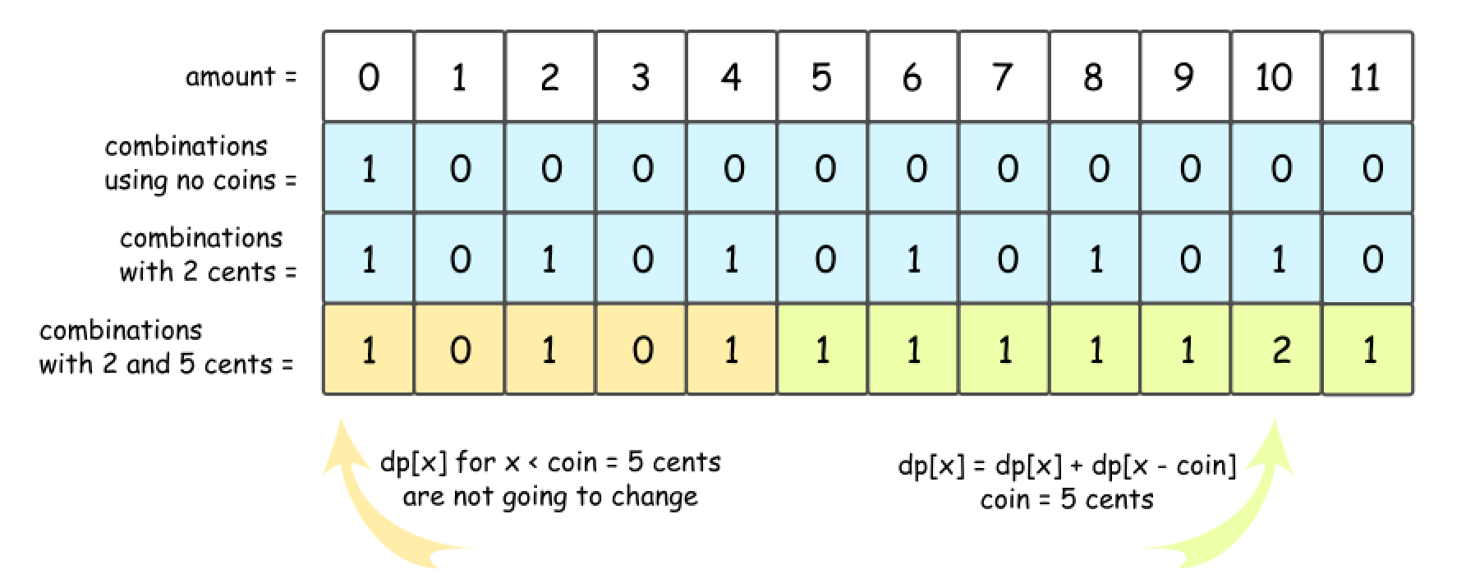

The story is the same for 10 cent coins.

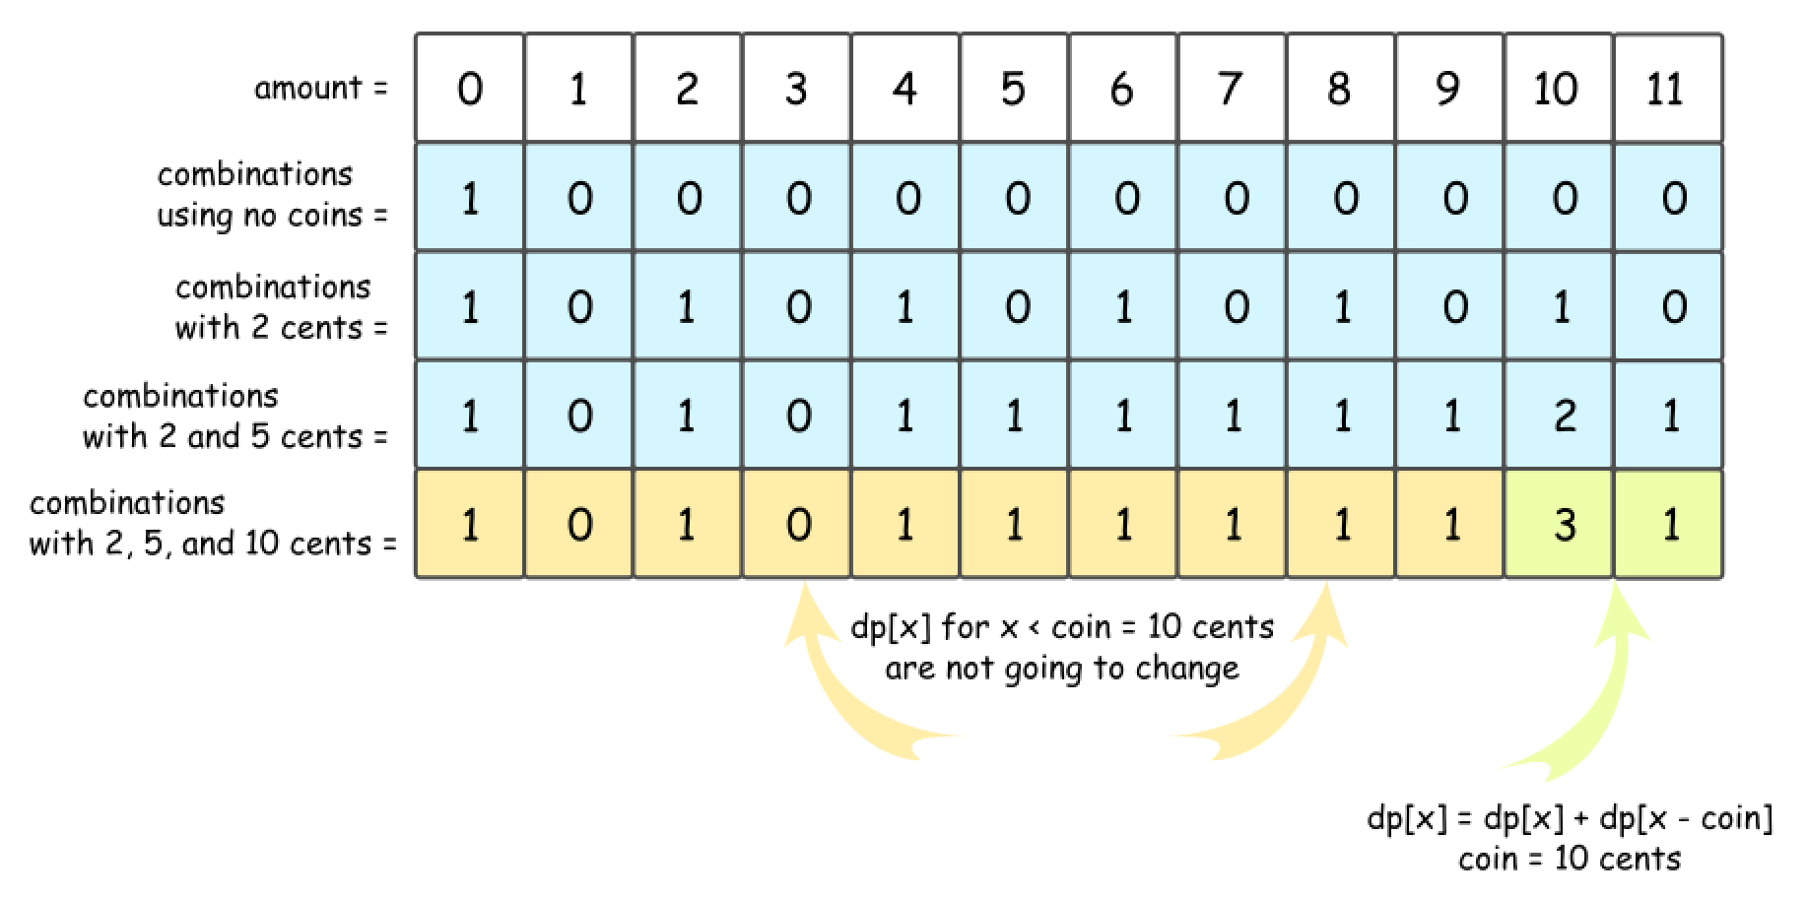

Now the strategy is here:

* Add coins one-by-one, starting from base case "no coins".
* For each added coin, compute recursively the number of combinations for each amount of money from 0 to amount.

**Algorithm**

* Initiate number of combinations array with the base case "no coins": dp[0] = 1, and all the rest = 0.
* Loop over all coins:
  + For each coin, loop over all amounts from 0 to amount:
    - For each amount x, compute the number of combinations: dp[x] += dp[x - coin].
* Return dp[amount].

**Implementation**

|  |
| --- |
| class Solution {  public int change(int amount, int[] coins) {  int[] dp = new int[amount + 1];  dp[0] = 1;  for (int coin : coins) {  for (int x = coin; x < amount + 1; ++x) {  dp[x] += dp[x - coin];  }  }  return dp[amount];  }  } |

**Complexity Analysis**

* Time complexity: \mathcal{O}(N \times \textrm{amount})O(*N*×amount), where N is a length of coins array.
* Space complexity: \mathcal{O}(\textrm{amount})O(amount) to keep dp array.

**Power of Two**

Given an integer n, return *true* if it is a power of two. Otherwise, return *false*.

An integer n is a power of two, if there exists an integer x such that n == 2x.

**Example 1:**

**Input:** n = 1

**Output:** true

**Explanation:** 20 = 1

**Example 2:**

**Input:** n = 16

**Output:** true

**Explanation:** 24 = 16

**Example 3:**

**Input:** n = 3

**Output:** false

**Example 4:**

**Input:** n = 4

**Output:** true

**Example 5:**

**Input:** n = 5

**Output:** false

**Constraints:**

* -231 <= n <= 231 - 1

**Follow up:** Could you solve it without loops/recursion?

## Solution

#### **Overview**

We're not going to discuss here an obvious \mathcal{O}(\log N)O(log*N*) time solution

|  |
| --- |
| class Solution {  public boolean isPowerOfTwo(int n) {  if (n == 0) return false;  while (n % 2 == 0) n /= 2;  return n == 1;  }  } |

Instead, the problem will be solved in \mathcal{O}(1)O(1) time with the help of bitwise operators. The idea is to discuss such bitwise tricks as

* How to get / isolate the rightmost 1-bit : x & (-x).
* How to turn off (= set to 0) the rightmost 1-bit : x & (x - 1).

These tricks are often used as something obvious in more complex bit-manipulation solutions, like for [N Queens problem](https://leetcode.com/articles/n-queens-ii/), and it's important to recognize them to understand what is going on.

#### **Intuition**

The idea behind both solutions will be the same: a power of two in binary representation is one 1-bit, followed by some zeros:

1 = (0000 0001)_21=(00000001)2​

2 = (0000 0010)_22=(00000010)2​

4 = (0000 0100)_24=(00000100)2​

8 = (0000 1000)_28=(00001000)2​

A number which is not a power of two, has more than one 1-bit in its binary representation:

3 = (0000 0011)_23=(00000011)2​

5 = (0000 0101)_25=(00000101)2​

6 = (0000 0110)_26=(00000110)2​

7 = (0000 0111)_27=(00000111)2​

The only exception is 0, which should be treated separately.

#### **Approach 1: Bitwise Operators : Get the Rightmost 1-bit**

**Get/Isolate the Rightmost 1-bit**

Let's first discuss why x & (-x) is a way to keep the rightmost 1-bit and to set all the other bits to 0.

Basically, that works because of [two's complement](https://en.wikipedia.org/wiki/Two%27s_complement). In two's complement notation -x−*x* is the same as \lnot x + 1¬*x*+1. In other words, to compute -x−*x* one has to revert all bits in x*x* and then to add 1 to the result.

Adding 1 to \lnot x¬*x* in binary representation means to carry that 1-bit till the rightmost 0-bit in \lnot x¬*x* and to set all the lower bits to zero. Note, that the rightmost 0-bit in \lnot x¬*x* corresponds to the rightmost 1-bit in x*x*.

In summary, -x−*x* is the same as \lnot x + 1¬*x*+1. This operation reverts all bits of x except the rightmost 1-bit.

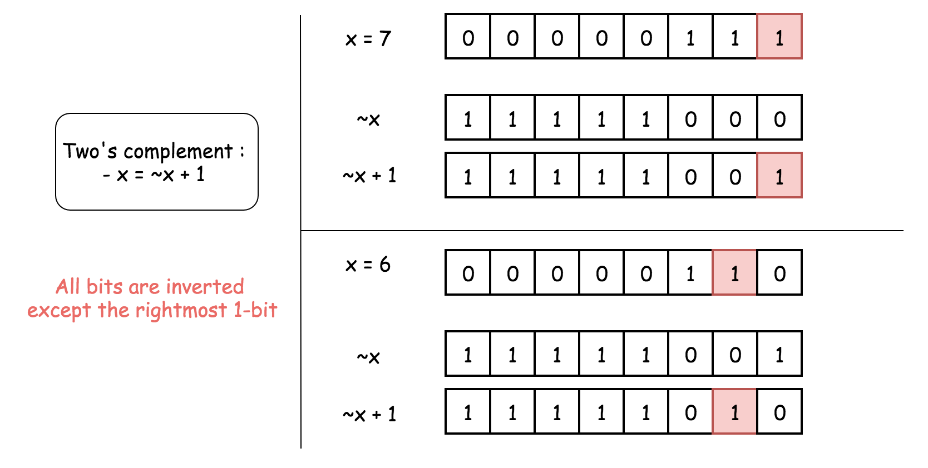

Hence, x and -x have just one bit in common - the rightmost 1-bit. That means that x & (-x) would keep that rightmost 1-bit and set all the other bits to 0.

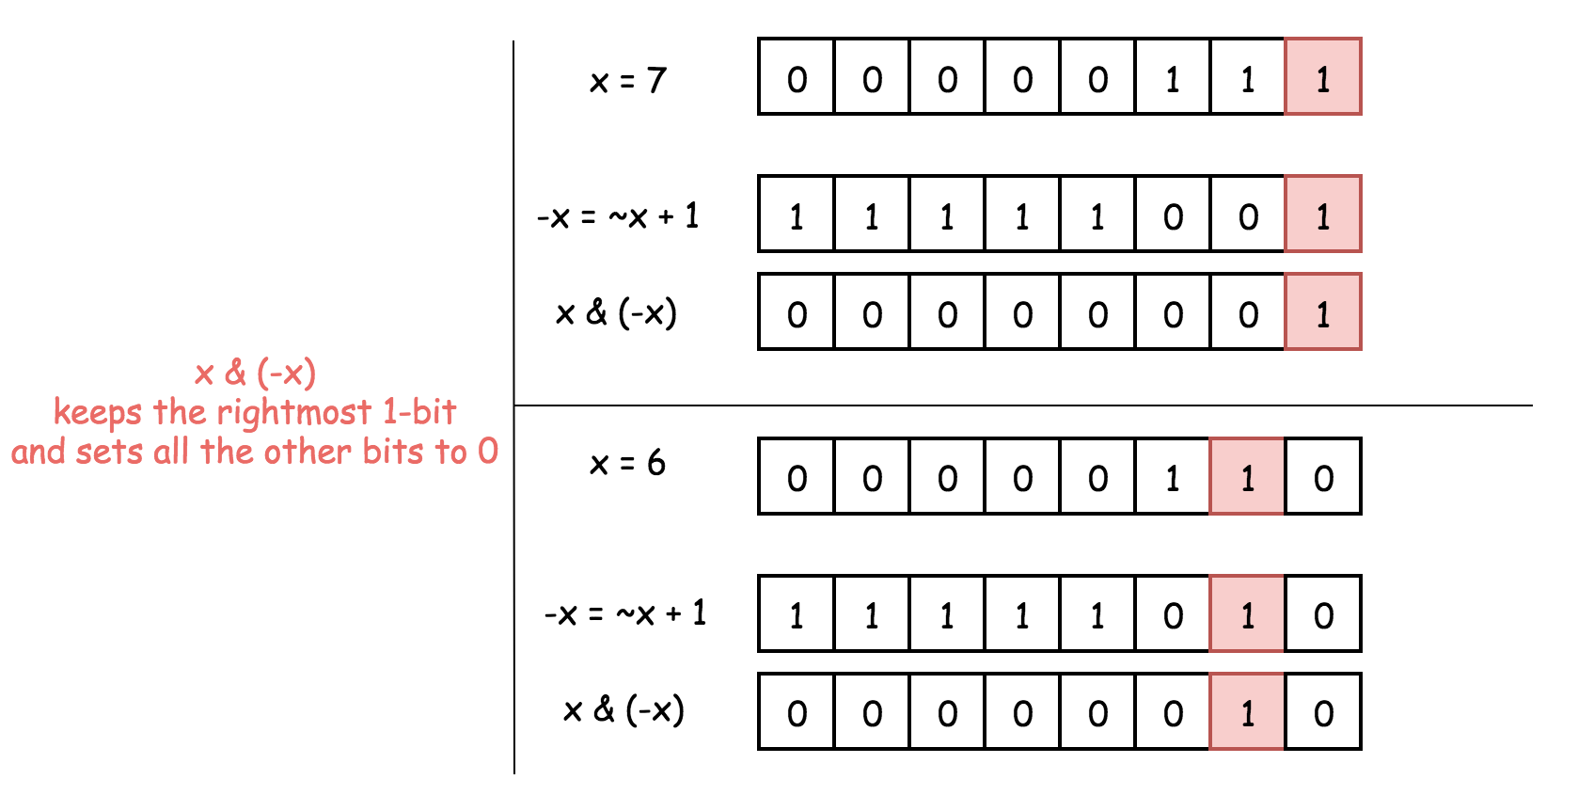

**Detect Power of Two**

So let's do x & (-x) to keep the rightmost 1-bit and to set all the others bits to zero. As discussed above, for the power of two it would result in x itself, since a power of two contains just one 1-bit.

Other numbers have more than 1-bit in their binary representation and hence for them x & (-x) would not be equal to x itself.

Hence a number is a power of two if x & (-x) == x.

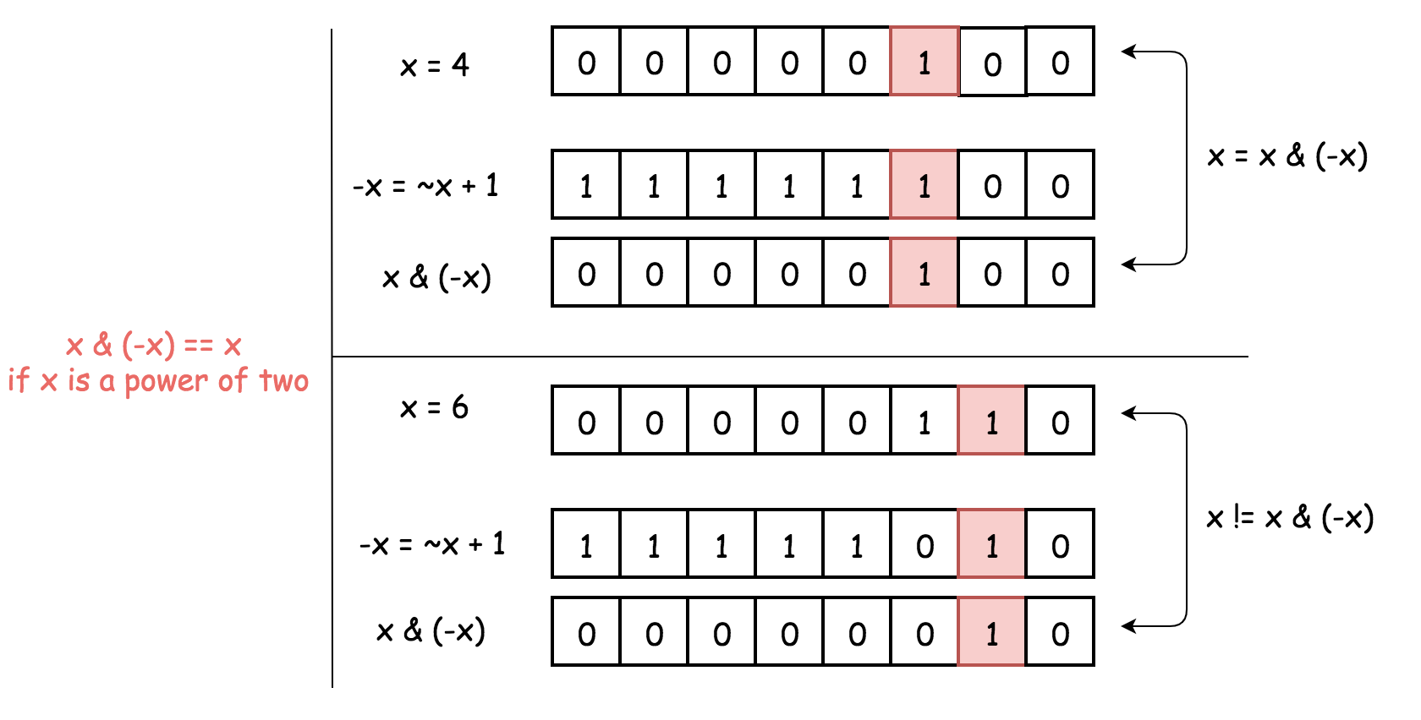

**Implementation**

|  |
| --- |
| class Solution {  public boolean isPowerOfTwo(int n) {  if (n == 0) return false;  long x = (long) n;  return (x & (-x)) == x;  }  } |

**Complexity Analysis**

* Time complexity : \mathcal{O}(1)O(1).
* Space complexity : \mathcal{O}(1)O(1).

#### **Approach 2: Bitwise operators : Turn off the Rightmost 1-bit**

**Turn off the Rightmost 1-bit**

Let's first discuss why x & (x - 1) is a way to set the rightmost 1-bit to zero.

To subtract 1 means to change the rightmost 1-bit to 0 and to set all the lower bits to 1.

Now AND operator: the rightmost 1-bit will be turned off because 1 & 0 = 0, and all the lower bits as well.

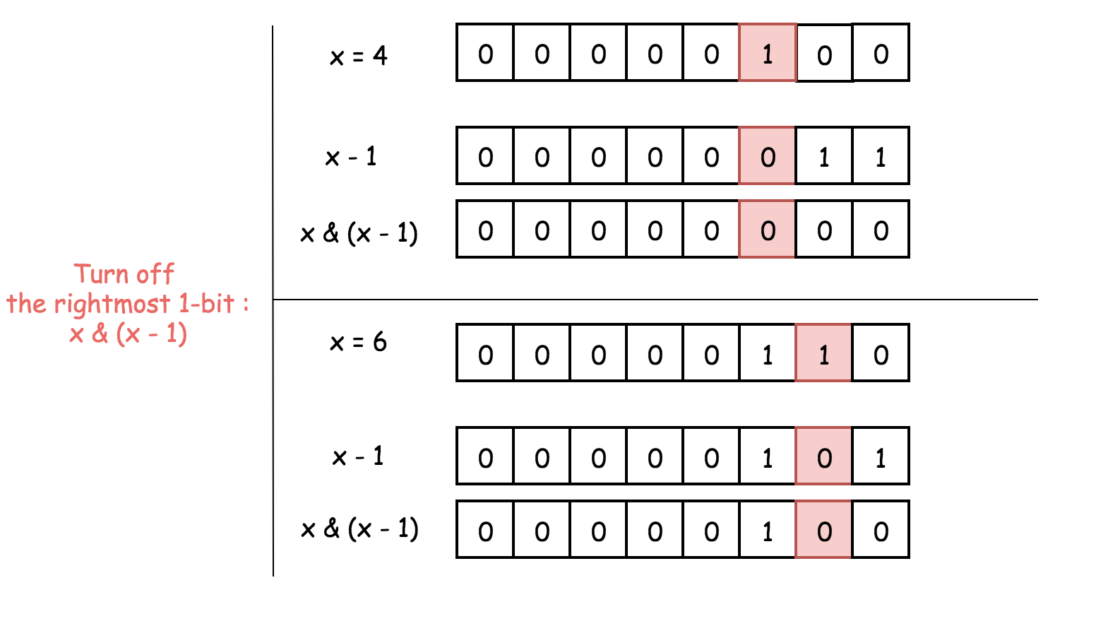

**Detect Power of Two**

The solution is straightforward:

1. Power of two has just one 1-bit.
2. x & (x - 1) sets this 1-bit to zero, and hence one has to verify if the result is zero x & (x - 1) == 0.

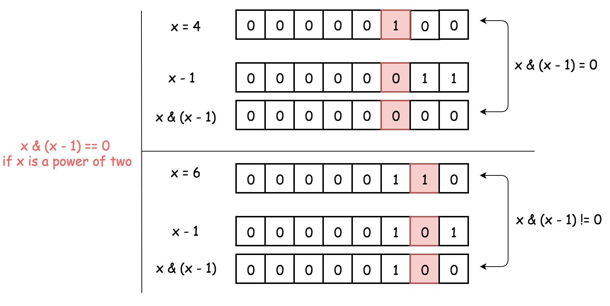

**Implementation**

|  |
| --- |
| class Solution {  public boolean isPowerOfTwo(int n) {  if (n == 0) return false;  long x = (long) n;  return (x & (x - 1)) == 0;  }  } |

**Complexity Analysis**

* Time complexity : \mathcal{O}(1)O(1).
* Space complexity : \mathcal{O}(1)O(1).

**Is Subsequence**

Given two strings s and t, check if s is a **subsequence** of t.

A **subsequence** of a string is a new string that is formed from the original string by deleting some (can be none) of the characters without disturbing the relative positions of the remaining characters. (i.e., "ace" is a subsequence of "abcde" while "aec" is not).

**Example 1:**

**Input:** s = "abc", t = "ahbgdc"

**Output:** true

**Example 2:**

**Input:** s = "axc", t = "ahbgdc"

**Output:** false

**Constraints:**

* 0 <= s.length <= 100
* 0 <= t.length <= 104
* s and t consist only of lowercase English letters.

**Follow up:** If there are lots of incoming s, say s1, s2, ..., sk where k >= 109, and you want to check one by one to see if t has its subsequence. In this scenario, how would you change your code?

## Solution

#### **Overview**

First of all, one might be deceived by the **Easy** tag of the problem. The solution might be simple (i.e. judging by the number of code lines), yet the problem itself is much more intriguing, especially when one is asked to prove the correctness of the solution, not to mention that we have an interesting and legitimate follow-up question.

Also, one might be puzzled with the hints from the problem description, which says "Binary Search", "Dynamic Programing" and "Greedy". There is no doubt that each of them does characterize some trait of the solutions, although the order of these keywords might be misleading. Arguably, the keyword **Greedy** is more important than the other two.

One will see in the following sections, how each of the above **techniques** plays out in the solutions. We will also cover the follow-up question in one of the solutions.

#### **Approach 1: Divide and Conquer with Greedy**

**Intuition**

The problem concerns the string matching issues, for which often one can apply a technique called ***divide and conquer***.

The general idea of the divide and conquer technique is to reduce the problem down into subproblems with smaller scales recursively until the problem becomes small enough to tackle with. We then use the results of subproblems to construct the solution for the original problem.

For more details, one can refer to the chapter of [divide and conquer](https://leetcode.com/explore/learn/card/recursion-ii/470/divide-and-conquer/) in our Explore card.

Here we show how to break down our problem step by step. Given two strings \text{source}source and \text{target}target, we are asked to determine if the \text{source}source string is a subsequence of the \text{target}target string, i.e. \text{isSubsequence(source, target)}isSubsequence(source, target)

Let us start from the first characters of each string, i.e. \text{source[0]}source[0], \text{target[0]}target[0]. By comparing them, there could be two cases as follows:

Case 1): they are identical, i.e. \text{source[0]} = \text{target[0]}source[0]=target[0]

In this case, the best strategy would be to **cross out** the first characters in both strings, and then continue with the matching job.

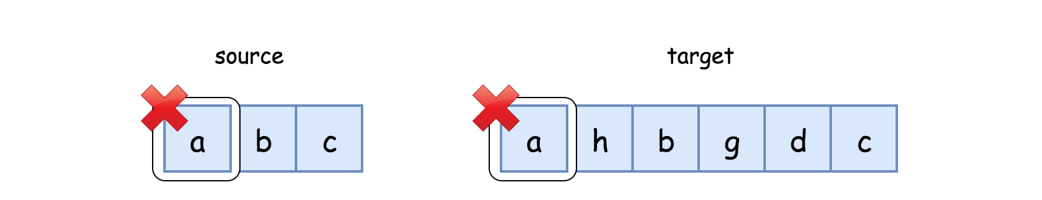

By the above action, we reduce the input into a smaller scale. It boils down to determine if the rest source string (i.e. \text{source[1:]}source[1:]) is a subsequence of the rest of target string (i.e. \text{target[1:]}target[1:]), which we could summarize in the following recursive formula:

\text{isSubsequence(source, target)} = \text{isSubsequence(source[1:], target[1:])}isSubsequence(source, target)=isSubsequence(source[1:], target[1:])

Case 2): they are not identical, i.e. \text{source[0]} \neq \text{target[0]}source[0]​=target[0]

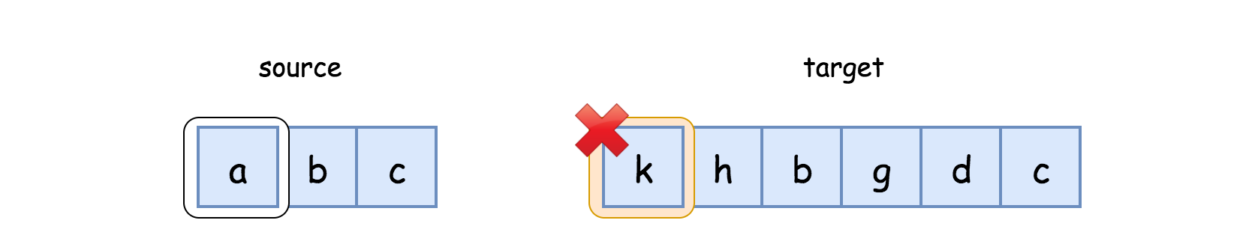

In this case, the only thing we can do is to **skip** (cross out) the first character in the target string, and keep on searching in the target string in the hope that we would find a letter that could match the first character in the source string.

Now, it boils down to determine if the source string could be a subsequence for the rest of the target string, which we summarize as follows:

\text{isSubsequence(source, target)} = \text{isSubsequence(source, target[1:])}isSubsequence(source, target)=isSubsequence(source, target[1:])

Let us combine the above two cases as follows, which consists of our baby steps of divide and conquer, by looking at the first characters of each string.

\text{isSubsequence(source, target)} = \left\{ \begin{array}{l} \text{isSubsequence(source[1:], target[1:])} \\ \text{isSubsequence(source, target[1:])} \end{array} \right.isSubsequence(source, target)={isSubsequence(source[1:], target[1:])isSubsequence(source, target[1:])​

It should be intuitive to implement a recursive solution with the above formulas.

To make the recursion complete, we should also define the ***base cases*** properly. In this problem, we have two particular base cases:

* The \text{source}source becomes empty, i.e. we found matches for all the letters in the source string. Hence, the source string is a subsequence of the target string.
* The \text{target}target becomes empty, i.e. we exhaust the target string, yet there are still some letters left unmatched in the source string. Hence, the source string is not a subsequence of the target string.

**Greedy**

Before jumping into the implementation, we would like to discuss an important strategy that we adopted here, other than the divide and conquer technique.

That is right. It is the ***Greedy*** strategy, which we did not mention in the intuition section.

As one might recall, when the first characters of the source and target strings match, we mentioned that the ***best strategy*** is to cross out the matched characters from both strings and then continue with the matching.

The other possible action could be that we **dismiss** this match and continue the search in the target string.

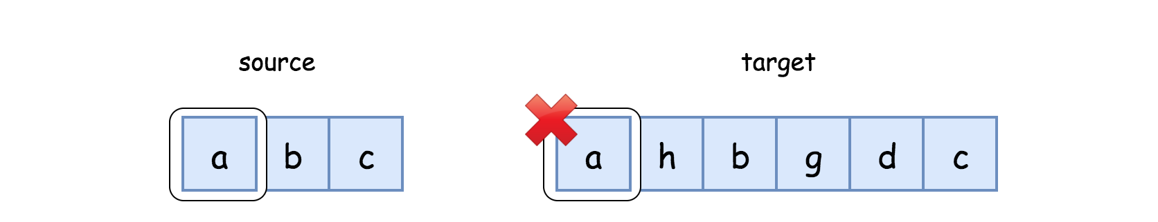

By adopting the best strategy, we were ***greedily*** crossing out the matched character from the source string, rather than deferring the match.

One might question if the result is correct with the greedy strategy, since it does seem that we were missing out some other alternatives.

To prove the **correctness** of greedy algorithms, often we apply the contradiction technique, i.e. deriving a contradicted fact while assuming the alternative argument is correct.

It could be tedious to give a rigid mathematical proof on why the greedy algorithm is correct here. Here we would like to present simply two arguments without detailed proofs:

* If the source is **not** a subsequence of the target string, in no case will our greedy algorithm return a positive result.
* If the source is indeed a subsequence of the target string (there could exist multiple solutions), then our greedy algorithm will return a positive result as well. For an obvious reason, our greedy algorithm does not exhaust all possible matches. However, one match suffices.

**Algorithm**

Following the recursive formulas that we presented before, it should be intuitive to implement a solution with recursion.

As a reminder, here is the formulas:

isSubsequence(source, target)={isSubsequence(source[1:], target[1:])isSubsequence(source, target[1:])​

|  |
| --- |
| class Solution {  String source, target;  Integer leftBound, rightBound;  private boolean rec_isSubsequence(int leftIndex, int rightIndex) {  // base cases  if (leftIndex == leftBound)  return true;  if (rightIndex == rightBound)  return false;  // consume both strings or just the target string  if (source.charAt(leftIndex) == target.charAt(rightIndex))  ++leftIndex;  ++rightIndex;  return rec_isSubsequence(leftIndex, rightIndex);  }  public boolean isSubsequence(String s, String t) {  this.source = s;  this.target = t;  this.leftBound = s.length();  this.rightBound = t.length();  return rec_isSubsequence(0, 0);  }  } |

Note, the above implementations happen to comply with a particular form of recursion, called **tail recursion**, which is a runtime optimization technique that is supported in some programming languages such as C and C++.

For more details, one can refer to the article of [tail recursion](https://leetcode.com/explore/learn/card/recursion-i/256/complexity-analysis/2374/) in our Explore card.

**Complexity Analysis**

Let |S|∣*S*∣ be the length of the source string, and |T|∣*T*∣ be the length of the target string.

* Time Complexity: \mathcal{O}(|T|)O(∣*T*∣).
  + At each invocation of the rec_isSubsequence() function, we would consume one character from the target string and optionally one character from the source string.
  + The recursion ends when either of the strings becomes empty. In the worst case, we would have to scan the entire target string. As a result, the overall time complexity of the algorithm is \mathcal{O}(|T|)O(∣*T*∣).
  + Note, even when the source string is longer than the target string, the recursion would end anyway when we exhaust the target string. Hence, the number of recursions is not bounded by the length of the source string.
* Space Complexity: \mathcal{O}(|T|)O(∣*T*∣)
  + The recursion incurs some additional memory consumption in the function call stack. As we discussed previously, in the worst case, the recursion would happen |T|∣*T*∣ times. Therefore, the overall space complexity is \mathcal{O}(|T|)O(∣*T*∣).
  + With the optimization of tail recursion, this extra space overhead could be exempted, due to the fact that the call stack is reused for all consecutive recursions. However, Python and Java do not support tail recursion. Hence, this overhead cannot be waived.

#### **Approach 2: Two-Pointers**

**Intuition**

Following the same intuition above, we could further optimize the space complexity of the previous solutions, by replacing the recursion with the iteration.

More specifically, we iterate through the source and target strings, respectively with a **pointer**.

Each pointer marks a position that we progress on the matching of the characters.

**Algorithm**

We designate two pointers for iteration, with the left pointer referring to the source string and the right pointer to the target string.

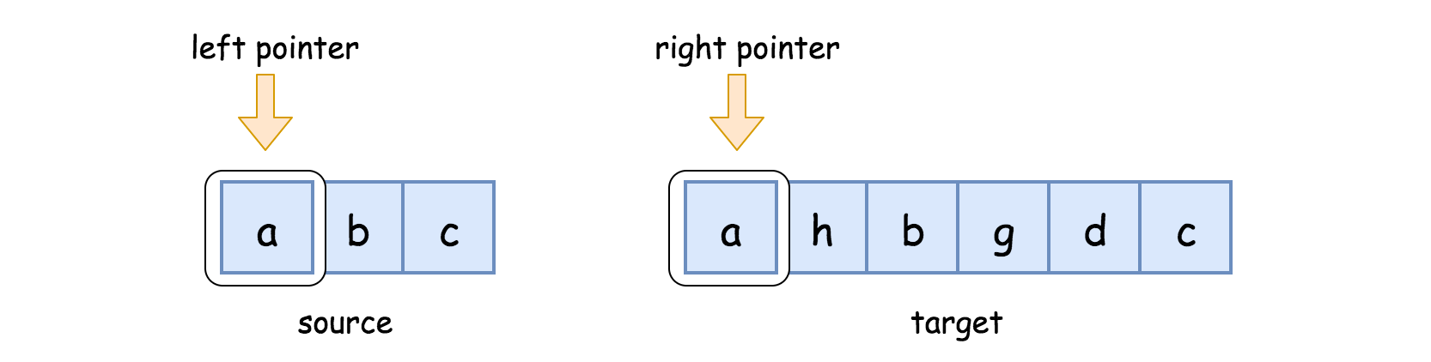

We move the pointers accordingly on the following two cases:

* If source[left] == target[right]: we found a match. Hence, we move both pointers one step forward.
* If source[left] != target[right]: no match is found. We then move only the right pointer on the target string.

The iteration would terminate, when either of the pointers exceeds its boundary.

At the end of the iteration, the result **solely** depends on the fact that whether we have consumed all the characters in the source string. If so, we have found a suitable match for each character in the source string. Therefore, the source string is a subsequence of the target string.

|  |
| --- |
| class Solution {  public boolean isSubsequence(String s, String t) {  Integer leftBound = s.length(), rightBound = t.length();  Integer pLeft = 0, pRight = 0;  while (pLeft < leftBound && pRight < rightBound) {  // move both pointers or just the right pointer  if (s.charAt(pLeft) == t.charAt(pRight)) {  pLeft += 1;  }  pRight += 1;  }  return pLeft == leftBound;  }  } |

**Complexity Analysis**

Let |S|∣*S*∣ be the length of the source string, and |T|∣*T*∣ be the length of the target string.

* Time Complexity: \mathcal{O}(|T|)O(∣*T*∣)
  + The analysis is the same as the previous approach.
* Space Complexity: \mathcal{O}(1)O(1)
  + We replace the recursion with iteration. In the iteration, a constant memory is consumed regardless of the input.

#### **Approach 3: Greedy Match with Character Indices Hashmap**

**Intuition**

With the above two approaches under the belt, let us now look at the follow-up question raised in the problem description, which we cite as follows:

If there are lots of incoming S*S*, say S_1*S*1​, S_2*S*2​, ..., and you want to check one by one to see if T*T* has its subsequence. In this scenario, how would you change your code?

In the above scenario, we would expect several incoming source strings, but a constant target string. We are asked to match each of the source strings against the target string.

If we apply our previous algorithms, for each match, the overall time complexity would be \mathcal{O}(|T|)O(∣*T*∣).

In other words, regardless of the source strings, in the worst case, we have to scan the target string repeatedly, even though the target string remains the same.

Now with the bottleneck identified, we could ask ourselves if we could do something about it.

The reason why we scan the target string is to **look for** the next character that matches a given character in the source string. In essence, this is a **lookup** operation in the array data structure.

To speed up the lookup operation, the data structure of **hashmap** could come in handy, since it has a \mathcal{O}(1)O(1) time complexity for its lookup operation.

Indeed, we could build a hashmap out of the target string, with each unique character as key and the indices of its appearance as value.

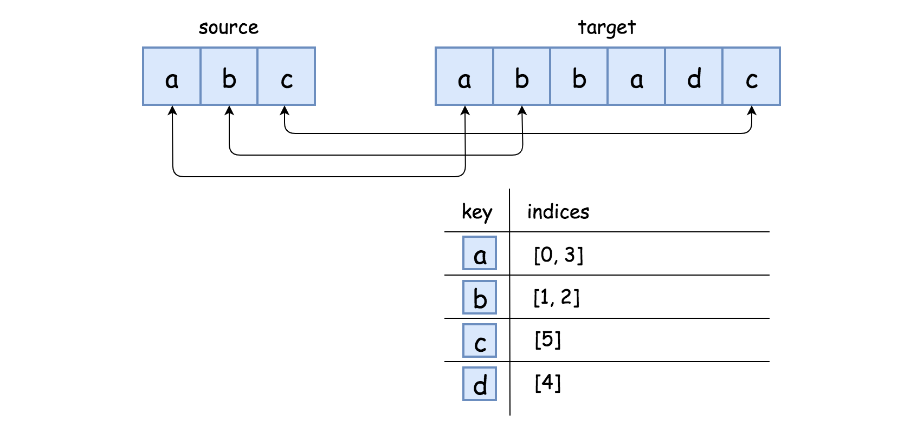

Moreover, we should pre-compute this hashmap once and then reuse it for all the following matches.

With this hashmap, rather than scanning through the entire target string, we could instantly retrieve all the relevant positions in the target string to look at, given a character from the source string.

**Algorithm**

Essentially, the algorithm with hashmap remains rather similar with our previous approaches, i.e. we still need to iterate through the source string to find the matches, and more importantly, we still do the match in the greedy manner.

* First, we build a hashmap out of the target string. Each key is a unique character in the target string, e.g. a. Its corresponding value would be a list of indices where the character appears in the target string, e.g. [0, 3].
* We then iterate through the source string.
* This time, rather than keeping two pointers, we need only one pointer on the target string. The pointer marks our progress on the target string.
* As we've seen from all the previous approaches, the pointer on the target string should move ***monotonically***, i.e. in no case, we would move the pointer to an earlier position.
* We use the pointer to check if an index is suitable or not. For instance, for the character a whose corresponding indices are [0, 3], we need to pick an index out of all the appearances as a match. Suppose at certain moment, the pointer is located at the index 1. Then, the suitable greedy match would be the index of 3, which is the first index that is larger than the current position of the target pointer.

|  |
| --- |
| class Solution {  public boolean isSubsequence(String s, String t) {  // precomputation, build the hashmap out of the target string  HashMap<Character, List<Integer>> letterIndicesTable = new HashMap<>();  for (int i = 0; i < t.length(); ++i) {  if (letterIndicesTable.containsKey(t.charAt(i)))  letterIndicesTable.get(t.charAt(i)).add(i);  else {  ArrayList<Integer> indices = new ArrayList<Integer>();  indices.add(i);  letterIndicesTable.put(t.charAt(i), indices);  }  }  Integer currMatchIndex = -1;  for (char letter : s.toCharArray()) {  if (!letterIndicesTable.containsKey(letter))  return false; // no match, early exist  boolean isMatched = false;  // greedy match with linear search  for (Integer matchIndex : letterIndicesTable.get(letter)) {  if (currMatchIndex < matchIndex) {  currMatchIndex = matchIndex;  isMatched = true;  break;  }  }  if (!isMatched)  return false;  }  // consume all characters in the source string  return true;  }  } |

**Optimization**

As one might notice, we added a last touch to the above algorithm to make it faster.

Given a list of indices for a matched character, in order to find the suitable index, we could simply do the **linear search** as we did in the above Java implementation.

Since the list of indices is ordered, due to the process of construction, we could also apply the **binary search** on the list to locate the desired index faster. As a comparison, we implemented this in the Python implementation.

Now hopefully, no one is puzzled with the keyword of binary search from the hints of the problem.

**Complexity Analysis**

Let |T|∣*T*∣ be the length of the target string, and |S|∣*S*∣ be the length of the source string.

* Time Complexity: \mathcal{O}(|T| + |S| \cdot \log{|T|})O(∣*T*∣+∣*S*∣⋅log∣*T*∣).
  + First of all, we build a hashmap out of the target string, which would take \mathcal{O}(|T|)O(∣*T*∣) time complexity. But if we redesign the API to better fit the scenario of the follow-up question, we should put the construction of the hashmap in the constructor of the class, which should be done only once. The cost of this construction would be amortized by the following calls of string matches.
  + As the second part of the algorithm, we scan through the source string, and lookup the corresponding indices in the hashmap. The lookup operation in hashmap is constant. However, to find the suitable index would take either \mathcal{O}(|T|)O(∣*T*∣) with the linear search or \mathcal{O}(\log{|T|})O(log∣*T*∣) with the binary search. To summarize, this part would be bounded by \mathcal{O}(|S| \cdot \log{|T|})O(∣*S*∣⋅log∣*T*∣).
  + As one can see, the second part heavily depends on the distribution of the characters in the target string. If the characters are distributed evenly, the entries in the hashmap would have a shorter list of indices, which in return would shorten the search time. But in general, one could consider the approach with hashmap should be faster than the two-pointers approach, although their time complexities say otherwise.
* Space Complexity: \mathcal{O}(|T|)O(∣*T*∣)
  + We built a hashmap that consists of the indices for each character in the target string. Hence, the size of values (indices) in hashmap would be |T|∣*T*∣. In the worst case, we might have as many keys as the values, i.e. each character corresponds to a unique index. In total, the space complexity of the hashmap would be \mathcal{O}(|T|)O(∣*T*∣).

#### **Approach 4: Dynamic Programming**

**Intuition**

Based on the description of the problem, it reminds us of a well-known problem called [Edit Distance](https://leetcode.com/problems/edit-distance/) on LeetCode, which is also known as [Levenshtein disance](https://en.wikipedia.org/wiki/Levenshtein_distance).

The problem of edit distance is to find the minimal number of edit operations to convert one string to another string. The permitted operations are deletion, insertion and replacement.

Intuitively, one can consider our subsequence problem as a simplified edit distance with only the deletion operation.

The classic solution to solve the edit distance problem is to apply the **dynamic programming** technique. Similarly, we should be able to solve our problem here with dynamic programming as well.

**Algorithm**

With dynamic programming, essentially we build a matrix (dp[row][col]) where each element in the matrix represents the maximal number of deletions that we can have between a prefix of source string and a prefix of the target string, namely source[0:col] and target[0:row].

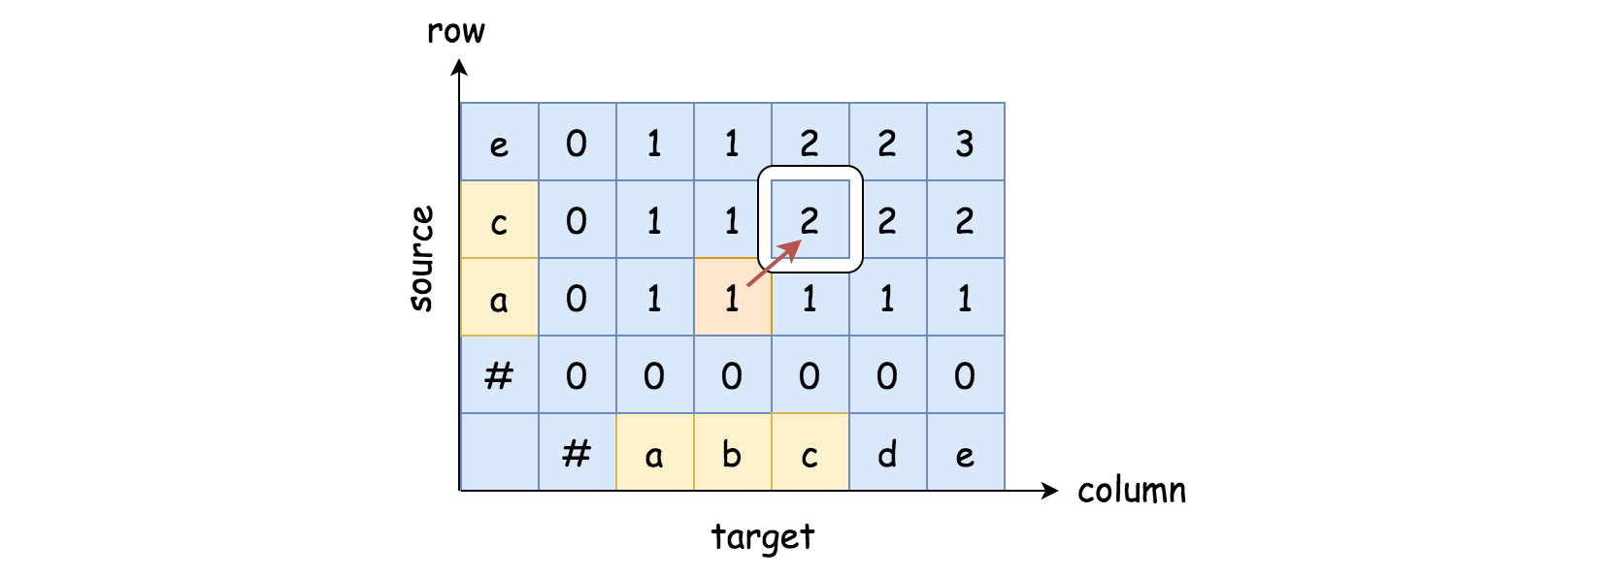

In the above graph, we show an example of the dp matrix. For instance, for the element of dp[2][3] as we highlighted, it indicates that the maximal number of deletions (i.e. matches) that we can have between the source prefix ac and the target prefix abc is 2.

Suppose that we can obtain this dp matrix, the problem becomes simple.

Once we have the dp matrix, it boils down to see if we can have as many deletions as the number of characters in the source string, i.e. if we could consume the entire source string with the matches from the target string.

In other words, it suffices to examine the last row of the dp matrix (dp[len(source)]), to see if there is any number that is equal to the length of the source string.

In the following animation, we show how to calculate each element in the dp matrix.



Since the problem of *edit distance* is a hard one and so with its solution, we invite you to check out our article of [edit distance](https://leetcode.com/articles/edit-distance/), which explains the solution in details.

Here we present a modified version of the edit distance solution, based on the above idea.

|  |
| --- |
| class Solution {  public boolean isSubsequence(String s, String t) {  Integer sourceLen = s.length(), targetLen = t.length();  // the source string is empty  if (sourceLen == 0)  return true;  int[][] dp = new int[sourceLen + 1][targetLen + 1];  // DP calculation, we fill the matrix column by column, bottom up  for (int col = 1; col <= targetLen; ++col) {  for (int row = 1; row <= sourceLen; ++row) {  if (s.charAt(row - 1) == t.charAt(col - 1))  // find another match  dp[row][col] = dp[row - 1][col - 1] + 1;  else  // retrieve the maximal result from previous prefixes  dp[row][col] = Math.max(dp[row][col - 1], dp[row - 1][col]);  }  // check if we can consume the entire source string,  // with the current prefix of the target string.  if (dp[sourceLen][col] == sourceLen)  return true;  }  // matching failure  return false;  }  } |

**Complexity Analysis**

Let |T|∣*T*∣ be the length of the target string, and |S|∣*S*∣ be the length of the source string.

* Time Complexity: \mathcal{O}(|S| \cdot |T|)O(∣*S*∣⋅∣*T*∣)
  + We build a matrix of size |S| \cdot |T|∣*S*∣⋅∣*T*∣. In the worst case, we would need to iterate through each element in the matrix. Therefore, the overall time complexity of the algorithm is \mathcal{O}(|S| \cdot |T|)O(∣*S*∣⋅∣*T*∣).
  + It is not necessarily the case that we have to iterate through the entire matrix. As one notices, we do have an early exit condition while we fill the values in the matrix.
  + Generally speaking, the dynamic programming algorithms tend to be faster than other solutions, since it reuses the intermediate solutions rather than recalculating them. However, it is not the case here.
  + The DP solution here tries to calculate the solutions for all combinations of prefixes between the source and target strings. As a result, it is less efficient than the Greedy approach which has the time complexity of \mathcal{O}(|T|)O(∣*T*∣).
* Space Complexity: \mathcal{O}(|S| \cdot |T|)O(∣*S*∣⋅∣*T*∣), since we build a matrix of size |S| \cdot |T|∣*S*∣⋅∣*T*∣.

**Largest Divisible Subset**

Given a set of **distinct** positive integers nums, return the largest subset answer such that every pair (answer[i], answer[j]) of elements in this subset satisfies:

* answer[i] % answer[j] == 0, or
* answer[j] % answer[i] == 0

If there are multiple solutions, return any of them.

**Example 1:**

**Input:** nums = [1,2,3]

**Output:** [1,2]

**Explanation:** [1,3] is also accepted.

**Example 2:**

**Input:** nums = [1,2,4,8]

**Output:** [1,2,4,8]

**Constraints:**

* 1 <= nums.length <= 1000
* 1 <= nums[i] <= 2 * 109
* All the integers in nums are **unique**.

## Solution

#### **Mathematics**

Before elaborating the solutions, we give some corollaries that one can derive from the property of modulo operation, which would prove useful later to solve the problem.

Given a list of values [E, F, G] sorted in ascending order (i.e. E < F < G), and the list itself forms a divisible subset as described in the problem, then we could extend the subset without ***enumerating*** all numbers in the subset, in the following two cases:

* **Corollary I:** For any value that can be divided by the largest element in the divisible subset, by adding the new value into the subset, one can form another divisible subset, i.e. for all h, if h % G == 0, then [E, F, G, h] forms a new divisible subset.
* **Corollary II:** For all value that can divide the smallest element in the subset, by adding the new value into the subset, one can form another divisible subset, i.e. for all d, if E % d == 0, then [d, E, F, G] forms a new divisible subset.

The above two corollaries could help us to structure an efficient solution, since it suffices to have just one comparison in order to extend the subset.

#### **Approach 1: Dynamic Programming**

**Intuition**

At the first glance, the problem might seem to be similar with those combination problems such as [two sum](https://leetcode.com/problems/two-sum/) and [3sum](https://leetcode.com/problems/3sum/). Indeed, like those combinations problems, it turned out to be rather helpful to ***sort*** the original list first, which would help us to reduce the number of enumerations at the end.

As another benefit of sorting the original list, we would be able to apply the mathematical corollaries explained at the beginning of the article.

So first of all, we sort the original list. And as it turns out, this is another dynamic programming problem. The key of solving a dynamic programming problem is to formulate the problem in a recursive and sound way.

Here is our attempt, which you would see some theoretical supports later.

For an ordered list [X_1, X_2, ... X_n][*X*1​,*X*2​,...*Xn*​], we claim that the largest divisible subset from this list is the largest subset among all possible divisible subsets that **end with** each of the number in the list.

Let us define a function named \text{EDS}(X_i)EDS(*Xi*​), which gives the largest divisible subset that ends with the number X_i*Xi*​. By "ends with", we mean that the number X_i*Xi*​ should be the largest number in the subset. For example, given the list [2, 4, 7, 8][2,4,7,8], let us calculate \text{EDS}(4)EDS(4) by enumeration. First, we list all divisible subsets that ends with 44, which should be \{4\}{4} and \{2, 4\}{2,4}. Then by definition, we have \text{EDS}(4) = \{2, 4\}EDS(4)={2,4}. Similarly, one can obtain that \text{EDS}(2) = \{2\}EDS(2)={2} and \text{EDS}(7) = \{7\}EDS(7)={7}.

**Note:** a single number itself forms a divisible subset as well, though it might not be clearly stated in the problem statement.

Finally let us define our target function that gives the largest divisible subset from an order list [X_1, X_2, ... X_n][*X*1​,*X*2​,...*Xn*​], as \text{LDS}([X_1, X_2, ... X_n])LDS([*X*1​,*X*2​,...*Xn*​]). Now, without further due, we claim that the following equation should hold: \text{LDS}([X_1, X_2,...X_n]) = \max{ ( \forall \space \text{EDS}(X_i) )} \space, \space 1 \le i \le n \quad \quad (1)LDS([*X*1​,*X*2​,...*Xn*​])=max(∀ EDS(*Xi*​)) , 1≤*i*≤*n*(1)

We could prove the above formula literally by definition. First of all, \forall \space \text{EDS}(X_i)∀ EDS(*Xi*​) cover the divisible subsets in all cases (i.e. subsets ends with X_i*Xi*​). And then we pick the largest one among the largest subsets.

Furthermore, we could calculate the function \text{EDS}(X_i)EDS(*Xi*​) recursively, with the corollaries we defined at the beginning of the article.

**Algorithm**

Let us explain the algorithm on how to calculate \text{EDS}(X_i)EDS(*Xi*​), following the above example with the list of [2, 4, 7, 8][2,4,7,8]. As a reminder, previously we have obtained the \text{EDS}(X_i)EDS(*Xi*​) value for all elements less than 8, i.e.: \text{EDS}(2) = \{2\} \quad \text{EDS}(4) = \{2, 4\} \quad \text{EDS}(7) = \{7\}EDS(2)={2}EDS(4)={2,4}EDS(7)={7} To obtain \text{EDS}(8)EDS(8), we simply enumerate all elements before 88 and their \text{EDS}(X_i)EDS(*Xi*​) values respectively, with the following procedure:

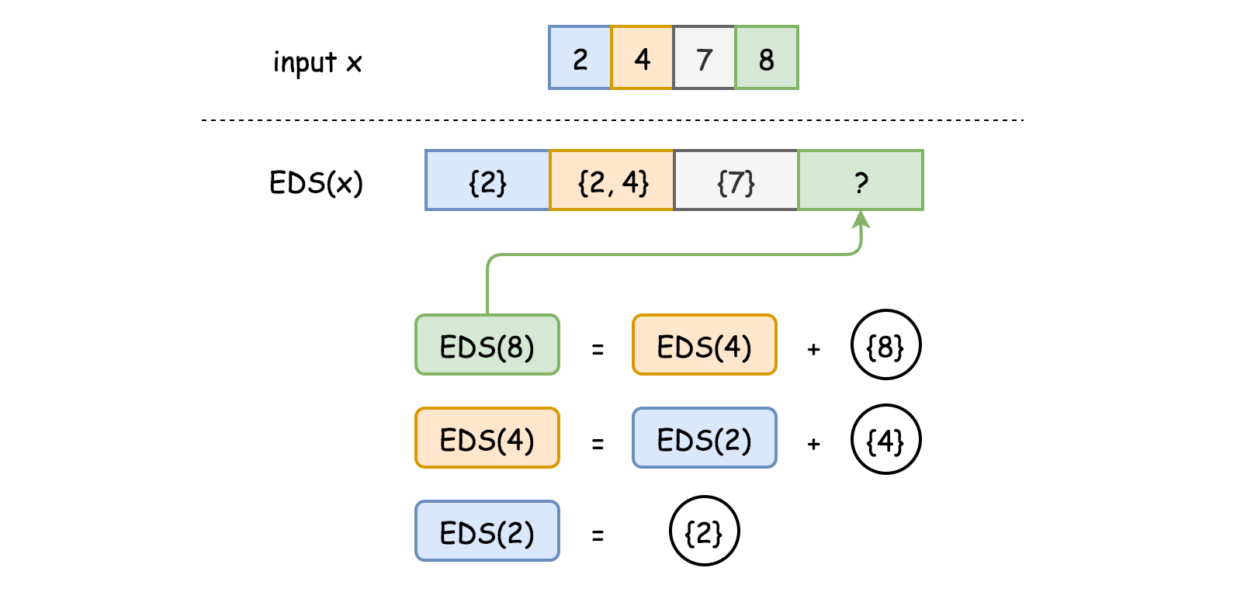

* If the number 88 can be divided by the element X_i*Xi*​, then by appending the number 88 to \text{EDS}(X_i)EDS(*Xi*​) we obtain another divisible subset that ends with 88, according to our **Corollary I**. And this new subset stands as a potential value for \text{EDS}(8)EDS(8). For example, since 8 \bmod 2 == 08mod2==0, therefore \{2, 8\}{2,8} could be the final value for \text{EDS}(8)EDS(8), and similarly with the subset \{2, 4, 8\}{2,4,8} obtained from \text{EDS}(4)EDS(4)
* If the number 88 can NOT be divided by the element X_i*Xi*​, then we could be sure that the value of \text{EDS}(X_i)EDS(*Xi*​) would not contribute to \text{EDS}(8)EDS(8), according to the definition of divisible subset. For example, the subset \text{EDS}(7) = \{7\}EDS(7)={7} has no impact for \text{EDS}(8)EDS(8).
* We then pick the largest new subsets that we form with the help of \text{EDS}(X_i)EDS(*Xi*​). Particularly, the subset \{8\}{8} stands for a valid candidate for \text{EDS}(8)EDS(8). And in a hypothetical case where 88 cannot be divided by any of its previous elements, we would have \text{EDS}(8) = \{8\}EDS(8)={8}.

Here we give some sample implementation based on the above idea. Note: for the Python implementation, we showcase the one from [StefanPochmann](https://leetcode.com/problems/largest-divisible-subset/discuss/84002/4-lines-in-Python) for its conciseness and efficiency.

|  |
| --- |
| class Solution {  public List<Integer> largestDivisibleSubset(int[] nums) {  // Test case with empty set.  int n = nums.length;  if (n == 0) return new ArrayList();    // Container to keep the largest divisible subset  // that ends with each of the nums.  List<ArrayList> EDS = new ArrayList();  for (int num : nums) EDS.add(new ArrayList());  /* Sort the original list in ascending order. */  Arrays.sort(nums);  /* Calculate all the values of EDS(X_i) */  for (int i = 0; i < n; ++i) {  List<Integer> maxSubset = new ArrayList();    // Find the largest divisible subset of previous elements.  for (int k = 0; k < i; ++k)  if (nums[i] % nums[k] == 0 && maxSubset.size() < EDS.get(k).size())  maxSubset = EDS.get(k);    // Extend the found subset with the element itself.  EDS.get(i).addAll(maxSubset);  EDS.get(i).add(nums[i]);  }  /* Find the largest of EDS values */  List<Integer> ret = new ArrayList();  for (int i = 0; i < n; ++i)  if (ret.size() < EDS.get(i).size()) ret = EDS.get(i);  return ret;  }  } |

**Complexity Analysis**

* Time complexity : \mathcal{O}(N^2)O(*N*2). In the major loop of the algorithm, we need to calculate the \text{EDS}(X_i)EDS(*Xi*​) for each element in the input list. And for each \text{EDS}(X_i)EDS(*Xi*​) calculation, we need to enumerate all elements before X_i*Xi*​. As a result, we end up with the \mathcal{O}(N^2)O(*N*2) time complexity.
* Space complexity : \mathcal{O}(N^2)O(*N*2). We maintain a container to keep track of \text{EDS}(X_i)EDS(*Xi*​) value for each element in the list. And in the worst case where the entire list is a divisible set, the value of \text{EDS}(X_i)EDS(*Xi*​) would be the sublist of [X_1, X_2...X_i][*X*1​,*X*2​...*Xi*​]. As a result, we end up with the \mathcal{O}(N^2)O(*N*2) space complexity.

#### **Approach 2: Dynamic Programming with Less Space**

**Intuition**

Following the same intuition of dynamic programming, however we could do a bit better on the space complexity.

Instead of keeping the largest divisible subset for each of the input elements, i.e. \text{EDS}(X_i)EDS(*Xi*​), we could simply record its size, namely \text{size}(\text{EDS}(X_i))size(EDS(*Xi*​)). As a result, we reduce the space complexity from \mathcal{O}(N^2)O(*N*2) to \mathcal{O}(N)O(*N*).

In exchange, we need to reconstruct the largest divisible subset at the end, which is a tradeoff between time and space.

**Algorithm**

The main algorithm remains almost the same as the Approach #1, which includes calculating **the size** of the largest divisible subset that ends with each element X_i*Xi*​. We denote this resulting vector as dp[i].

The difference is that we need some additional logic to extract the resulting subset from dp[i]. Here we elaborate the procedure with a concrete example shown in the graph below.

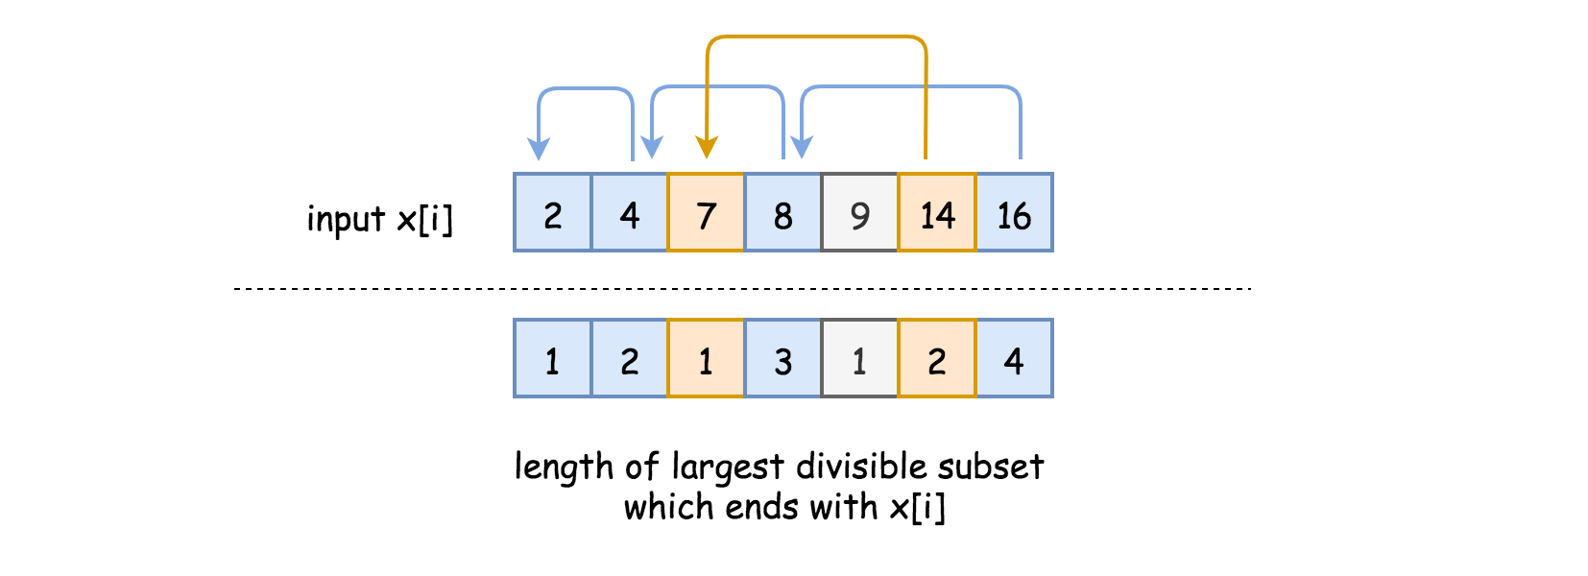

In the upper part of the graph, we have a list of elements (X_i*Xi*​) sorted in ascending order. And in the lower part of the graph, we have the size value of the largest divisible subset that ends with each element X_i*Xi*​.

To facilitate the reading, we draw a link between each element X_i*Xi*​ with its neighbor element in its largest divisible subset. For example, for the element X_i = 8*Xi*​=8, the resulting largest divisible subset that ends with 88 would be \{2, 4, 8\}{2,4,8}, and we see a link between 88 and its neighbor 44.

* The reconstruction of the resulting subset begins with finding the largest size (i.e. 44) and its index in dp[i]. The resulting largest divisible subset would end with the element who has the max value of dp[i].
* Then starting from the index of the largest size, we run a loop to go backwards (from X_i*Xi*​ to X_1*X*1​) to find the next element that should be included in the resulting subset.
* We have two criteria to determine this next element: (1). the element should be able to divide the previous tail element in the resulting subset, e.g. 16 \bmod 8 == 016mod8==0. (2). The value of dp[i] should correspond to the current size of the divisible subset, e.g. the element 7 would NOT be the next neighbor element after the element 8, since their dp[i] values do not match up.

|  |
| --- |
| class Solution {  public List<Integer> largestDivisibleSubset(int[] nums) {  // Test case with empty set.  int n = nums.length;  if (n == 0) return new ArrayList();    // Container to keep the size of the largest divisible subset  // that ends with each of the nums.  Integer[] dp = new Integer[n];  /* Sort the original list in ascending order. */  Arrays.sort(nums);  Integer maxSubsetSize = -1, maxSubsetIndex = -1;    /* Calculate the rest of EDS(X_i) */  for (int i = 0; i < n; ++i) {  Integer subsetSize = 0;  // Find the size of the largest divisible subset.  for (int k = 0; k < i; ++k)  if (nums[i] % nums[k] == 0 && subsetSize < dp[k])  subsetSize = dp[k];  // Extend the found subset with the element itself.  dp[i] = subsetSize + 1;    // We reuse this loop to obtain the largest subset size  // in order to prepare for the reconstruction of subset.  if (maxSubsetSize < dp[i]) {  maxSubsetSize = dp[i];  maxSubsetIndex = i;  }  }    /* Reconstruct the largest divisible subset */  LinkedList<Integer> subset = new LinkedList();  Integer currSize = maxSubsetSize;  Integer currTail = nums[maxSubsetIndex];  for (int i = maxSubsetIndex; i >= 0; --i) {  if (currSize == 0) break;    if (currTail % nums[i] == 0 && currSize == dp[i]) {  subset.addFirst(nums[i]);  currTail = nums[i];  currSize -= 1;  }  }  return subset;  }  } |

**Complexity Analysis**

* Time complexity : \mathcal{O}(N^2)O(*N*2). The additional logic to reconstruct the resulting subset would take us an extra \mathcal{O}(N)O(*N*) time complexity which is inferior to the main loop that takes \mathcal{O}(N^2)O(*N*2).
* Space complexity : \mathcal{O}(N)O(*N*). The vector dp[i] that keeps tracks of the size of the largest divisible subset which ends with each of the elements, would take \mathcal{O}(N)O(*N*) space in all cases.

#### **Approach 3: Recursion with Memoization**

**Intuition**

A typical code pattern for dynamic programming problems is to maintain a matrix or vector of intermediate solutions, and having one or two loops that traverse the matrix or vector. During the loop, we reuse the intermediate solutions instead of recalculating them at each occasion.

As one might notice, the above code pattern reminds us the techniques of recursion with memoization. Indeed, there is more than one way to implement the solution with the methodology of dynamic programming.

**Algorithm**

Once we figure out the essence of the problem, as summarized in the **Formula (1)**, it might be more intuitive to implement it via recursion with memoization.

Here we highlight the importance of applying **memoization** together with the recursion, in this case.

Following the same example in Approach #1, we draw the call graph below for the calculation of \text{EDS}(8)EDS(8), where each node represents the invocation of the function \text{EDS}(X_i)EDS(*Xi*​) and on the edge we indicate the sequence of the invocations.

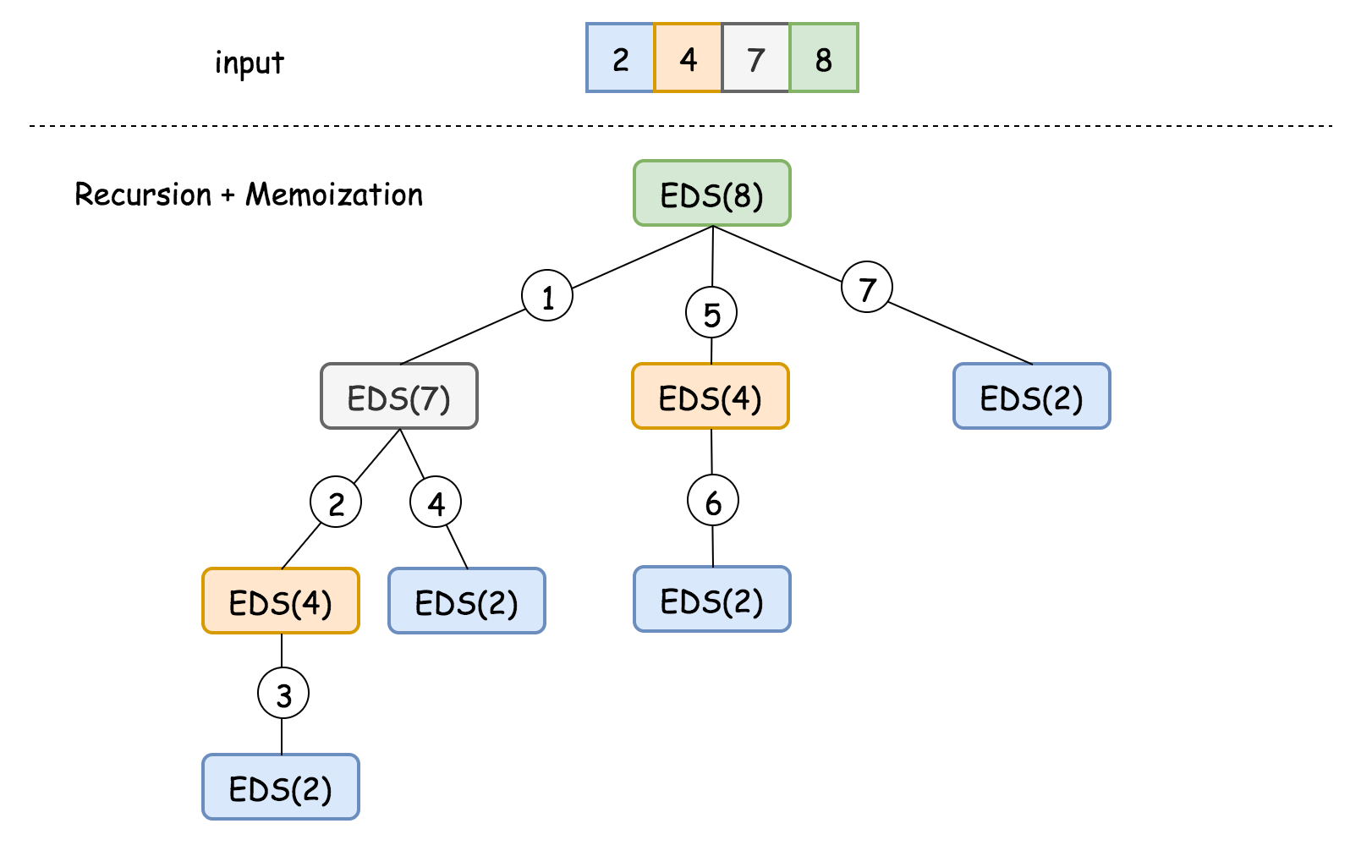

As one can see, if we do not keep the intermediate results, the number of calculation would grow exponentially with the length of the list.

|  |
| --- |
| class Solution {  HashMap<Integer, List<Integer>> _eds = new HashMap<Integer, List<Integer>>();  int [] _nums = {};  private List<Integer> EDS(Integer i) {  // memoization  if (this._eds.containsKey(i)) return this._eds.get(i);    List<Integer> maxSubset = new ArrayList();  // Find the largest divisible subset of previous elements.  for (int k = 0; k < i; ++k) {  if (this._nums[i] % this._nums[k] == 0) {  List<Integer> subset = EDS(k);  if (maxSubset.size() < subset.size()) maxSubset = subset;  }  }  // Extend the found subset with the element itself.  List<Integer> newEntry = new ArrayList();  newEntry.addAll(maxSubset);  newEntry.add(this._nums[i]);  // update the cached values  this._eds.put(i, newEntry);  return newEntry;  }  public List<Integer> largestDivisibleSubset(int[] nums) {  // Test case with empty set.  int n = nums.length;  if (n == 0) return new ArrayList();    // Container to keep the largest divisible subset  // that ends with each of the nums  // key: the index of the element  this._eds = new HashMap<Integer, List<Integer>>();    /* Sort the original list in ascending order. */  Arrays.sort(nums);  this._nums = nums;    List<Integer> maxSubset = new ArrayList();  /* Calculate the values of all EDS(X_i),  while keeping track of the largest one as the result value. */  for (int i = 0; i < n; ++i) {  List<Integer> subset = EDS(i);  if (maxSubset.size() < subset.size()) maxSubset = subset;  }    // return the largest one  return maxSubset;  }  } |

**Complexity Analysis**

* Time complexity : \mathcal{O}(N^2)O(*N*2).
  + In the above implementation, we adopt the bottom-up strategy where we first calculate the \text{EDS}(X_i)EDS(*Xi*​) for elements with lower index. Through the memoization technique, the latter \text{EDS}(X_i)EDS(*Xi*​) calculation could reuse the intermediate ones. As a result, we reach the same time complexity as in the Approach #1.
* Space complexity : \mathcal{O}(N^2)O(*N*2).
  + In this implementation, we decide to keep the subset instead of its size, as the intermediate solutions. As we discussed in previous approaches, this would lead to the \mathcal{O}(N^2)O(*N*2) space complexity, with the worst scenario where the entire input list being a divisible set.
  + In addition, due to the use of recursion, the program would incur a maximum \mathcal{O}(N)O(*N*) space for the call stacks, during the invocation of \text{EDS}(X_n)EDS(*Xn*​) for the last element in the ordered list. Though, overall the space complexity remains as \mathcal{O}(N^2)O(*N*2).

**Cheapest Flights Within K Stops**

There are n cities connected by m flights. Each flight starts from city u and arrives at v with a price w.

Now given all the cities and flights, together with starting city src and the destination dst, your task is to find the cheapest price from src to dst with up to k stops. If there is no such route, output -1.

**Example 1:**

**Input:**

n = 3, edges = [[0,1,100],[1,2,100],[0,2,500]]

src = 0, dst = 2, k = 1

**Output:** 200

**Explanation:**

The graph looks like this:

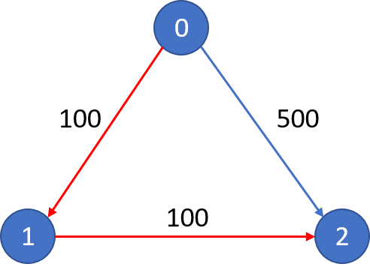

The cheapest price from city 0 to city 2 with at most 1 stop costs 200, as marked red in the picture.

**Example 2:**

**Input:**

n = 3, edges = [[0,1,100],[1,2,100],[0,2,500]]

src = 0, dst = 2, k = 0

**Output:** 500

**Explanation:**

The graph looks like this:



The cheapest price from city 0 to city 2 with at most 0 stop costs 500, as marked blue in the picture.

**Constraints:**

* The number of nodes n will be in range [1, 100], with nodes labeled from 0 to n - 1.
* The size of flights will be in range [0, n * (n - 1) / 2].
* The format of each flight will be (src, dst, price).
* The price of each flight will be in the range [1, 10000].
* k is in the range of [0, n - 1].
* There will not be any duplicated flights or self cycles.

## Solution

#### **Approach 1: Dijkstra's Algorithm**

**Intuition**

If we forget about the part where the number of stops is limited, then the problem simply becomes the shortest path problem on a weighted graph, right? We can treat this as a graph problem where:

* the cities can be treated as nodes in a graph
* the connections between each of the cities can be treated as the edges and finally
* the cost of going from one city to another would be the weight of the edges in the graph.

It's important to model the problem in a way that standard algorithms or their slight variations can be used for the solutions. Whenever we have a problem where we're given a bunch of entities and they have some sort of connections between them, more often than not it can be modeled as a graph problem. Once you've figured out that the question can be modeled as a graph problem, you then need to think about the various aspects of a graph i.e.

* directed vs undirected
* weighted vs unweighted
* cyclic vs acyclic

These aspects will help define the algorithm that you can consider for solving the problem at hand. For example a standard rule of thumb that is followed for solving shortest path problems is that we mostly use [Breadth-first search](https://en.wikipedia.org/wiki/Breadth-first_search) for unweighted graphs and use [Dijkstra's algorithm](https://en.wikipedia.org/wiki/Dijkstra%27s_algorithm) for weighted graphs. An implied condition to apply the Dijkstra's algorithm is that the weights of the graph must be positive. If the graph has negative weights and can have negative weighted cycles, we would have to employ another algorithm called the [Bellman Ford's](https://en.wikipedia.org/wiki/Bellman%E2%80%93Ford_algorithm). The point here is that the properties of the graph and the goal define the kind of algorithms we might be able to use.

Coming back to the original statement at the beginning of the article. If we don't consider the part where the number of stops is limited, this problem becomes a standard shortest paths problem in a weighted graph with positive weights and hence, it becomes a prime candidate for Dijkstra's. As we all know, Dijkstra's uses a min-heap (priority queue) as the main data structure for always picking out the node which can be reached in the shortest amount of time/cost/weight from the current point starting all the way from the source. That approach as it is won't work out for this problem.

First of all, we need to keep track of the number of stops taken to reach a node (city), in addition to the shortest path from the source node. This is important because if at any point we find that we have exhausted K*K* stops, we can't progress any further from that node because the number of stops are bounded by the problem. Let's consider a simple example and run through it with the basic Dijkstra's algorithm and see why we might run into a problem with the off-the-shelf code i.e. Dijkstra's without any modifications.

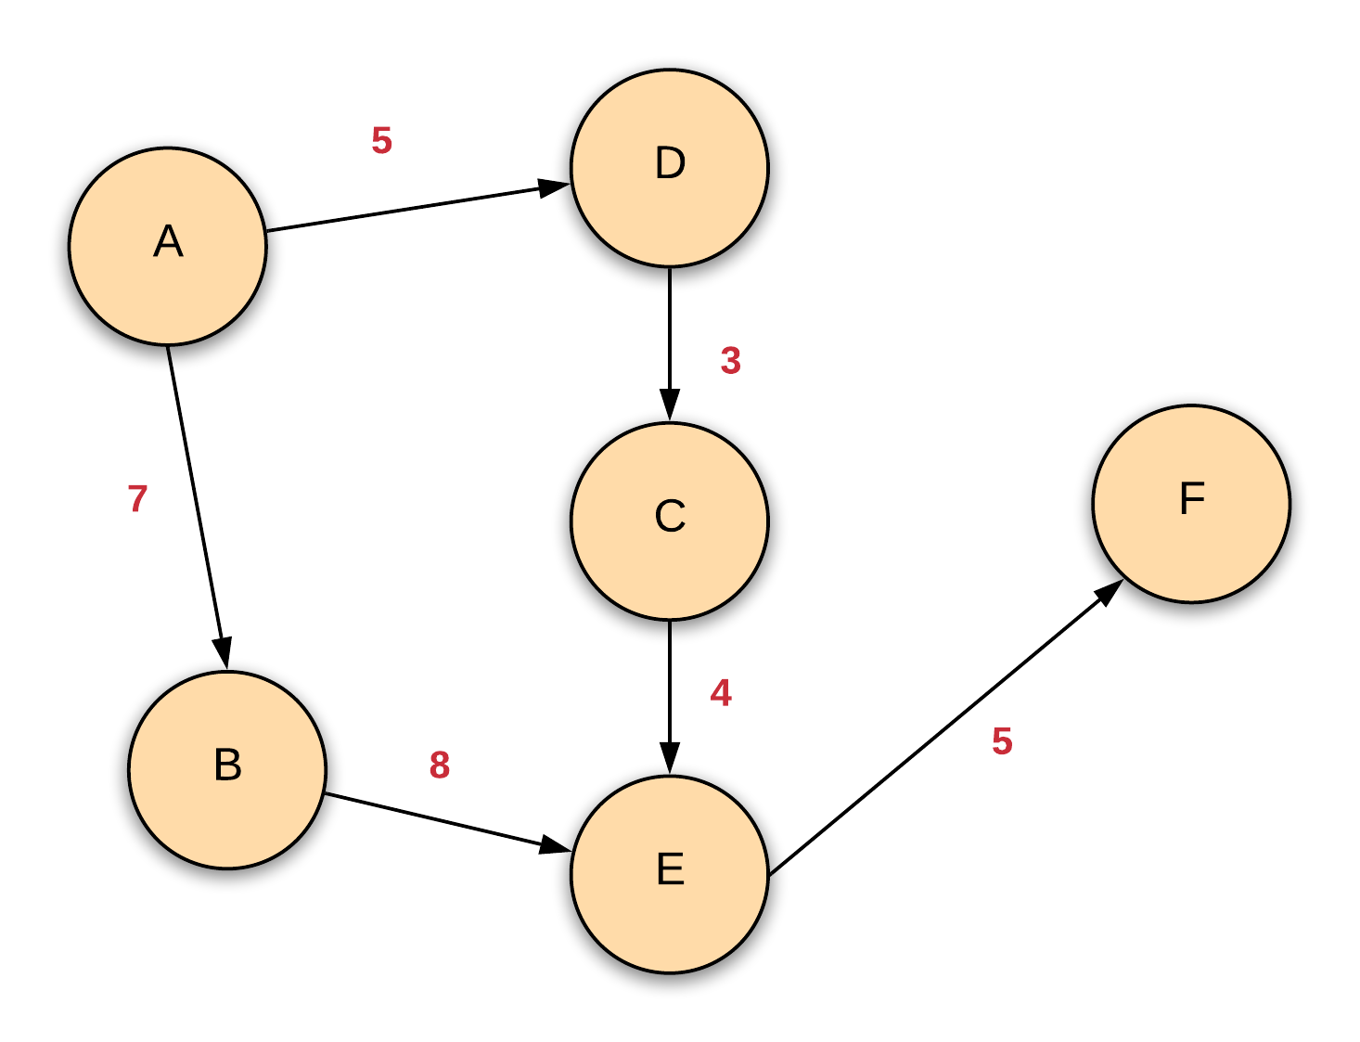

Now suppose that we want to go from the source node A in the graph above to the destination node E via the cheapest possible route with at most 2 stops. Let's ignore the number of stops for now and see how the usual Dijkstra would unfold and pick the nodes. So first of all, we will consider the neighbors of the source node and add them to our min-heap. Next, we will pick the element with the current shortest distance which would be D with a value of 5 as opposed to B with 7.

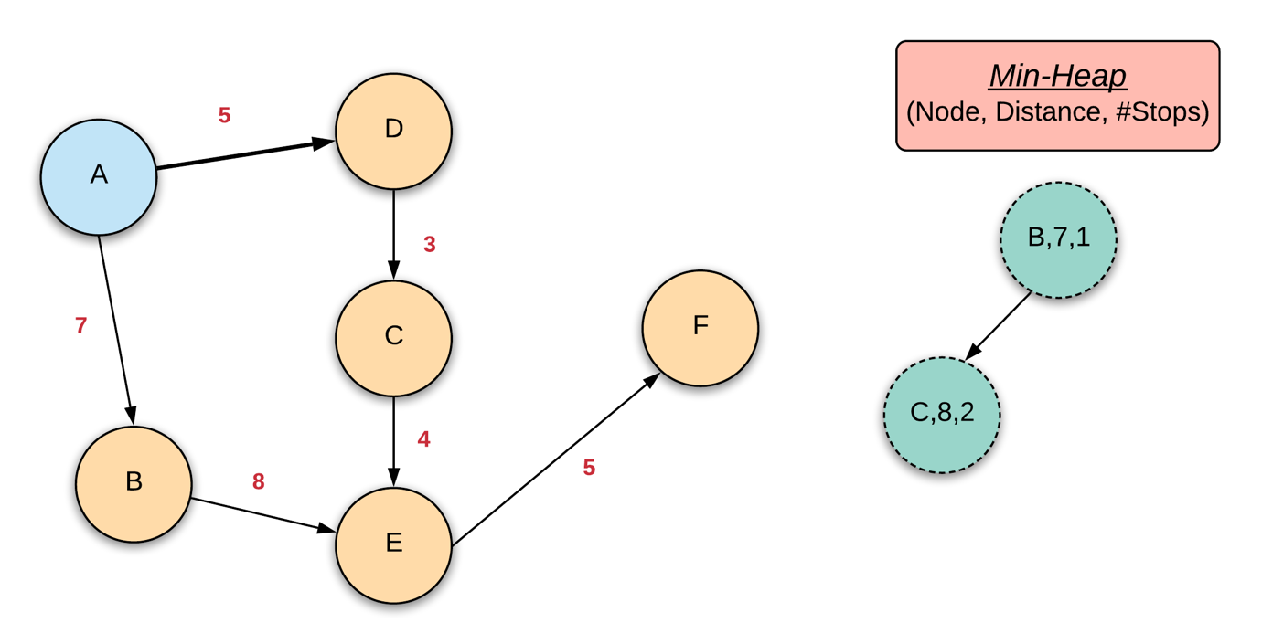

Moving on, the next node that will be picked is B since it has the current shortest distance from the source. Let's see what the heap looks like once we pick B and process its neighbors. Note that according to the algorithm, once a node has been processed i.e., once a node is popped from the min-heap, we never consider that node again in some other node's neighbors i.e., we never add it again to the heap down the line. This is because of the greedy nature of the algorithm. When a node is removed from the heap, it is guaranteed that the distance from the source at that point is the shortest distance. The processed nodes are marked in blue in the figures here.

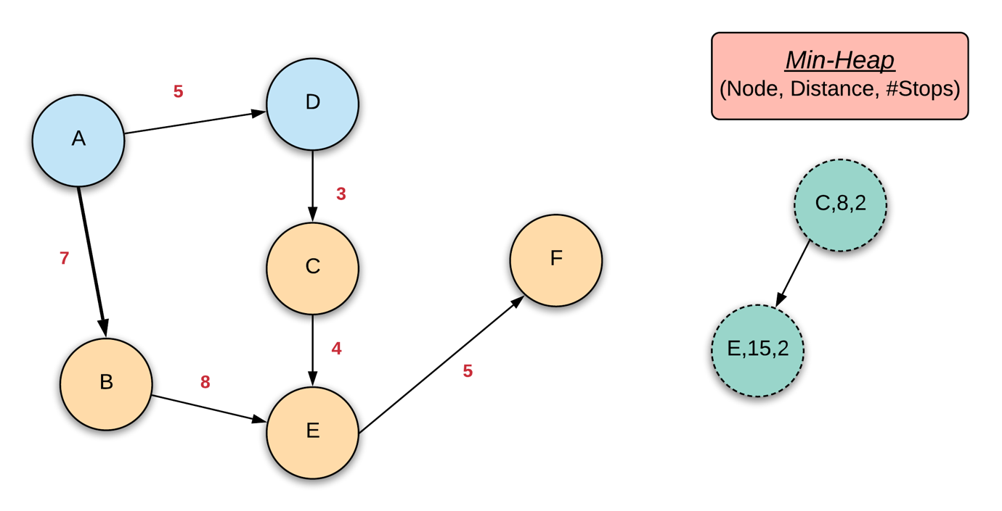

Moving on, the algorithm will pick C and its neighbor E will be added into the heap. You'll notice that there are two nodes containing the city E which is fine since E hasn't been processed yet and this just means there are multiple paths of reaching E.

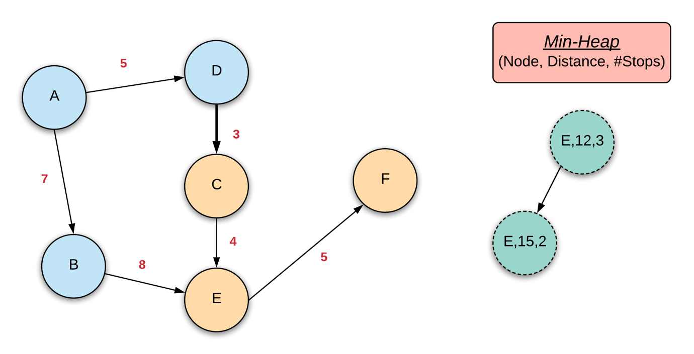

Next, we will remove the node E with a distance of 12 from the source and 3 stops from the source. At this point, we cannot go any further i.e. we cannot consider its neighbor because We have already exhausted the number of stops in this example. So, we don't add the neighbor which also happens to be the destination node to the heap. The only node left in the heap is E with a distance of 15 from source and 2 stops from the source.

Here's the problem now. We will not consider this node because we have already processed the node E in the previous step. Clearly, the distance 15 is greater than 12. So Dijkstra's will discard this heap node and the algorithm will finish, without ever reaching the destination!

The thing we need to modify here is that we need to re-consider a node if the distance from the source is shorter than what we have recorded. So we won't change the min-heap's priority which is to pick nodes with the shortest distance from the source. However, if we ever encounter a node that has already been processed before but the number of stops from the source is lesser than what was recorded before, we will add it to the heap so that it gets considered again! That's the only change we need to make to make Dijkstra's compliant with the limitation on the number of stops.

**Algorithm**

1. Initialize a min-heap or a priority queue. Let's call it H for our algorithm.
2. We will need a couple of arrays here. One would be for maintaining the shortest distances of each node from the source and another one would be for maintaining the shortest number of stops from the source.
3. Next, we need to convert the input into an adjacency matrix format. So, we will process the given input and build an adjacency matrix out of it.
4. Add (\text{source}, 0, 0)(source,0,0) into the heap. The middle value represents the current shortest distance from the source and the last value represents the current minimum number of stops from the source to reach this node.
5. We assume that these values for all the other nodes in the graph are inf.
6. We continue processing the nodes until either of the following conditions are met:
   1. We reach the destination node or
   2. We exhaust the heap which would mean we were not able to reach the destination at all.
7. At each step, we remove a node from the heap i.e. ExtractMin operation on the min-heap. This would represent the node with the shortest distance from the source amongst the ones in the heap. Let's call this node C.
8. We iterate over all of C's neighbors which we can obtain from our adjacency matrix. For each neighbor, we check if the value \text{dC} + \text{W}_\text{C, V}dC+WC, V​ is less than \text{dV}dV where V*V* represents the neighbor node, \text{dC}dC and \text{dV}dV represent the shortest distances (from the dictionary) of these nodes from the source and finally, \text{W}_\text{C, V}WC, V​ represents the weight (cost of the flight) from node (city) C*C* to V*V*.
9. If this is not the case then we check if number of stops for node C*C* + 1 is lower than the number of stops for the node V*V* (from the other dictionary). If that is the case, then it means there is a path from the source to the node V*V* which is slightly expensive than what we have right now, but it has lesser stops and hence, it should be considered.
10. If either of the two conditions above are satisfied, we add the node V*V* to the heap with updated distance and number of stops. In any case, we will update the corresponding dictionary as well.

|  |
| --- |
| class Solution {    public int findCheapestPrice(int n, int[][] flights, int src, int dst, int K) {    // Build the adjacency matrix  int adjMatrix[][] = new int[n][n];  for (int[] flight: flights) {  adjMatrix[flight[0]][flight[1]] = flight[2];  }    // Shortest distances array  int[] distances = new int[n];    // Shortest steps array  int[] currentStops = new int[n];  Arrays.fill(distances, Integer.MAX_VALUE);  Arrays.fill(currentStops, Integer.MAX_VALUE);  distances[src] = 0;  currentStops[src] = 0;    // The priority queue would contain (node, cost, stops)  PriorityQueue<int[]> minHeap = new PriorityQueue<int[]>((a, b) -> a[1] - b[1]);  minHeap.offer(new int[]{src, 0, 0});    while (!minHeap.isEmpty()) {    int[] info = minHeap.poll();  int node = info[0], stops = info[2], cost = info[1];    // If destination is reached, return the cost to get here  if (node == dst) {  return cost;  }    // If there are no more steps left, continue  if (stops == K + 1) {  continue;  }    // Examine and relax all neighboring edges if possible  for (int nei = 0; nei < n; nei++) {  if (adjMatrix[node][nei] > 0) {  int dU = cost, dV = distances[nei], wUV = adjMatrix[node][nei];    // Better cost?  if (dU + wUV < dV) {  minHeap.offer(new int[]{nei, dU + wUV, stops + 1});  distances[nei] = dU + wUV;  }  else if (stops < currentStops[nei]) {    // Better steps?  minHeap.offer(new int[]{nei, dU + wUV, stops + 1});  currentStops[nei] = stops;  }  }  }  }    return distances[dst] == Integer.MAX_VALUE? -1 : distances[dst];  }  } |

**Complexity Analysis**

* Time Complexity: Let E*E* represent the number of flights and V*V* represent the number of cities. The time complexity is mainly governed by the number of times we pop and push into the heap. We will process each node (city) atleast once and for each city popped from the queue, we iterate over its adjacency matrix and can potentially add all its neighbors to the heap. Thus, the time taken for extract min and then addition to the heap (or simply, heap replace) would be \text{O}(\text{V}^2 \cdot \text{log V})O(V2⋅log V).
  + Let's talk a bit more about the implementation of Dijkstra's here. The traditional algorithm is not exactly written the way we've explained above.
  + The traditional algorithm adds all the nodes into the heap with the source having a distance value of 0 and all others having a value inf.
  + When we process the neighbors of a node and find that a particular neighbor can be reached in a shorter distance (or lesser number of stops), we update its value in the heap. In our implementation, we add a new node with updated values rather than updating the value of the existing node. To do that, we will need another dictionary that will probably keep the index location for a node in the heap or something like that. This would be necessary because a heap is not a binary search tree and it doesn't have any search properties for quick search and updates.
  + If we keep the number of nodes in the heap fixed to V*V*, then the complexity would be \text{O}((\text{V} + \text{E}) \cdot \text{log V})O((V+E)⋅log V). Granted, in our case, the heap might contain more than \text{V}V nodes at some point due to the same city being added multiple times. Therefore, the complexity would be slightly more. That is not being accounted for here since that is an implementation detail and not necessary for the algorithm we discussed here.
  + Yet another point to keep in mind here is that we are using an adjacency matrix rather than adjacency list here. The typical Dijkstra's algorithm would use an adjacency list and that brings down the complexity slightly because you don't "check" if a connection exists or not unlike in adjacency matrix. However, since the number of nodes are very less for this problem, we preferred to take the route of adjacency matrix as that gives us sequential access to elements and leads to speed-ups due to cache localization.
* Space Complexity: \text{O}(\text{V}^2)O(V2) is the overall space complexity. \text{O}(\text{V})O(V) is occupied by the two dictionaries and also by the heap and \text{V}^2V2 by the adjacency matrix structure. As mentioned above, there might be duplicate cities in the heap with different distances and number of stops due to our implementation. But we are not taking that into consideration here. This is the space complexity of the traditional Dijkstra's and it doesn't change with the algorithm modifications (not the implementation modifications) we've done here.

#### **Approach 2: Depth-First-Search with Memoization**

**Intuition**

This problem can easily be modeled as a dynamic programming problem on graphs. What does a dynamic programming problem entail?

* It has a recursive structure.
* A bunch of choices to explore at each step.
* Use the optimal solutions for sub-problems to solve top-level problems.
* A base case.

This problem fits the bill. We have a dedicated start and endpoint. We have a bunch of choices for each node in the form of its neighbors. And, we want to minimize the overall shortest distance from the source to the destination which can be represented as a recursive structure in terms of shortest distances of its neighbors to the destination. So, we can apply a dynamic programming approach to solve this problem. We'll look at a recursive implementation here with memoization first and then talk about the iterative approach as well.

As with any recursive approach, we need to figure out the state of recursion. There are two parameters here which will control our recursion. One is obviously the node itself. The other is the number of steps. Let's call our recursion function recurse and define what the state of recursion looks like. \text{recurse}(\text{node},\text{stops})recurse(node,stops) will basically return the shortest distance for us to reach the destination from \text{node}node considering that there are stops left. This being said, it's easy to figure out what the top-level problem would be. It would be \text{recurse}(\text{0},\text{K})recurse(0,K).

Let's consider the following graph to understand why memoization (or caching) is required here.

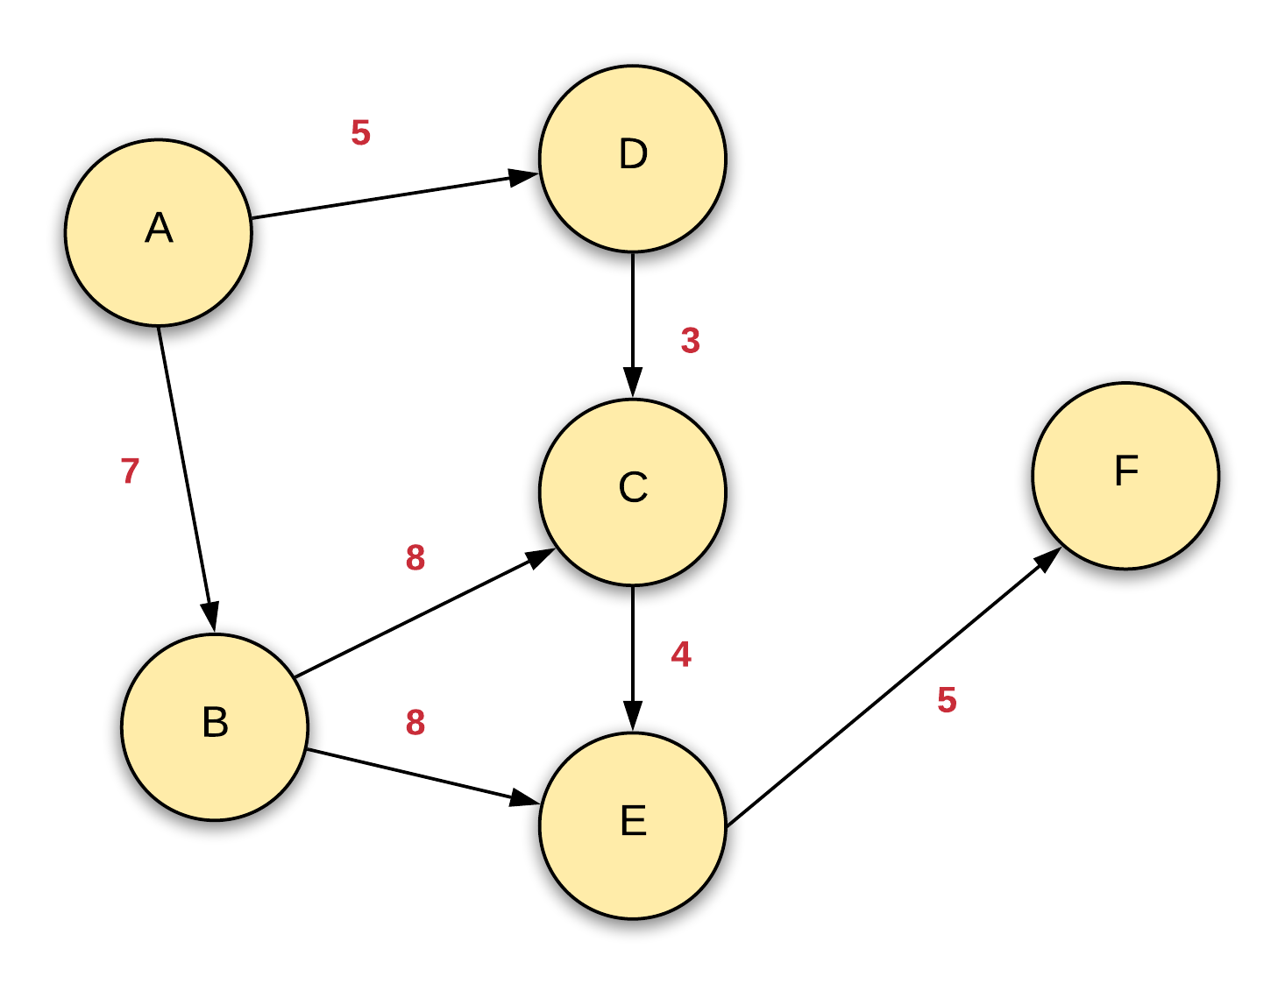

Say we start the source node A and build our recursion tree from there. There are two possible routes of getting to the node C with exactly 2 stops. Let's look at what these are.

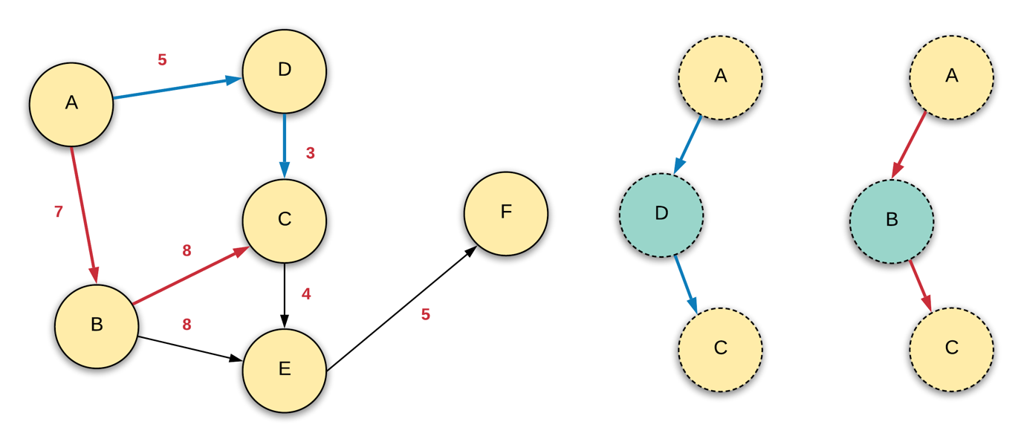

While the cost of these two paths is different, once we are at the node C, we have 2 steps less than what we had when we started off from the source node A. Our recursion representation doesn't care about the path you took to get to a node. It is about the shortest (cheapest) path from the current node with the given number of steps to get to a destination. In that sense, both these scenarios are exactly the same because both lead us to the same recursion state which is (\text{recurse}(\text{C}, \text{K-2}))(recurse(C,K-2)) and hence, the result for this recursion state can be cached or memoized.

**Algorithm**

1. We'll define a function called recurse which will take two inputs: node and stops.
2. We'll also define a dictionary memo of tuples that will store the optimal solution for each recursion state encountered.
3. At each stage, we'll first check if we have reached the destination or not. If we have, then no more moves have to be made and we return a value of 0 since the destination is at a zero distance from itself.
4. Next, we check if we have any more stops left. If we don't then we return inf basically representing that we cannot reach the destination from the current recursion state.
5. Finally, we check if the current recursion state is cached in the memo dictionary and if it is, we return the answer right away.
6. If none of these conditions are met,we progress in our recursion. For that we will iterate over the adjacency matrix to obtain the neighbors for the current node and make a recursive call for each one of them. The node would be the neighboring node and the number of stops would incremeneted by 1.
7. To each of these recursion calls, we add the weight of the corresponding edge i.e.

recurse(neighbor, stops + 1) + weight(node, neighbor)

1. We need to return the result of recurse(src, 0) as the answer.

|  |
| --- |
| class Solution {    private int[][] adjMatrix;  private HashMap<Pair<Integer, Integer>, Long> memo;    public int findCheapestPrice(int n, int[][] flights, int src, int dst, int K) {    this.adjMatrix = new int[n][n];  this.memo = new HashMap<Pair<Integer, Integer>, Long>();    for (int[] flight: flights) {  this.adjMatrix[flight[0]][flight[1]] = flight[2];  }    long ans = this.findShortest(src, K, dst, n);  return ans >= Integer.MAX_VALUE ? -1 : (int)ans;  }    public long findShortest(int node, int stops, int dst, int n) {    // No need to go any further if the destination is reached  if (node == dst) {  return 0;  }      // Can't go any further if no stops left  if (stops < 0) {  return Integer.MAX_VALUE;  }    Pair<Integer, Integer> key = new Pair<Integer, Integer>(node, stops);      // If the result of this state is already cached, return it  if (this.memo.containsKey(key)) {  return this.memo.get(key);  }    // Recursive calls over all the neighbors  long ans = Integer.MAX_VALUE;  for (int neighbor = 0; neighbor < n; ++neighbor) {    int weight = this.adjMatrix[node][neighbor];    // 0 value means no edge  if (weight > 0) {  ans = Math.min(ans, this.findShortest(neighbor, stops - 1, dst, n) + weight);  }  }    // Cache the result  this.memo.put(key, ans);  return ans;  }  } |

**Complexity Analysis**

* Time Complexity: The time complexity for a recursive solution is defined by the number of recursive calls we make and the time it takes to process one recursive call. The number of recursive calls we can potentially make is \text{O}(\text{V} \cdot \text{K})O(V⋅K). In each recursive call, we iterate over a given node's neighbors. That takes time O(\text{V})*O*(V) because we are using an adjacency matrix. Thus, the overall time complexity is \text{O}(\text{V}^2 \cdot \text{K})O(V2⋅K).
* Space Complexity: \text{O}(\text{V} \cdot \text{K} + \text{V}^2)O(V⋅K+V2) where \text{O}(\text{V} \cdot \text{K})O(V⋅K) is occupied by the memo dictionary and the rest by the adjacency matrix structure we build in the beginning.

#### **Approach 3: Bellman-Ford**

**Intuition**

Let's look at the official definition of the Bellman-Ford algorithm straight from Wikipedia:

Like Dijkstra's algorithm, Bellman-Ford proceeds by relaxation, in which approximations to the correct distance are replaced by better ones until they eventually reach the solution. In both algorithms, the approximate distance to each vertex is always an overestimate of the true distance and is replaced by the minimum of its old value and the length of a newly found path.

However, Dijkstra's algorithm uses a priority queue to greedily select the closest vertex that has not yet been processed, and performs this relaxation process on all of its outgoing edges; by contrast, the Bellman-Ford algorithm simply relaxes all the edges and does this {|V|-1}∣*V*∣−1 times, where |V|∣*V*∣ is the number of vertices in the graph. In each of these repetitions, the number of vertices with correctly calculated distances grows, from which it follows that eventually, all vertices will have their correct distances. This method allows the Bellman-Ford algorithm to be applied to a wider class of inputs than Dijkstra.

The term relax an edge simply means that for a given edge U -> V we check if \text{dU} + W_{\text{U,V}} < \text{dV}dU+*W*U,V​<dV where \text{dU}dU and \text{dV}dV represent the shortest path distances of these nodes from the source right now. To relax an edge means to see if the shortest distance can be updated or not.

An important part to understanding the Bellman Ford's working is that at each step, the relaxations lead to the discovery of new shortest paths to nodes. After the first iteration over all the vertices, the algorithm finds out all the shortest paths from the source to nodes which can be reached with one hop (one edge). That makes sense because the only edges we'll be able to relax are the ones that are directly connected to the source as all the other nodes have shortest distances set to inf initially.

Similarly, after the (\text{K}+1)^{\text{th}}(K+1)th step, Bellman-Ford will find the shortest distances for all the nodes that can be reached from the source using a maximum of K stops. Isn't that what the question asks us to do? If we run Bellman-Ford for \text{K} + 1K+1 iterations, it will find out shortest paths of length K*K* or less and it will find all such paths. We can then check if our destination node was reached or not and if it was, then the value for that node would be our shortest path!

Let's quickly look at a couple of iterations of Bellman-Ford on a sample graph to understand how relaxation works and how \text{K+1}K+1 iterations can possibly give us our solution. The image below showcases the initial setup before the first iteration of Bellman-Ford is executed.

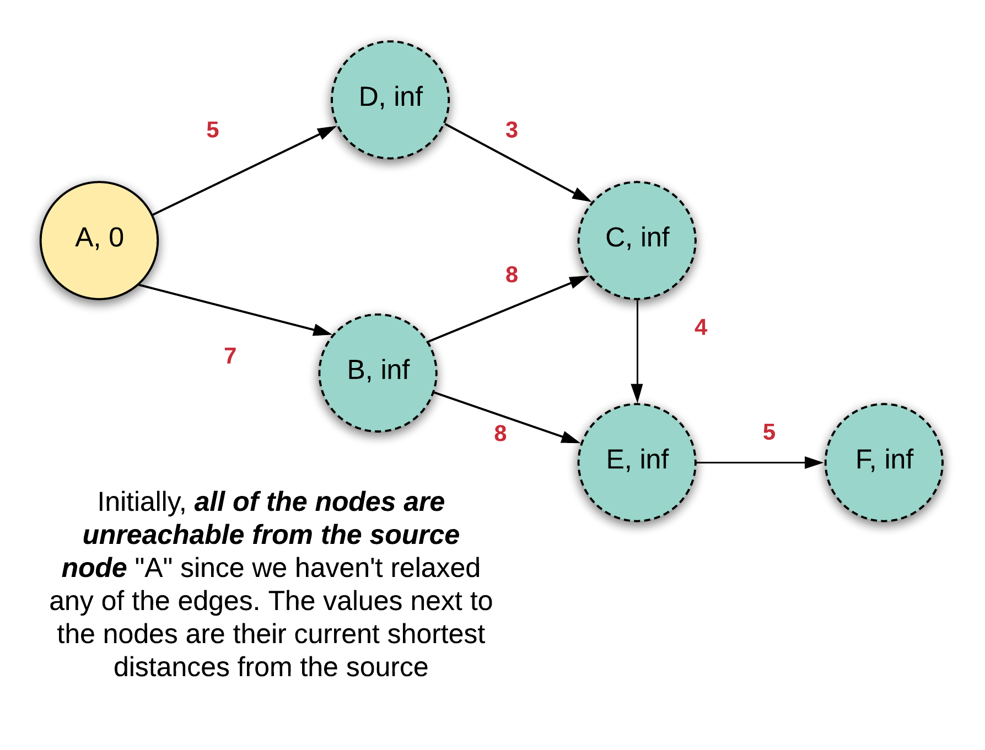

Let's look at what the graph looks like after a single iteration.

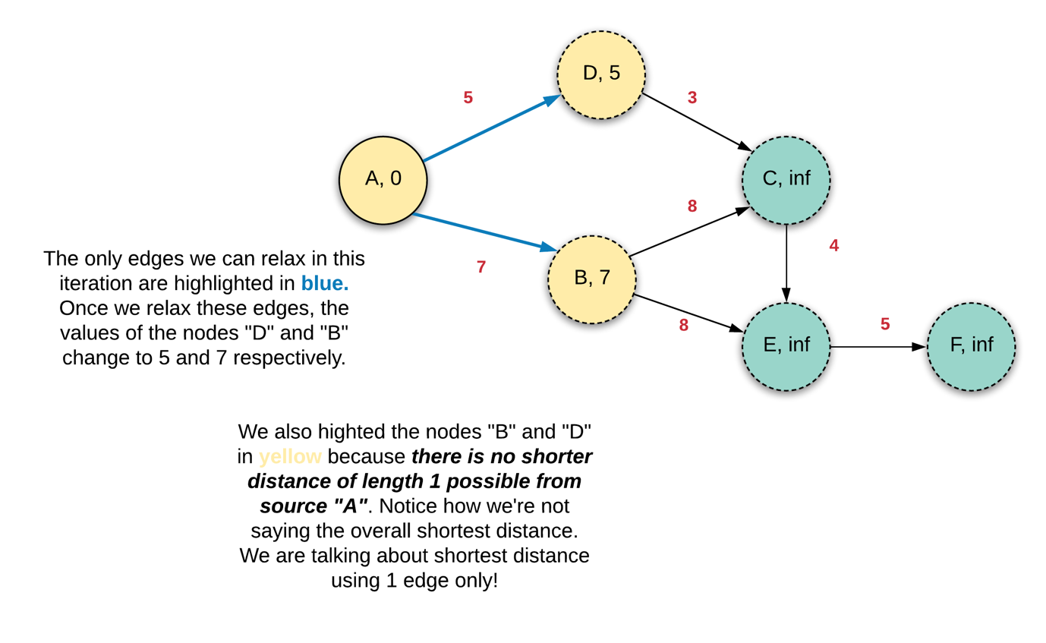

It's important to understand the meaning of what we said in the figure above. We are not saying that after the first iteration we will find the absolute shortest distance from A to B and D. We are just saying that the shortest distance using a single edge only will be found after first iteration. What happens in the next iteration? Well, we will find all the shortest paths that can be reached from the source by using at-most 2 edges. In this example, since the values for nodes B and D were updated in the previous iteration, they will be re-used in the next iteration to relax edges B -> E, B -> C, and D -> C.

Isn't that what Dynamic Programming is all about......

Well, yes! Using the optimal solutions to sub-problems to find optimal solutions to bigger problems. We use the optimal solutions to shortest paths using 1 edge to find shortest paths using 2 edges and so on.

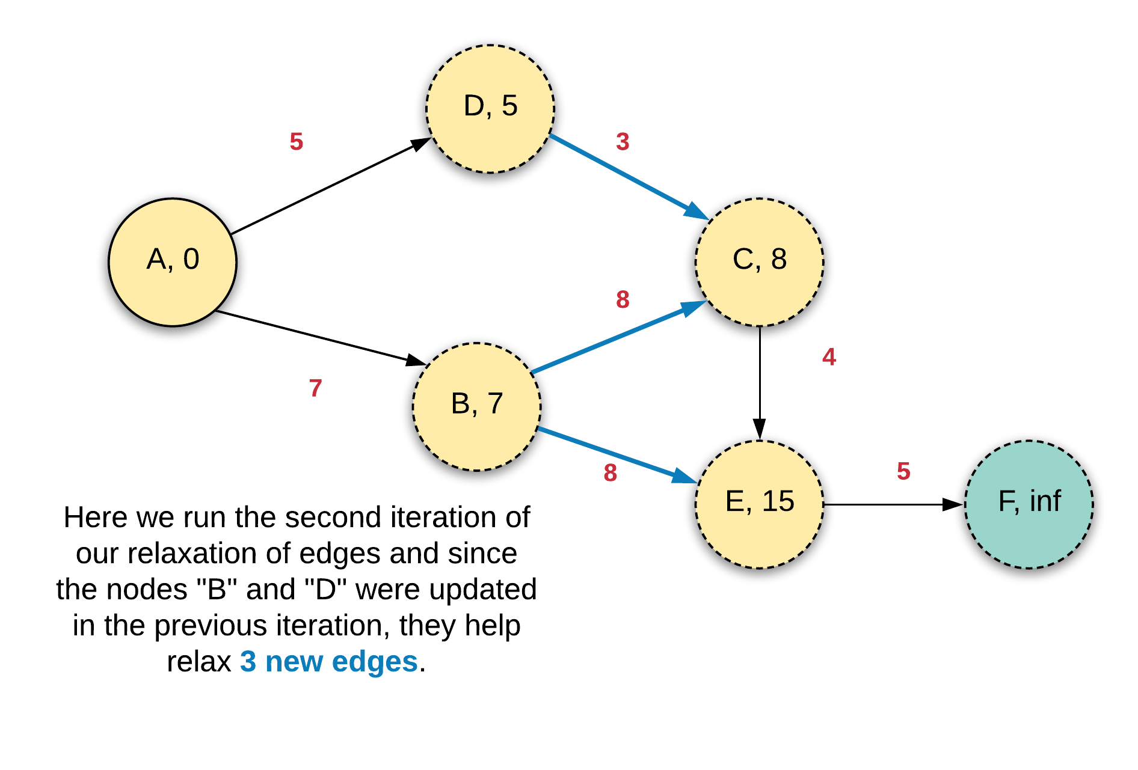

We'll go one final iteration here since this is where things get interesting and this will bring some more clarity. The node E was discovered in the second iteration and we have the value 15 corresponding to it. However, one of the incoming edges C -> E wasn't relaxed in the second iteration because C was also discovered during that iteration. Now that we have a non-infinite value associated with C, we can use it to relax the edge C -> E and that leads to an even shorter path from A ... E!

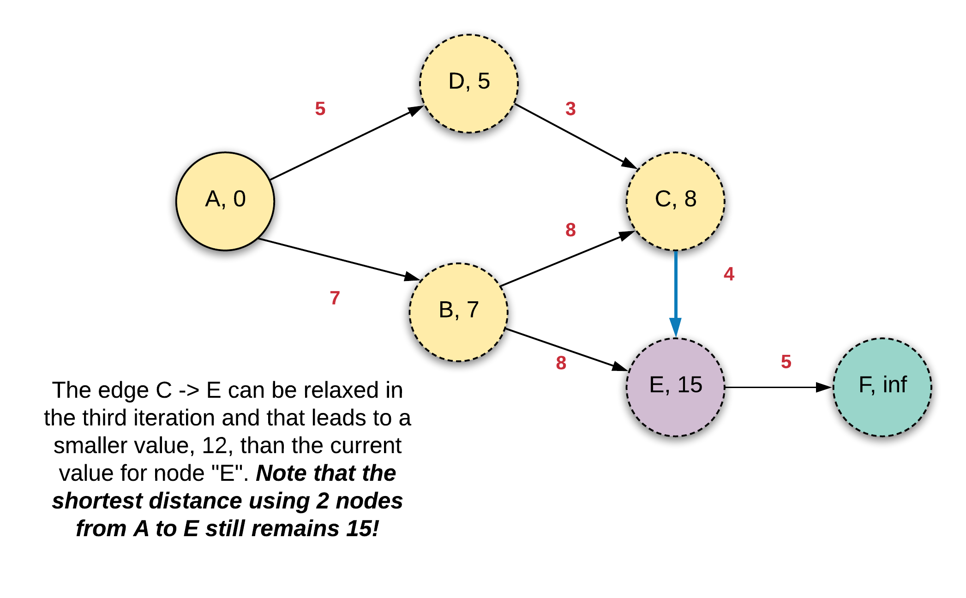

Another important thing to note about this algorithm is that we don't need to build an adjacency matrix. This algorithm simply iterates over the edges of the graph and that information is already available in the input for the program. So we save on space there as opposed to other algorithms which we've seen.

**Algorithm**

1. We have a loop that does K + 1 iterations. The plus one is because we need to find the cheapest flight route with at most K stops in between. That translates to K + 1 edges at most.
2. In each iteration, we loop over all the edges in the graph and try to relax each one of them. Again, note that the edges or the flights are already given to us in the input and don't need to build any kind of adjacency list or matrix structure which is otherwise standard for other graph algorithms.
3. After K + 1 iterations, we check if the destination has been reached or not. If it's been discovered, then the distance at that point will be the shortest using at most K + 1 edges.
4. We use an array to store the current shortest distances of each node from the source. This is possible because the number of nodes is less and we don't need to use a dictionary here. However, a single array is not sufficient here because any values updated in a particular iteration cannot be used to update other values in the same iteration. Thus, we need another distance array which will kind of server as values in the previous iteration. So we essentially use 2 arrays of size V*V* and we swap between them in each iteration i.e.
5. Iteration-0 ----
6. Array-1 is the main array
7. Array-2 becomes the previous array
8. Iteration-1 ----
9. Array-2 is the main array

Array-1 becomes the previous array

Let's look at how the two arrays look like at the start of the first iteration. We'll take a look at a couple of iterations so that the it's easier to understand the implementations.

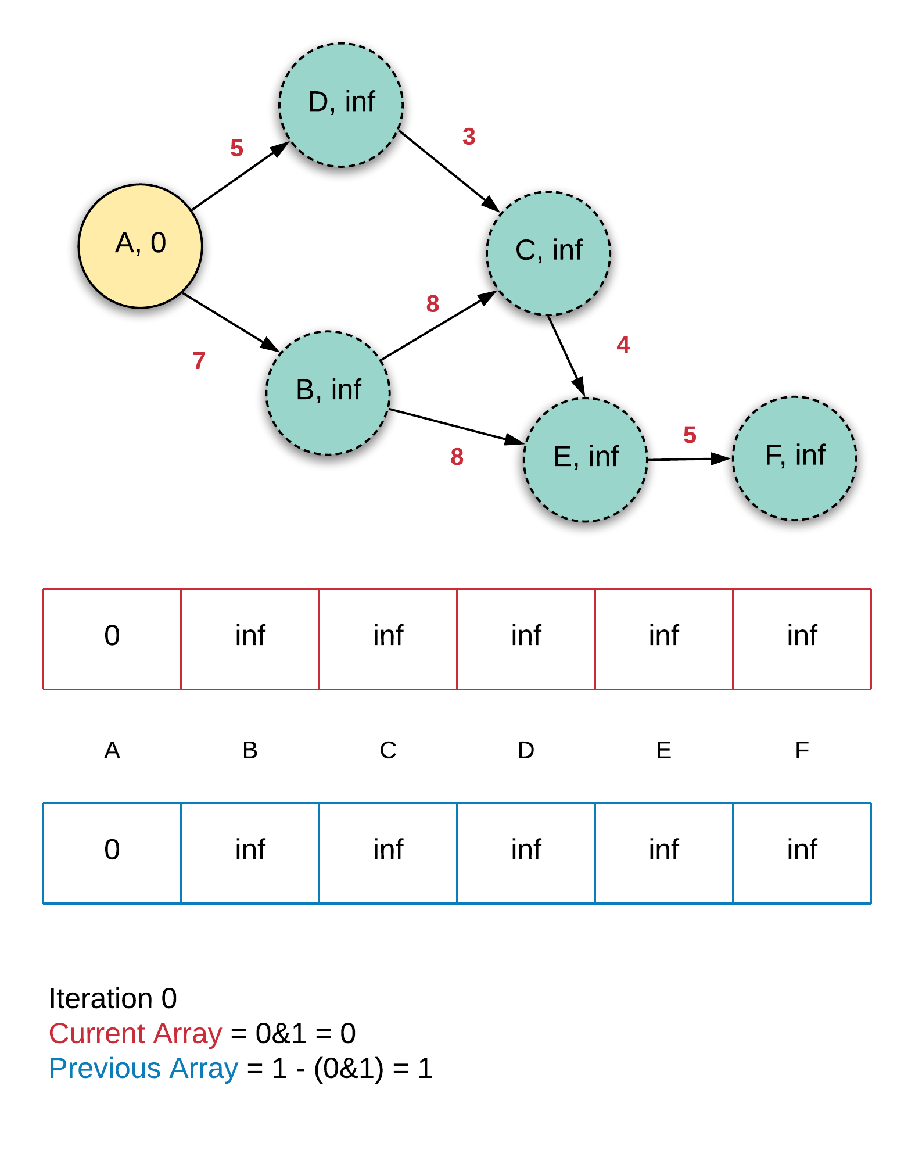

We discovered two new vertices which are directly connected from the source and their corresponding distances were updated accordingly.

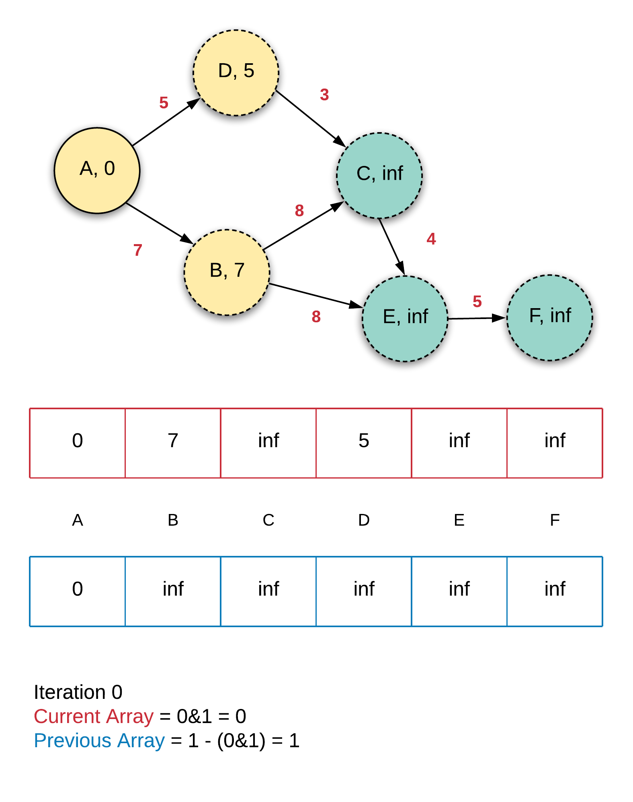

Now let's look at how the two arrays would look like at the start of the second iteration. Now the roles would be reversed. The current array in the previous iteration now servers as the previous array.

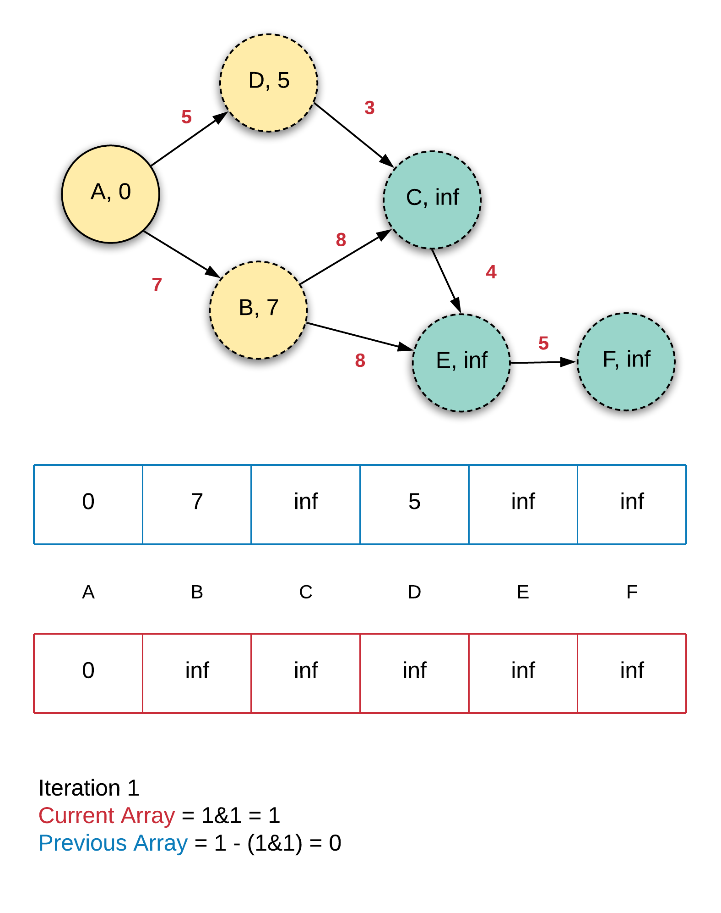

Notice how the two arrays have swapped roles. You might be thinking that even though the red array is the current one, it doesn't have the latest values 7 and 5. Well, they will be used for the calculation of distance of node C and also, they will be copied over (re-calculated again due to the node A in previous array). Let's see how the two arrays look after the second iteration is complete.

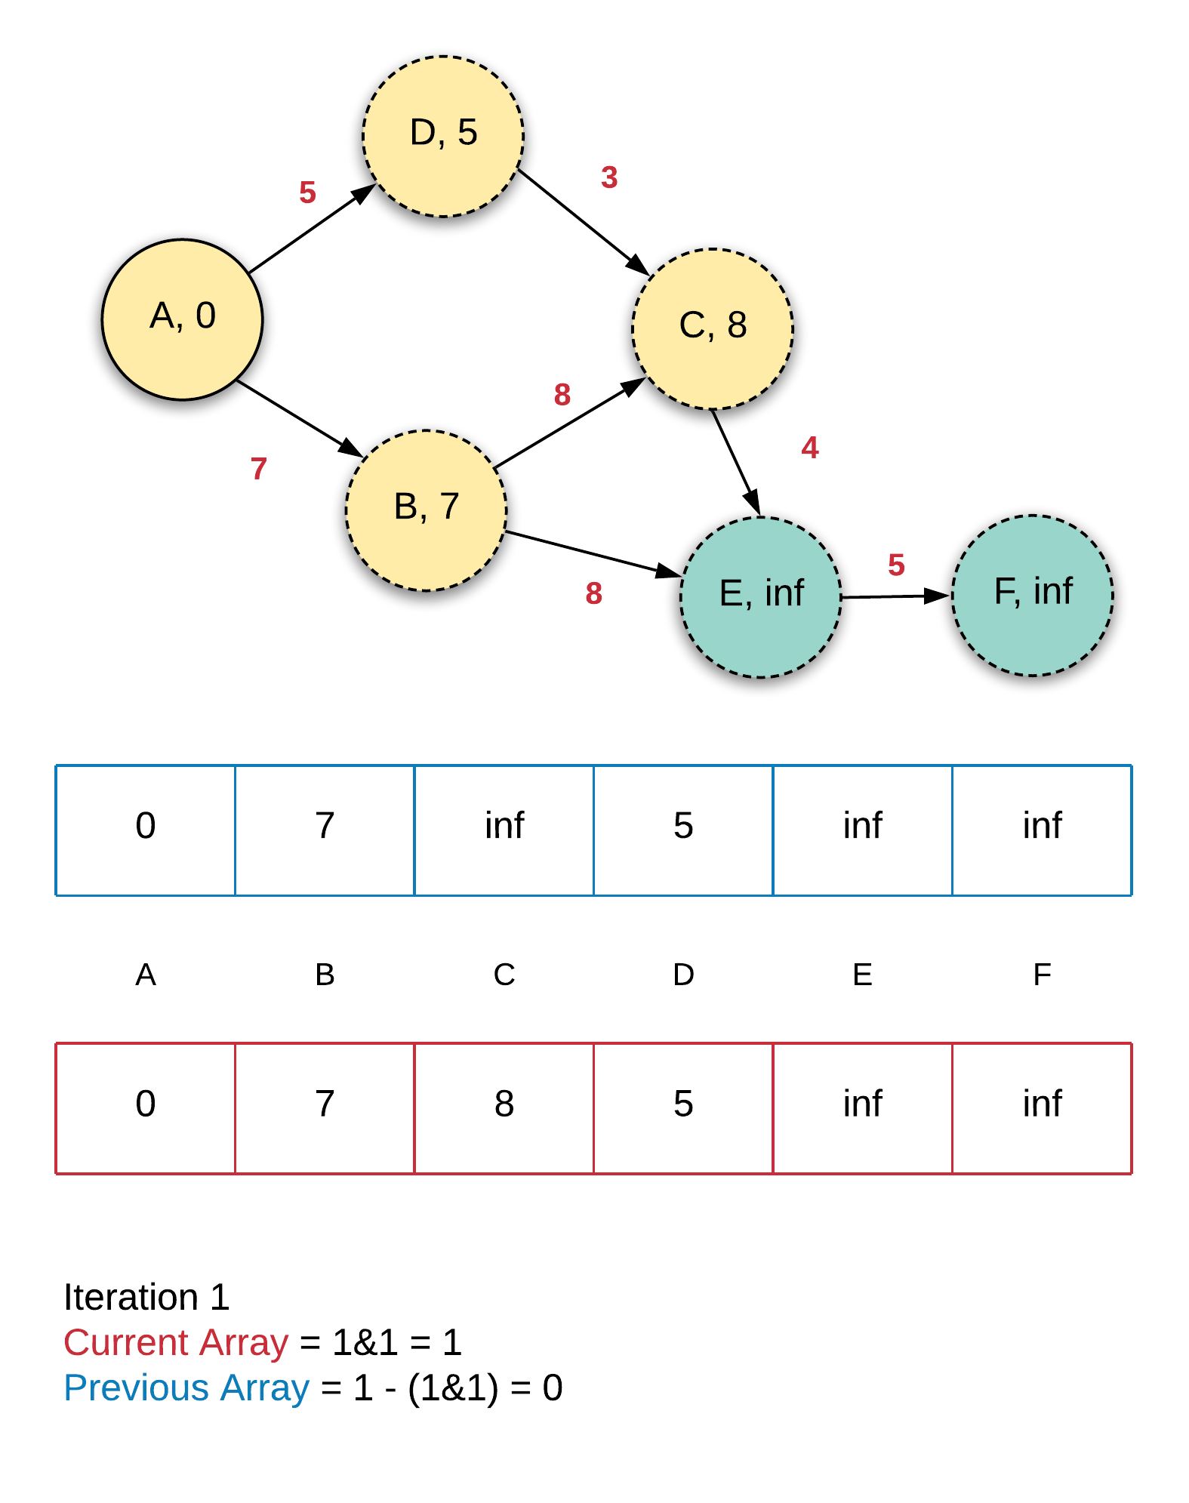

|  |
| --- |
| class Solution {    public int findCheapestPrice(int n, int[][] flights, int src, int dst, int K) {    // We use two arrays for storing distances and keep swapping  // between them to save on the memory  long[][] distances = new long[2][n];  Arrays.fill(distances[0], Integer.MAX_VALUE);  Arrays.fill(distances[1], Integer.MAX_VALUE);  distances[0][src] = distances[1][src] = 0;    // K + 1 iterations of Bellman Ford  for (int iterations = 0; iterations < K + 1; iterations++) {    // Iterate over all the edges  for (int[] edge : flights) {    int s = edge[0], d = edge[1], wUV = edge[2];    // Current distance of node "s" from src  long dU = distances[1 - iterations&1][s];    // Current distance of node "d" from src  // Note that this will port existing values as  // well from the "previous" array if they didn't already exist  long dV = distances[iterations&1][d];    // Relax the edge if possible  if (dU + wUV < dV) {  distances[iterations&1][d] = dU + wUV;  }  }  }    return distances[K&1][dst] < Integer.MAX_VALUE ? (int)distances[K&1][dst] : -1;  }  } |

**Complexity Analysis**

* Time Complexity: O(\text{K} \cdot \text{E})*O*(K⋅E) since we have \text{K}+1K+1 iterations and in each iteration, we go over all the edges in the graph.
* Space Complexity: \text{O}(\text{V})O(V) occupied by the two distance arrays.

#### **Approach 4: Breadth First Search**

**Intuition**

We say that the breadth-first search is a good algorithm to use if we want to find the shortest path in an undirected, unweighted graph. The claim for BFS is that the first time a node is discovered during the traversal, that distance from the source would give us the shortest path. The same cannot be said for a weighted graph. For a weighted graph, there is no correlation between the number of edges composing the path and the actual length of the path which is composed of the weights of all the edges in it. Thus, we cannot employ breadth-first search for weighted graphs.

Breadth-first search has no way of knowing if a particular discovery of a node would give us the shortest path to that node. And so, the only possible way for BFS (or DFS) to find the shortest path in a weighted graph is to search the entire graph and keep recording the minimum distance from source to the destination vertex.

That being said, Breadth-first search is actually a great algorithm of choice for this problem because the number of levels to be explored by the algorithm is bounded by K

The number of levels that the search would go to is limited by the value K+1 in the question. So essentially, we would be trying to find the shortest path, but we won’t have to explore the entire graph as such. We will just go up to the level K+1 and we just need to return the shortest path to the destination (if reachable by level K+1) at the end of the algorithm.

An important consideration here is the size of the queue. We need to control it somehow otherwise, even at very small depths, the graph could grow exponentially. For this very problem however, we will be able to bound the size of a given level (and hence the queue) by V*V*, the number of vertices in the graph. Let's think about what it means to encounter the same node multiple times during breadth first traversal.

Since we will be going only till the level K+1, we don't really have to worry about the number of stops getting exhausted or something. So if the number of stops are out of the way, the only way we will consider adding a node again to the queue is if we found a shorter distance from the source than what we already have stored for that node. If that is not the case then on encountering a node again during the traversal, we can safely discard it i.e not add it to the queue again.

Since this is weighted graph, we cannot assume anything about the shortest distance from source to a node when its first discovered after being popped from the queue. We will have to go to all the K+1 levels and once we've exhausted K+1 levels, we can be sure that the shortest distances we have are the "best" we can find with K+1 edges or less.

**Algorithm**

1. This is standard BFS and we'll be using a queue here. Let's call it Q.
2. We'll need a dictionary to keep track of shortest distances from the source. An important thing to note in this approach is that we need to keep a dictionary with the node, stops as the key. Basically, we need to keep track of the shortest distance of a node from the source provided that it takes stops stops to reach it.
3. Add the source node to the queue. There are multiple ways of tracking the level of a node during breadth-first traversal. We'll be using the size of the queue at the beginning of the level to loop over a particular level.
4. We iterate until we exhaust the queue or K+1 levels whichever comes first.
5. For each iteration, we pop a node from the queue and iterate over its neighbors which we can get from the adjacency matrix.
6. For each of the neighbors, we check if the current edge improves that neighbor's shortest distance from source or not. If it does, then we update the shortest distance dictionary (array) accordingly and also add the neighbor to the queue.
7. We continue doing this for until one of our terminal conditions are met.
8. We will also maintain an ans variable to track the minimum distance of the destination from the source. At each step, whenever we update the shortest distance of a node from source, we check if that node is the destination and if it is, we will update the ans variable accordingly.
9. At the end, we simply check if we were able to reach the destination node by looking at the ans variable's value. If we did reach it, then the recorded distance would be the shortest in under K hops (or K + 1 edges at most).

|  |
| --- |
| class Solution {    public int findCheapestPrice(int n, int[][] flights, int src, int dst, int K) {    // Build the adjacency matrix  int adjMatrix[][] = new int[n][n];  for (int[] flight: flights) {  adjMatrix[flight[0]][flight[1]] = flight[2];  }    // Shortest distances dictionary  HashMap<Pair<Integer, Integer>, Long> distances = new HashMap<Pair<Integer, Integer>, Long>();  distances.put(new Pair<Integer, Integer>(src, 0), 0L);    // Number of stops done  int stops = 0;    // Final answer  long ans = Long.MAX_VALUE;    // BFS Queue  LinkedList<Integer> bfsQueue = new LinkedList<Integer>();  bfsQueue.add(src);    // Iterate until we exhaust K+1 levels or the queue gets empty  while (!bfsQueue.isEmpty() && stops < K + 1) {    // Iterate on current level  int length = bfsQueue.size();  for (int i = 0; i < length; ++i) {    // Loop over neighbors of popped node  int node = bfsQueue.poll();  for (int nei = 0; nei < n; ++nei) {    if (adjMatrix[node][nei] > 0) {    long dU = distances.getOrDefault(new Pair<Integer, Integer>(node, stops), Long.MAX_VALUE);  long dV = distances.getOrDefault(new Pair<Integer, Integer>(nei, stops + 1), Long.MAX_VALUE);  long wUV = adjMatrix[node][nei];  // No need to update the minimum cost if we have already exhausted our K stops.  if (stops == K && nei != dst) {  continue;  }  if (dU + wUV < dV) {  distances.put(new Pair<Integer, Integer>(nei, stops + 1), dU + wUV);  bfsQueue.add(nei);    // If the neighbor is infact the destination, update the answer accordingly  if (nei == dst) {  ans = Math.min(ans, dU + wUV);  }  }  }  }  }    stops++;  }    return ans == Long.MAX_VALUE ? -1 : (int) ans;  }  } |

**Complexity Analysis**

* Time Complexity: O(\text{E} \cdot \text{K})*O*(E⋅K) since we can process each edge multiple times depending upon the improvement in the shortest distances. However, the maximum number of times an edge would be processed is bounded by \text{K + 1}K + 1 since that's the number of levels we are going to explore in this algorithm.
* Space Complexity: O(\text{V}^2 + \text{V} \cdot \text{K})*O*(V2+V⋅K). The first part is the standard memory occupied by the adjacency matrix and in addition to that, the distances dictionary can occupy a maximum of O(\text{V} \cdot \text{K})*O*(V⋅K).

**Surrounded Regions**

Given an m x n matrix board containing 'X' and 'O', capture all regions surrounded by 'X'.

A region is **captured** by flipping all 'O's into 'X's in that surrounded region.

**Example 1:**

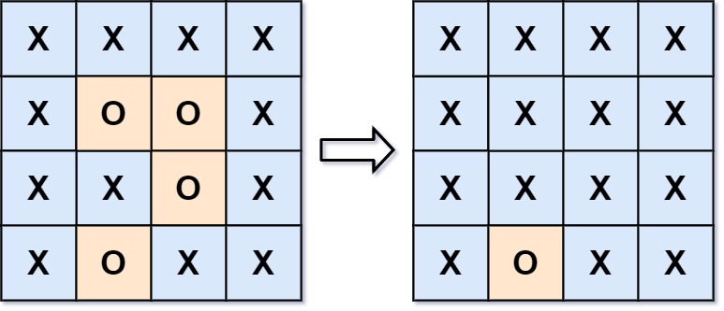

**Input:** board = [["X","X","X","X"],["X","O","O","X"],["X","X","O","X"],["X","O","X","X"]]

**Output:** [["X","X","X","X"],["X","X","X","X"],["X","X","X","X"],["X","O","X","X"]]

**Explanation:** Surrounded regions should not be on the border, which means that any 'O' on the border of the board are not flipped to 'X'. Any 'O' that is not on the border and it is not connected to an 'O' on the border will be flipped to 'X'. Two cells are connected if they are adjacent cells connected horizontally or vertically.

**Example 2:**

**Input:** board = [["X"]]

**Output:** [["X"]]

**Constraints:**

* m == board.length
* n == board[i].length
* 1 <= m, n <= 200
* board[i][j] is 'X' or 'O'.

## Solution

#### **Overview**

This problem is almost identical as the [capture rule](https://en.wikipedia.org/wiki/Rules_of_Go#Capture) of the Go game, where one captures the opponent's stones by surrounding them. The difference is that in the Go game the borders of the board are considered to the walls that surround the stones, while in this problem a group of cells (i.e. region) is considered to be ***escaped*** from the surrounding if it reaches any border.

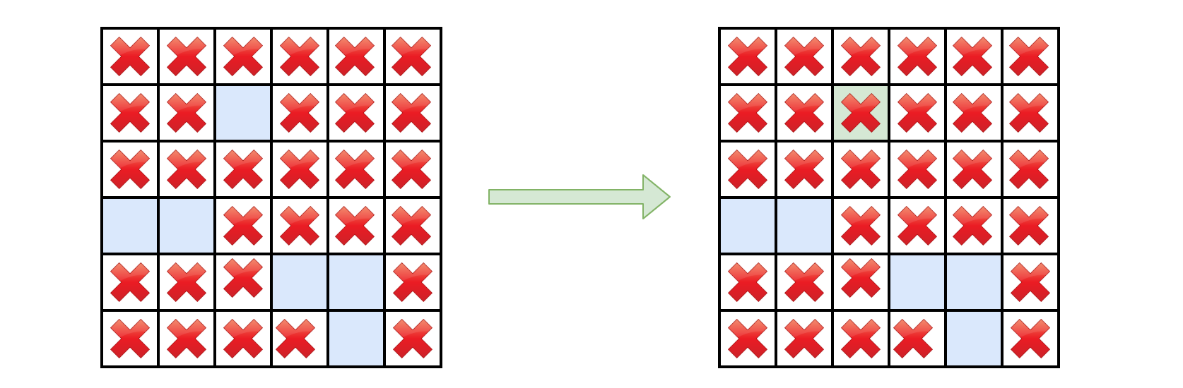

This problem is yet another problem concerning the ***traversal of 2D grid***, e.g. [Robot room cleaner](https://leetcode.com/articles/robot-room-cleaner/).

As similar to the traversal problems in a tree structure, there are generally two approaches in terms of solution: ***DFS*** (Depth-First Search) and ***BFS*** (Breadth-First Search).

One can apply either of the above strategies to traverse the 2D grid, while taking some specific actions to resolve the problems.

Given a traversal strategy (DFS or BFS), there could be a thousand implementations for a thousand people, if we indulge ourselves to exaggerate a bit. However, there are some common neat ***techniques*** that we could apply along with both of the strategies, in order to obtain a more optimized solution.

#### **Approach 1: DFS (Depth-First Search)**

**Intuition**

The goal of this problem is to mark those ***captured*** cells.

If we are asked to summarize the algorithm in one sentence, it would be that we enumerate all those candidate cells (i.e. the ones filled with O), and check one by one if they are captured or not, i.e. we start with a candidate cell (O), and then apply either DFS or BFS strategy to explore its surrounding cells.

**Algorithm**

Let us start with the DFS algorithm, which usually results in a more concise code than the BFS algorithm. The algorithm consists of three steps:

* Step 1). We select all the cells that are located on the borders of the board.
* Step 2). Start from each of the above selected cell, we then perform the DFS traversal.
  + If a cell on the border happens to be O, then we know that this cell is alive, together with the other O cells that are connected to this border cell, based on the description of the problem. Two cells are connected, if there exists a path consisting of only O letter that bridges between the two cells.
  + Based on the above conclusion, the goal of our DFS traversal would be to mark out all those ***connected*** O cells that is originated from the border, with any distinguished letter such as E.
* Step 3). Once we iterate through all border cells, we would then obtain three types of cells:
  + The one with the X letter: the cell that we could consider as the wall.
  + The one with the O letter: the cells that are spared in our DFS traversal, i.e. these cells has no connection to the border, therefore they are ***captured***. We then should replace these cell with X letter.
  + The one with the E letter: these are the cells that are marked during our DFS traversal, i.e. these are the cells that has at least one connection to the borders, therefore they are not captured. As a result, we would revert the cell to its original letter O.

We demonstrate how the DFS works with an example in the following animation.



|  |
| --- |
| public class Solution {  protected Integer ROWS = 0;  protected Integer COLS = 0;  public void solve(char[][] board) {  if (board == null || board.length == 0) {  return;  }  this.ROWS = board.length;  this.COLS = board[0].length;  List<Pair<Integer, Integer>> borders = new LinkedList<Pair<Integer, Integer>>();  // Step 1). construct the list of border cells  for (int r = 0; r < this.ROWS; ++r) {  borders.add(new Pair(r, 0));  borders.add(new Pair(r, this.COLS - 1));  }  for (int c = 0; c < this.COLS; ++c) {  borders.add(new Pair(0, c));  borders.add(new Pair(this.ROWS - 1, c));  }  // Step 2). mark the escaped cells  for (Pair<Integer, Integer> pair : borders) {  this.DFS(board, pair.first, pair.second);  }  // Step 3). flip the cells to their correct final states  for (int r = 0; r < this.ROWS; ++r) {  for (int c = 0; c < this.COLS; ++c) {  if (board[r][c] == 'O')  board[r][c] = 'X';  if (board[r][c] == 'E')  board[r][c] = 'O';  }  }  }  protected void DFS(char[][] board, int row, int col) {  if (board[row][col] != 'O')  return;  board[row][col] = 'E';  if (col < this.COLS - 1)  this.DFS(board, row, col + 1);  if (row < this.ROWS - 1)  this.DFS(board, row + 1, col);  if (col > 0)  this.DFS(board, row, col - 1);  if (row > 0)  this.DFS(board, row - 1, col);  }  }  class Pair<U, V> {  public U first;  public V second;  public Pair(U first, V second) {  this.first = first;  this.second = second;  }  } |

**Optimizations**

In the above implementation, there are a few techniques that we applied ***under the hood***, in order to further optimize our solution. Here we list them one by one.

Rather than iterating all candidate cells (the ones filled with O), we check only the ones on the ***borders***.

In the above implementation, our starting points of *DFS* are those cells that meet two conditions: 1). on the border. 2). filled with O.

*As an alternative solution, one might decide to iterate all O cells, which is less optimal compared to our starting points.*

As one can see, during DFS traversal, the alternative solution would traverse the cells that eventually might be captured, which is not necessary in our approach.

Rather than using a sort of visited[cell_index] map to keep track of the visited cells, we simply mark visited cell ***in place***.

*This technique helps us gain both in the space and time complexity.*

As an alternative approach, one could use a additional data structure to keep track of the visited cells, which goes without saying would require additional memory. And also it requires additional calculation for the comparison. Though one might argue that we could use the hash table data structure for the visited[] map, which has the \mathcal{O}(1)O(1) asymptotic time complexity, but it is still more expensive than the simple comparison on the value of cell.

Rather than doing the boundary check within the DFS() function, we do it ***before*** the invocation of the function.

As a comparison, here is the implementation where we do the boundary check within the DFS() function.

|  |
| --- |
| def DFS(self, board, row, col):  if row < 0 or row >= self.ROWS or col < 0 or col >= self.COLS:  return  if board[row][col] != 'O':  return  board[row][col] = 'E'  # jump to the neighbors without boundary checks  for ro, co in [(0, 1), (1, 0), (0, -1), (-1, 0)]:  self.DFS(board, row+ro, col+co) |

This measure reduces the number of recursion, therefore it reduces the overheads with the function calls.

As trivial as this modification might seem to be, it actually reduces the runtime of the Python implementation from 148 ms to 124 ms, i.e. 16% of reduction, which beats 97% of submissions instead of 77% at the moment.

**Complexity Analysis**

* Time Complexity: \mathcal{O}(N)O(*N*) where N*N* is the number of cells in the board. In the worst case where it contains only the O cells on the board, we would traverse each cell twice: once during the DFS traversal and the other time during the cell reversion in the last step.
* Space Complexity: \mathcal{O}(N)O(*N*) where N*N* is the number of cells in the board. There are mainly two places that we consume some additional memory.
  + We keep a list of border cells as starting points for our traversal. We could consider the number of border cells is proportional to the total number (N*N*) of cells.
  + During the recursive calls of DFS() function, we would consume some space in the function call stack, i.e. the call stack will pile up along with the depth of recursive calls. And the maximum depth of recursive calls would be N*N* as in the worst scenario mentioned in the time complexity.
  + As a result, the overall space complexity of the algorithm is \mathcal{O}(N)O(*N*).

#### **Approach 2: BFS (Breadth-First Search)**

**Intuition**

In contrary to the DFS strategy, in BFS (Breadth-First Search) we prioritize the visit of a cell's neighbors before moving further (deeper) into the neighbor's neighbor.

Though the order of visit might differ between DFS and BFS, eventually both strategies would visit the same set of cells, for most of the 2D grid traversal problems. This is also the case for this problem.

**Algorithm**

We could reuse the bulk of the DFS approach, while simply replacing the DFS() function with a BFS() function. Here we just elaborate the implementation of the BFS() function.

* Essentially we can implement the BFS with the help of queue data structure, which could be of Array or more preferably LinkedList in Java or Deque in Python.
* Through the queue, we maintain the order of visit for the cells. Due to the **FIFO** (First-In First-Out) property of the queue, the one at the head of the queue would have the highest priority to be visited.
* The main logic of the algorithm is a loop that iterates through the above-mentioned queue. At each iteration of the loop, we pop out the **head** element from the queue.
  + If the popped element is of the candidate cell (i.e. O), we mark it as escaped, otherwise we skip this iteration.
  + For a candidate cell, we then simply append its neighbor cells into the queue, which would get their turns to be visited in the next iterations.

As comparison, we demonstrate how BFS works with the same example in DFS, in the following animation.



|  |
| --- |
| public class Solution {  protected Integer ROWS = 0;  protected Integer COLS = 0;  public void solve(char[][] board) {  if (board == null || board.length == 0) {  return;  }  this.ROWS = board.length;  this.COLS = board[0].length;  List<Pair<Integer, Integer>> borders = new LinkedList<Pair<Integer, Integer>>();  // Step 1). construct the list of border cells  for (int r = 0; r < this.ROWS; ++r) {  borders.add(new Pair(r, 0));  borders.add(new Pair(r, this.COLS - 1));  }  for (int c = 0; c < this.COLS; ++c) {  borders.add(new Pair(0, c));  borders.add(new Pair(this.ROWS - 1, c));  }  // Step 2). mark the escaped cells  for (Pair<Integer, Integer> pair : borders) {  this.BFS(board, pair.first, pair.second);  }  // Step 3). flip the cells to their correct final states  for (int r = 0; r < this.ROWS; ++r) {  for (int c = 0; c < this.COLS; ++c) {  if (board[r][c] == 'O')  board[r][c] = 'X';  if (board[r][c] == 'E')  board[r][c] = 'O';  }  }  }  protected void BFS(char[][] board, int r, int c) {  LinkedList<Pair<Integer, Integer>> queue = new LinkedList<Pair<Integer, Integer>>();  queue.offer(new Pair<>(r, c));  while (!queue.isEmpty()) {  Pair<Integer, Integer> pair = queue.pollFirst();  int row = pair.first, col = pair.second;  if (board[row][col] != 'O')  continue;  board[row][col] = 'E';  if (col < this.COLS - 1)  queue.offer(new Pair<>(row, col + 1));  if (row < this.ROWS - 1)  queue.offer(new Pair<>(row + 1, col));  if (col > 0)  queue.offer(new Pair<>(row, col - 1));  if (row > 0)  queue.offer(new Pair<>(row - 1, col));  }  }  }  class Pair<U, V> {  public U first;  public V second;  public Pair(U first, V second) {  this.first = first;  this.second = second;  }  } |

**From BFS to DFS**

In the above implementation of BFS, the fun part is that we could easily convert the BFS strategy to DFS by changing one single line of code. And the obtained DFS implementation is done in iteration, instead of recursion.

The key is that instead of using the ***queue*** data structure which follows the principle of FIFO (First-In First-Out), if we use the ***stack*** data structure which follows the principle of LIFO (Last-In First-Out), we then switch the strategy from BFS to DFS.

Specifically, at the moment we pop an element from the queue, instead of popping out the *head* element, we pop the *tail* element, which then changes the behavior of the container from queue to stack. Here is how it looks like.

|  |
| --- |
| protected void DFS(char[][] board, int r, int c) {  LinkedList<Pair<Integer, Integer>> queue = new LinkedList<Pair<Integer, Integer>>();  queue.offer(new Pair<>(r, c));  while (!queue.isEmpty()) {  // pop out the _tail_ element, rather than the head  Pair<Integer, Integer> pair = queue.pollLast();  int row = pair.first, col = pair.second;  if (board[row][col] != 'O')  continue;  board[row][col] = 'E';  if (col < this.COLS - 1)  queue.offer(new Pair<>(row, col + 1));  if (row < this.ROWS - 1)  queue.offer(new Pair<>(row + 1, col));  if (col > 0)  queue.offer(new Pair<>(row, col - 1));  if (row > 0)  queue.offer(new Pair<>(row - 1, col));  }  } |

Note that, though the above implementations indeed follow the DFS strategy, they are NOT equivalent to the previous ***recursive*** version of DFS, i.e. they do not produce the exactly same sequence of visit.

In the recursive DFS, we would visit the right-hand side neighbor (row, col+1) first, while in the iterative DFS, we would visit the up neighbor (row-1, col) first.

In order to obtain the same order of visit as the recursive DFS, one should reverse the processing order of neighbors in the above iterative DFS.

**Complexity**

* Time Complexity: \mathcal{O}(N)O(*N*) where N*N* is the number of cells in the board. In the worst case where it contains only the O cells on the board, we would traverse each cell twice: once during the BFS traversal and the other time during the cell reversion in the last step.
* Space Complexity: \mathcal{O}(N)O(*N*) where N*N* is the number of cells in the board. There are mainly two places that we consume some additional memory.
  + We keep a list of border cells as starting points for our traversal. We could consider the number of border cells is proportional to the total number (N*N*) of cells.
  + Within each invocation of BFS() function, we use a queue data structure to hold the cells to be visited. We then need to estimate the upper bound on the size of the queue. Intuitively we could imagine the unfold of BFS as the structure of an onion. Each layer of the onion represents the cells that has the same distance to the starting point. Any given moment the queue would contain no more than two layers of onion, which in the worst case might cover almost all cells in the board.
  + As a result, the overall space complexity of the algorithm is \mathcal{O}(N)O(*N*).

**H-Index II**

Given an array of citations **sorted in ascending order**(each citation is a non-negative integer) of a researcher, write a function to compute the researcher's h-index.

According to the [definition of h-index on Wikipedia](https://en.wikipedia.org/wiki/H-index): "A scientist has index *h* if *h* of his/her *N* papers have **at least** *h* citations each, and the other *N − h* papers have **no more than** *h*citations each."

**Example:**

**Input:** citations = [0,1,3,5,6]

**Output:** 3

**Explanation:** [0,1,3,5,6] means the researcher has 5 papers in total and each of them had

received 0, 1, 3, 5, 6 citations respectively.

  Since the researcher has 3 papers with **at least** 3 citations each and the remaining

  two with **no more than** 3 citations each, her h-index is 3.

**Note:**

If there are several possible values for h, the maximum one is taken as the h-index.

**Follow up:**

* This is a follow up problem to [H-Index](https://leetcode.com/problems/h-index/description/), where citations is now guaranteed to be sorted in ascending order.
* Could you solve it in logarithmic time complexity?

   Hide Hint #1

Expected runtime complexity is in *O*(log *n*) and the input is sorted.

## Solution

#### **Approach 1: Linear search, O(k) time**

**Intuition**

Thanks to the fact that the list of citation numbers is sorted in the ascending order, one could solve the problem in a single pass of iteration.

Let's consider an article whose citation number c is index at i, i.e c = citations[i]. We would know that the number of articles whose citation number is higher than c would be n - i - 1.  
And together with the current article, there are n - i articles that are cited at least c times.

Given the definition of H-Index, we just need to find the first article at i whose citation number c = citation[i] is greater or equal to n - i, i.e. c >= n - i. As we know that all the articles following i would be cited at least c times, so in total there are *n - i* articles that are cited at least *c* times. As a result, according to the definition, the H-Index of the author should be n - i.

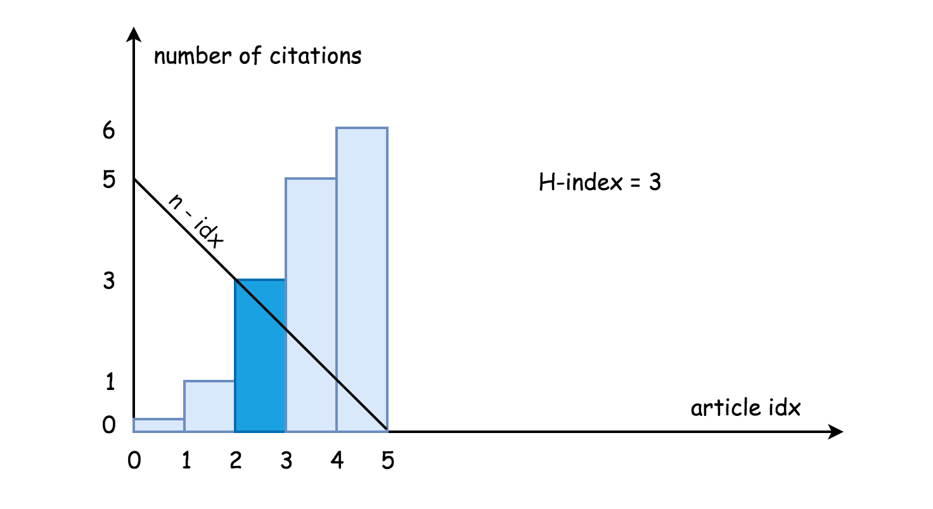

Following the above intuition, it is straightforward to implement the algorithm. We give some examples in the following.

**Implementation**

|  |
| --- |
| class Solution {  public int hIndex(int[] citations) {  int idx = 0, n = citations.length;  for(int c : citations) {  if (c >= n - idx) return n - idx;  else idx++;  }  return 0;  }  } |

**Complexity Analysis**

* Time complexity : \mathcal{O}(N)O(*N*) where N is the length of the input list, since in the worse case we would iterate the entire list.
* Space complexity : \mathcal{O}(1)O(1), it's a constant space solution.

#### **Approach 2: Binary Search, O(log N) time**

**Intuition**

Following in the intuition we elaborated in the Approach 1, the problem is actually boiled down to the following task:

Given a sorted list citations of size n in ascending order, one is asked to find the first number citations[i] which meets the constraint of citations[i] >= n - i.

With the above formulation of the problem, it becomes clear that one could apply the binary search algorithm to solve the problem. In binary search algorithm, we recursively reduce the searching scope into half, which leads to a more optimal \mathcal{O}(\log N)O(log*N*) time complexity comparing to the \mathcal{O}(N)O(*N*) of the linear search.

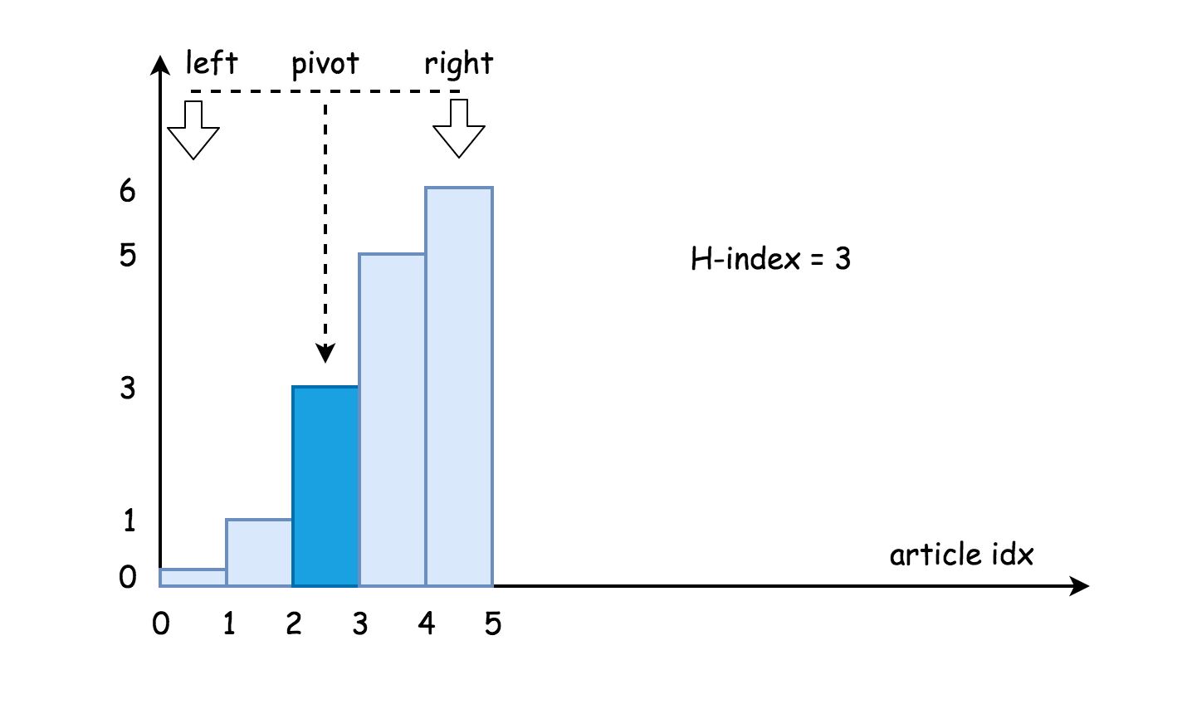

**Algorithm**

First we pick a pivot element that is in the middle of the list, i.e. citations[pivot], which would divide the original list into two sublists: citations[0 : pivot - 1] and citations[pivot + 1 : n].

Then comparing between the values of n - pivot and citations[pivot] element, our binary search algorithm breaks down to the following 3 cases:

* citations[pivot] == n - pivot: We found the desired element !
* citations[pivot] < n - pivot: Since the desired element should be greater or equal to n - pivot, we then further look into the sublist on the right hand side, i.e. citations[pivot + 1 : n].
* citations[pivot] > n - pivot: We should look into the sublist on the left hand side, i.e. citations[0 : pivot-1].

A minor difference to the typical binary search algorithm, is that in this case we return the value of n - pivot as the result, rather than the value of the desired element.

**Implementation**

|  |
| --- |
| class Solution {  public int hIndex(int[] citations) {  int idx = 0, n = citations.length;  int pivot, left = 0, right = n - 1;  while (left <= right) {  pivot = left + (right - left) / 2;  if (citations[pivot] == n - pivot) return n - pivot;  else if (citations[pivot] < n - pivot) left = pivot + 1;  else right = pivot - 1;  }  return n - left;  }  } |

**Complexity Analysis**

* Time complexity : \mathcal{O}(\log N)O(log*N*) since we apply binary search algorithm here.
* Space complexity : \mathcal{O}(1)O(1), it's a constant space solution.

**Longest Duplicate Substring**

Given a string s, consider all duplicated substrings: (contiguous) substrings of s that occur 2 or more times. The occurrences may overlap.

Return **any** duplicated substring that has the longest possible length. If s does not have a duplicated substring, the answer is "".

**Example 1:**

**Input:** s = "banana"

**Output:** "ana"

**Example 2:**

**Input:** s = "abcd"

**Output:** ""

**Constraints:**

* 2 <= s.length <= 3 * 104
* s consists of lowercase English letters.

Hide Hint #1

Binary search for the length of the answer. (If there's an answer of length 10, then there are answers of length 9, 8, 7, ...)

   Hide Hint #2

To check whether an answer of length K exists, we can use Rabin-Karp 's algorithm.

## Solution

#### **Approach 1: Binary Search + Rabin-Karp**

**String Searching Algorithms**

The problem is a follow-up of [Longest Repeating Substring](https://leetcode.com/problems/longest-repeating-substring/), and typically used to check if you're comfortable with [string searching algortihms](https://en.wikipedia.org/wiki/String-searching_algorithm#Single-pattern_algorithms).

Best algorithms have a linear execution time in average. The most popular ones are [Aho-Corasick](https://en.wikipedia.org/wiki/Aho%E2%80%93Corasick_algorithm), [KMP](https://en.wikipedia.org/wiki/Knuth%E2%80%93Morris%E2%80%93Pratt_algorithm) and [Rabin-Karp](https://en.wikipedia.org/wiki/Rabin%E2%80%93Karp_algorithm): Aho-Corasick is used by [fgrep](https://en.wikipedia.org/wiki/Grep#Variations), KMP is used for [chinese string searching](https://www.aclweb.org/anthology/C96-2200), and Rabin-Karp is used for plagiarism detection and in bioinformatics to look for similarities in two or more proteins.

The first two are optimised for a single pattern search, and Rabin-Karp for a multiple pattern search, that is exactly the case here.

**Split into two subtasks**

Here we have "two in one" problem :

1. Perform a search by a substring length in the interval from 1 to N.
2. Check if there is a duplicate substring of a given length L.

**Subtask one : Binary search**

A naive solution would be to check all possible string length one by one starting from N - 1: if there is a duplicate substring of length N - 1, then of length N - 2, etc. Note that if there is a duplicate substring of length k, that means that there is a duplicate substring of length k - 1. Hence one could use a binary search by string length here, and have the first problem solved in \mathcal{O}(\log N)O(log*N*) time.

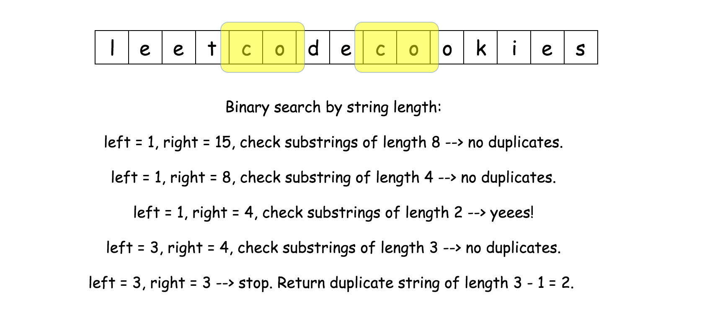

**Subtask two : Rabin-Karp**

Subtask two, to check if there is duplicate substring of a given length, is a multiple pattern search. Let's use Rabin-Karp algorithm to solve it in a linear time.

The idea is very simple :

* Move a sliding window of length L along the string of length N.
* Check if the string in the sliding window is in the hashset of already seen strings.
  + If yes, the duplicate substring is right here.
  + If not, save the string in the sliding window in the hashset.



The linear time implementation of this idea is a bit tricky because of two technical problems:

1. [How to implement a string slice in a constant time?](https://stackoverflow.com/questions/35180377/time-complexity-of-string-slice)
2. Hashset memory consumption could be huge for very long strings. One could keep the string hash instead of string itself but hash generation costs \mathcal{O}(L)O(*L*) for the string of length L, and the complexity of algorithm would be \mathcal{O}((N - L)L)O((*N*−*L*)*L*), N - L for the slice and L for the hash generation. One has to think how to generate hash in a constant time here.

Let's now address these problems.

**String slice in a constant time**

That's a very language-dependent problem. For the moment for Java and Python there is no straightforward solution, and to move sliding window in a constant time one has to convert string to another data structure.

Python is already providing [memoryview](https://docs.python.org/3/library/stdtypes.html#memoryview), which is known to be surprisingly slow, and there are a lot of discussion about [strview](https://mail.python.org/pipermail/python-ideas/2011-December/012993.html).

The simplest solution both for Java and Python is to convert string to integer array of ascii-values.

**Rolling hash : hash generation in a constant time**

To generate hash of array of length L, one needs \mathcal{O}(L)O(*L*) time.

How to have constant time of hash generation? Use the advantage of slice: only one integer in, and only one - out.

That's the idea of [rolling hash](https://en.wikipedia.org/wiki/Rolling_hash). Here we'll implement the simplest one, polynomial rolling hash. Beware that's polynomial rolling hash is NOT the [Rabin fingerprint](https://en.wikipedia.org/wiki/Rolling_hash#Rabin_fingerprint).

Since one deals here with lowercase English letters, all values in the integer array are between 0 and 25 : arr[i] = (int)S.charAt(i) - (int)'a'.  
So one could consider string abcd -> [0, 1, 2, 3] as a number in a [numeral system](https://en.wikipedia.org/wiki/Numeral_system) with the base 26. Hence abcd -> [0, 1, 2, 3] could be hashed as

h_0 = 0 \times 26^3 + 1 \times 26^2 + 2 \times 26^1 + 3 \times 26^0*h*0​=0×263+1×262+2×261+3×260

Let's write the same formula in a generalised way, where c_i*ci*​ is an integer array element and a = 26*a*=26 is a system base.

h_0 = c_0 a^{L - 1} + c_1 a^{L - 2} + ... + c_i a^{L - 1 - i} + ... + c_{L - 1} a^1 + c_L a^0*h*0​=*c*0​*aL*−1+*c*1​*aL*−2+...+*ci*​*aL*−1−*i*+...+*cL*−1​*a*1+*cL*​*a*0

h_0 = \sum_{i = 0}^{L - 1}{c_i a^{L - 1 - i}}*h*0​=∑*i*=0*L*−1​*ci*​*aL*−1−*i*

Now let's consider the slice abcd -> bcde. For int arrays that means [0, 1, 2, 3] -> [1, 2, 3, 4], to remove number 0 and to add number 4.

h_1 = (h_0 - 0 \times 26^3) \times 26 + 4 \times 26^0*h*1​=(*h*0​−0×263)×26+4×260

In a generalised way

h_1 = (h_0 a - c_0 a^L) + c_{L + 1}*h*1​=(*h*0​*a*−*c*0​*aL*)+*cL*+1​

Now hash regeneration is perfect and fits in a constant time. There is one more issue to address: possible overflow problem.

**How to avoid overflow**

a^L*aL* could be a large number and hence the idea is to set limits to avoid the overflow. To set limits means to limit a hash by a given number called modulus and use everywhere not hash itself but h % modulus.

It's quite obvious that modulus should be large enough, but how large? [Here one could read more about the topic](https://en.wikipedia.org/wiki/Linear_congruential_generator#Parameters_in_common_use), for the problem here the standard int overflow in 2^{32}232 is enough.

In a real life, when not all testcases are known in advance, one has to check if the strings with equal hashes are truly equal. Such false-positive strings could happen because of a modulus which is too small and strings which are too long. That leads to Rabin-Karp time complexity \mathcal{O}(NL)O(*NL*) in the worst case then almost all strings are false-positive. Here it's not the case because all testcases are known and one could adjust the modulus.

Another one overflow issue here is purely Java related. While in Python the hash regeneration goes perfectly fine, in Java the same thing is better to rewrite to avoid long overflow. Check [here](https://leetcode.com/problems/longest-duplicate-substring/discuss/292982/Java-version-with-comment) the nice explanation by @[hqt](https://leetcode.com/hqt/).

|  |
| --- |
| h = (h * a - nums[start - 1] * aL % modulus + modulus) % modulus;  h = (h + nums[start + L - 1]) % modulus; |

**Binary search algorithm**

* Use binary search by a substring length to check lengths from 1 to N left = 1, right = N. While left != right:
  + L = left + (right - left) / 2
  + If search(L) != -1 (i.e. there is a duplicate substring), left = L + 1
  + Otherwise (no duplicate substring), right = L.
* Return duplicate string of length left - 1, or an empty string if there is no such a string.

**Rabin-Karp algorithm**

search(L) :

* Compute the hash of substring S.substring(0, L) and initiate the hashset of already seen substring with this value.
* Iterate over the start position of substring : from 1 to N - L*N*−*L*.
  + Compute rolling hash based on the previous hash value.
  + Return start position if the hash is in the hashset, because that means a duplicate string.
  + Otherwise, add hash in the hashset.
* Return -1, that means there is no duplicate string of length L.

**Implementation**

|  |
| --- |
| class Solution {  /*  Rabin-Karp with polynomial rolling hash.  Search a substring of given length  that occurs at least 2 times.  Return start position if the substring exits and -1 otherwise.  */  public int search(int L, int a, long modulus, int n, int[] nums) {  // compute the hash of string S[:L]  long h = 0;  for(int i = 0; i < L; ++i) h = (h * a + nums[i]) % modulus;  // already seen hashes of strings of length L  HashSet<Long> seen = new HashSet();  seen.add(h);  // const value to be used often : a**L % modulus  long aL = 1;  for (int i = 1; i <= L; ++i) aL = (aL * a) % modulus;  for(int start = 1; start < n - L + 1; ++start) {  // compute rolling hash in O(1) time  h = (h * a - nums[start - 1] * aL % modulus + modulus) % modulus;  h = (h + nums[start + L - 1]) % modulus;  if (seen.contains(h)) return start;  seen.add(h);  }  return -1;  }  public String longestDupSubstring(String S) {  int n = S.length();  // convert string to array of integers  // to implement constant time slice  int[] nums = new int[n];  for(int i = 0; i < n; ++i) nums[i] = (int)S.charAt(i) - (int)'a';  // base value for the rolling hash function  int a = 26;  // modulus value for the rolling hash function to avoid overflow  long modulus = (long)Math.pow(2, 32);  // binary search, L = repeating string length  int left = 1, right = n;  int L;  while (left <= right) {  L = left + (right - left) / 2;  if (search(L, a, modulus, n, nums) != -1) left = L + 1;  else right = L - 1;  }  int start = search(left - 1, a, modulus, n, nums);  return S.substring(start, start + left - 1);  }  } |

**Complexity Analysis**

* Time complexity : \mathcal{O}(N \log N)O(*N*log*N*). \mathcal{O}(\log N)O(log*N*) for the binary search and \mathcal{O}(N)O(*N*) for Rabin-Karp algorithm.
* Space complexity : \mathcal{O}(N)O(*N*) to keep the hashset.

**Permutation Sequence**

**Solution**

The set [1, 2, 3, ..., n] contains a total of n! unique permutations.

By listing and labeling all of the permutations in order, we get the following sequence for n = 3:

1. "123"
2. "132"
3. "213"
4. "231"
5. "312"
6. "321"

Given n and k, return the kth permutation sequence.

**Example 1:**

**Input:** n = 3, k = 3

**Output:** "213"

**Example 2:**

**Input:** n = 4, k = 9

**Output:** "2314"

**Example 3:**

**Input:** n = 3, k = 1

**Output:** "123"

**Constraints:**

* 1 <= n <= 9
* 1 <= k <= n!

## Solution

#### **Solution Pattern**

There are three main types of interview questions about permutations:

* 1.[Generate all permutations](https://leetcode.com/articles/permutations/).
* 2.[Generate next permutation](https://leetcode.com/articles/next-permutation/).
* 3.Generate the permutation number k (current problem).

If the order of generated permutations is not important, one could use ["swap" backtracking](https://leetcode.com/articles/permutations/) to solve the first problem and to generate all N!*N*! permutations in \mathcal{O}(N \times N!)O(*N*×*N*!) time.

Although, it is better to generate permutations in lexicographically sorted order using [D.E. Knuth algorithm](https://leetcode.com/articles/next-permutation/). This algorithm generates new permutation from the previous one in \mathcal{O}(N)O(*N*) time. The same algorithm could be used to solve the second problem above.

The problem number three is where the fun starts because the above two algorithms do not apply:

* You will be asked to fit into polynomial time complexity, i.e. no backtracking.
* The previous permutation is unknown, i.e. you cannot use D.E. Knuth algorithm.

To solve the problem, one could use a pretty elegant idea that is based on the mapping. It's much easier to generate numbers than combinations or permutations.

So let us generate numbers, and then map them to combinations/subsets/permutations.

This sort of encoding is widely used in password-cracking algorithms.

For example, [in a previous article](https://leetcode.com/articles/subsets/) we discussed how one could map a subset with a binary bitmask of length N, where ith 0 means "the element number i is absent" and ith 1 means "the element number i is present".

One could do the same for permutations, mapping permutation with the integer in [Factorial Number System Representation](https://en.wikipedia.org/wiki/Factorial_number_system).

#### **Approach 1: Factorial Number System**

**Why Do We Need Factorial Number System**

Usually standard decimal or binary [positional system](https://en.wikipedia.org/wiki/Numeral_system#Positional_systems_in_detail) could meet our needs. For example, each subset could be described by a number in binary representation

k = \sum\limits_{m = 0}^{N - 1}{k_m 2^m}, \qquad 0 \le k_m \le 1*k*=*m*=0∑*N*−1​*km*​2*m*,0≤*km*​≤1

Here is how it works:

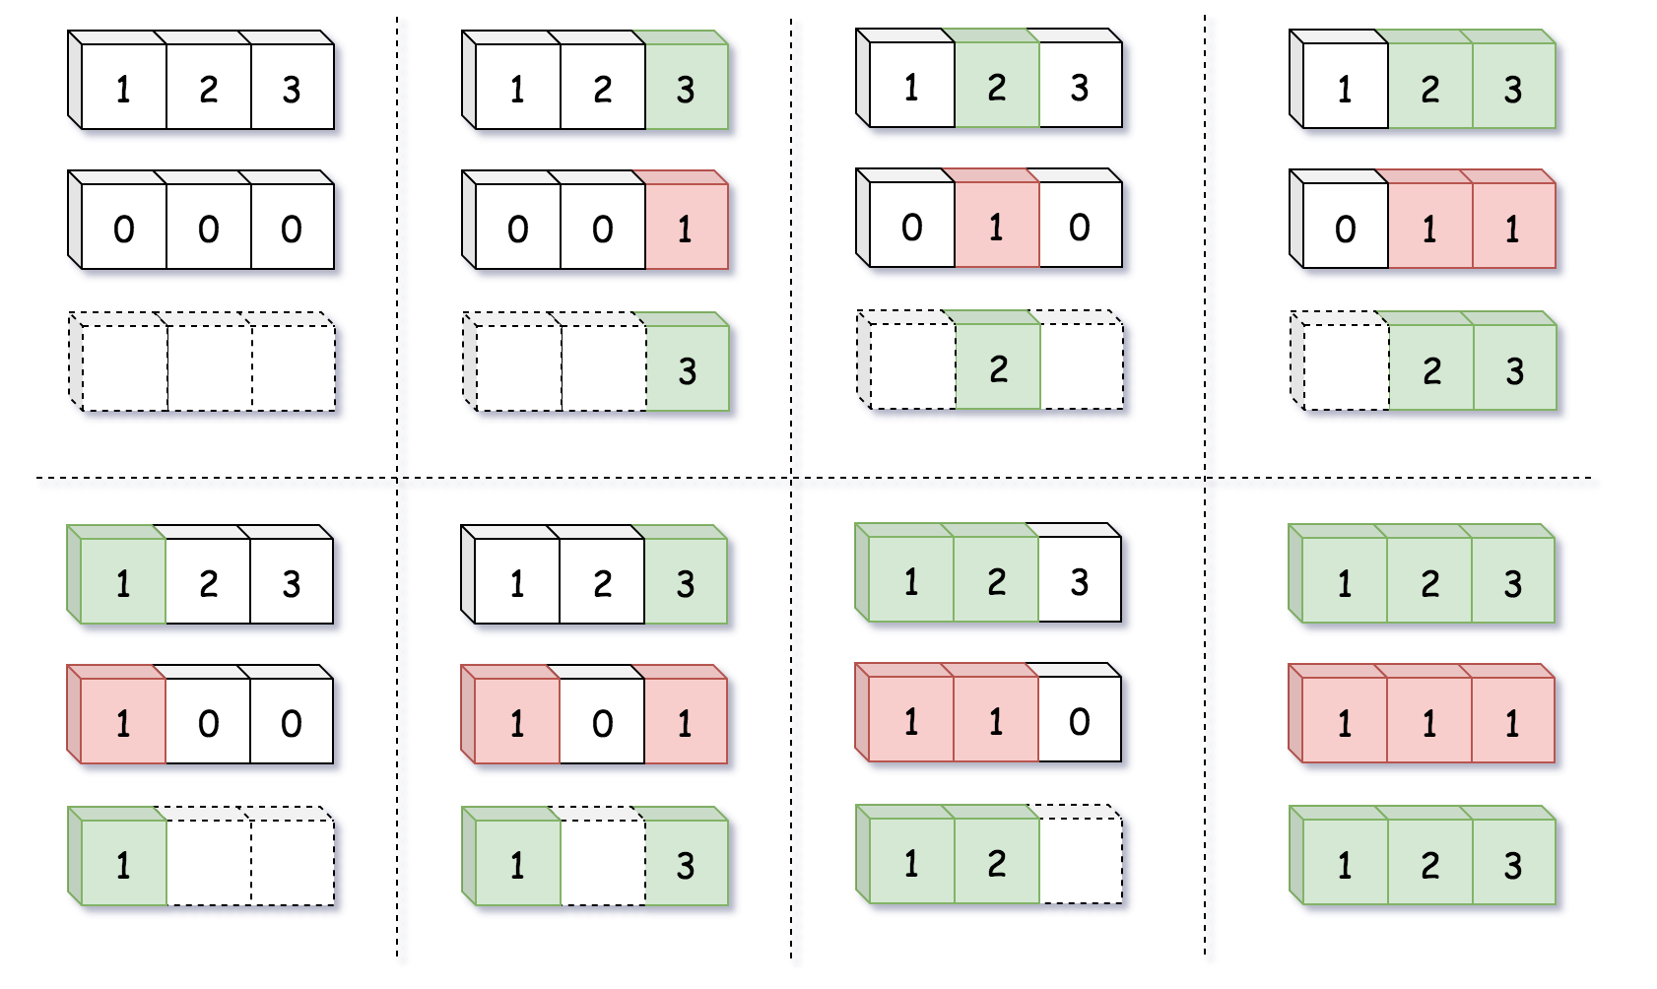

The problem with permutations is that there is a much more permutations than subsets, N!*N*! grows up much faster than 2^N2*N*. Therefore, the solution space provided by the positional system with constant base cannot match with the number of permutations.

Here is where the factorial number system enters the scene. It's a positional system with non-constant base m!*m*!

k = \sum\limits_{m = 0}^{N - 1}{k_m m!}, \qquad 0 \le k_m \le m*k*=*m*=0∑*N*−1​*km*​*m*!,0≤*km*​≤*m*

Note, that magnitude of weights is not constant as well and depends on base: 0 \le k_m \le m0≤*km*​≤*m* for the base m!*m*!, i.e. k_0 = 0*k*0​=0, 0 \le k_1 \le 10≤*k*1​≤1, 0 \le k_2 \le 20≤*k*2​≤2, etc.

Here is how this mapping works:

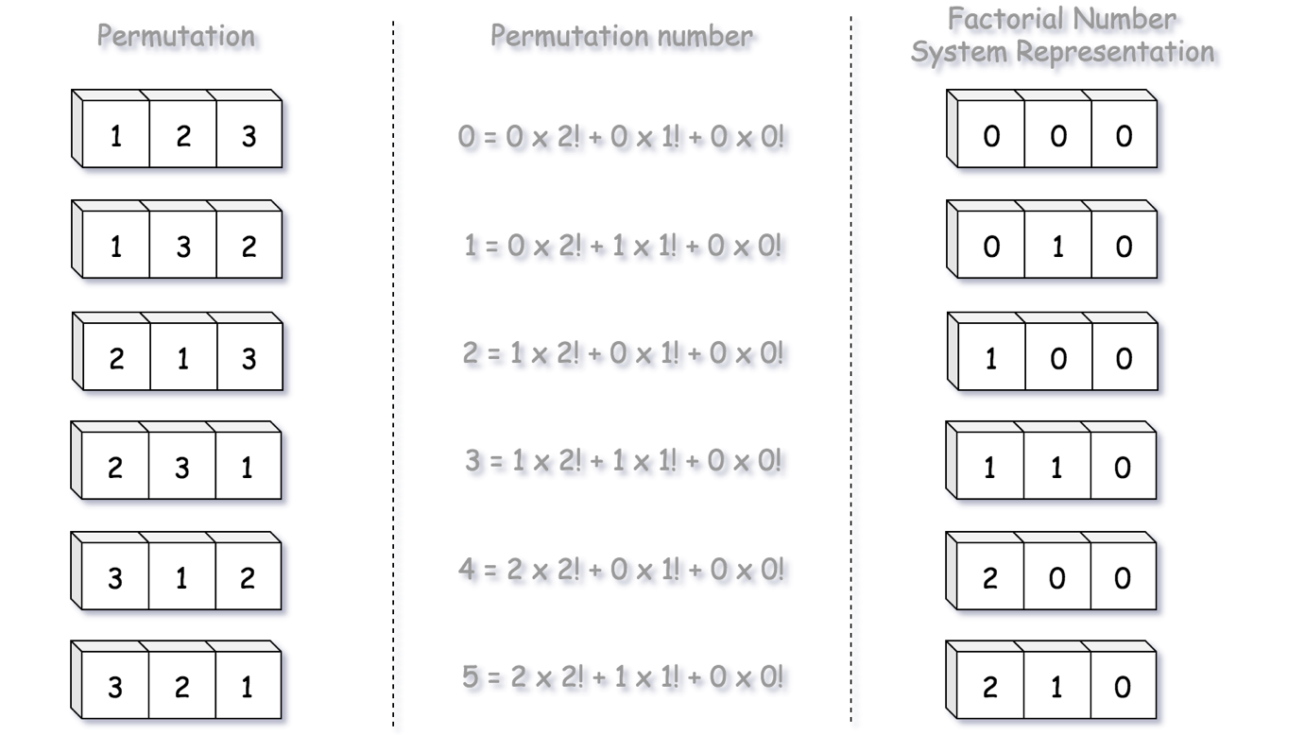

We could now map all permutations, from permutation number zero: k = 0 = \sum\limits_{m = 0}^{N - 1}{0 \times m!}*k*=0=*m*=0∑*N*−1​0×*m*! to permutation number N! - 1*N*!−1: k = N! - 1 = \sum\limits_{m = 0}^{N - 1}{m \times m!}*k*=*N*!−1=*m*=0∑*N*−1​*m*×*m*!.

Hence we have a way to encode permutation number into factorial representation. Now let us use this factorial representation to construct the permutation itself.

**How to Construct the Permutation from its Factorial Representation**

Let us pick up N = 3*N*=3, which corresponds to the input array nums = [1, 2, 3], and construct its permutation number k = 3*k*=3. Since we number the permutations from 0 to N! - 1*N*!−1 (and not from 1 to N!*N*! as in the problem description), for us that will be the permutation number k = 2*k*=2.

Let us first construct the factorial representation of k = 2*k*=2:

k = 2 = 1 \times 2! + 0 \times 1! + 0 \times 0! = (1, 0, 0)*k*=2=1×2!+0×1!+0×0!=(1,0,0)

The coefficients in factorial representation are indexes of elements in the input array. These are not direct indexes, but the indexes after the removal of already used elements. That's a consequence of the fact that each element should be used in permutation only once.

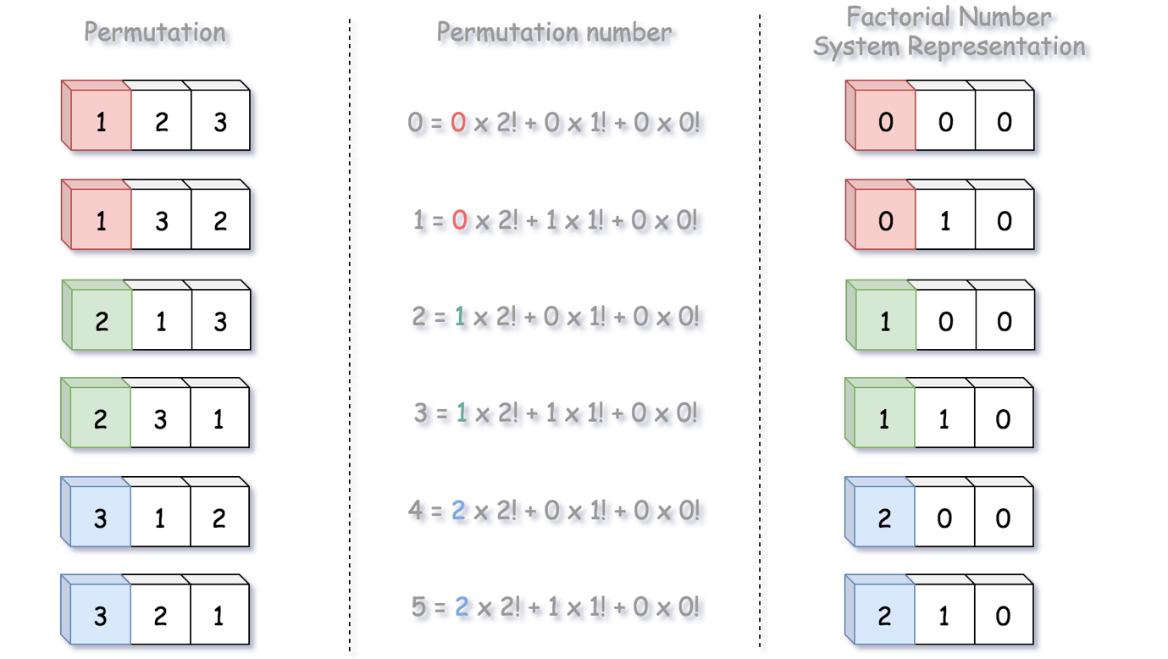

Here the first number is 1, i.e. the first element in the permutation is nums[1] = 2. Let us use nums[1] = 2 in the permutation and then delete it from nums, since each element should be used only once.

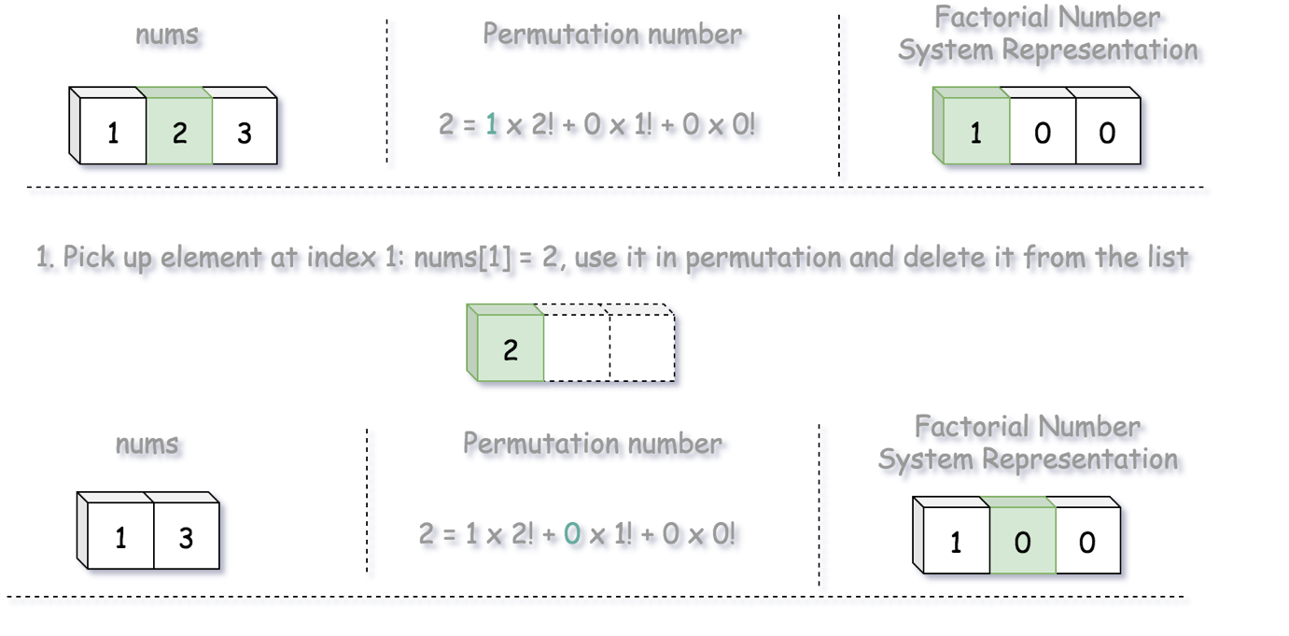

Next coefficient in factorial representation is 0. Let's use nums[0] = 1 in the permutation and then delete it from nums.

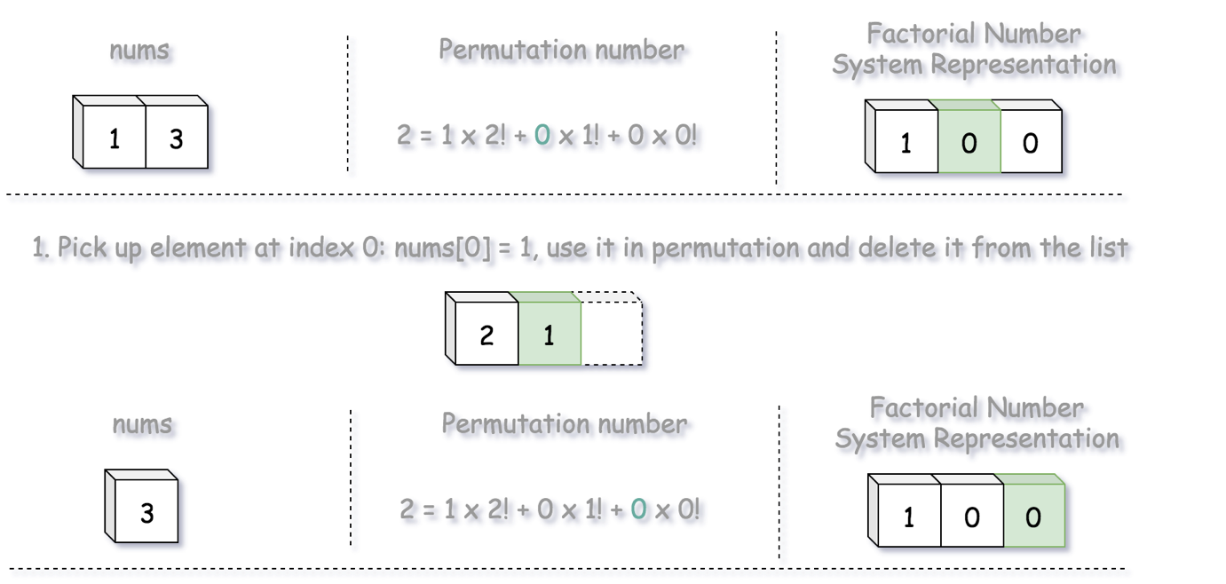

Next coefficient in factorial representation is 0. Let's use nums[0] = 3 in the permutation and then delete it from nums. The job is done.

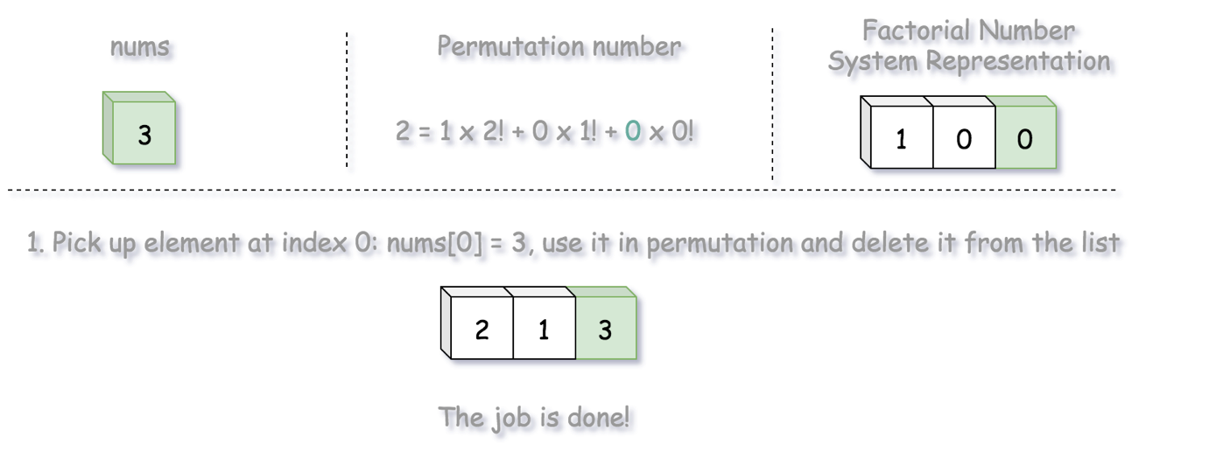

**Algorithm**

* Generate input array nums of numbers from 11 to N*N*.
* Compute all factorial bases from 00 to (N - 1)!(*N*−1)!.
* Decrease k*k* by 1 to make it fit into (0, N! - 1)(0,*N*!−1) interval.
* Compute factorial representation of k*k*. Use factorial coefficients to construct the permutation.
* Return the permutation string.

**Implementation**

|  |
| --- |
| class Solution {  public String getPermutation(int n, int k) {  int[] factorials = new int[n];  List<Integer> nums = new ArrayList() {{add(1);}};  factorials[0] = 1;  for(int i = 1; i < n; ++i) {  // generate factorial system bases 0!, 1!, ..., (n - 1)!  factorials[i] = factorials[i - 1] * i;  // generate nums 1, 2, ..., n  nums.add(i + 1);  }  // fit k in the interval 0 ... (n! - 1)  --k;  // compute factorial representation of k  StringBuilder sb = new StringBuilder();  for (int i = n - 1; i > -1; --i) {  int idx = k / factorials[i];  k -= idx * factorials[i];  sb.append(nums.get(idx));  nums.remove(idx);  }  return sb.toString();  }  } |

**Complexity Analysis**

* Time complexity: \mathcal{O}(N^2)O(*N*2), because to delete elements from the list in a loop one has to perform N + (N - 1) + ... + 1 = N(N - 1)/2*N*+(*N*−1)+...+1=*N*(*N*−1)/2 operations.
* Space complexity: \mathcal{O}(N)O(*N*).

**Dungeon Game**

The demons had captured the princess (**P**) and imprisoned her in the bottom-right corner of a dungeon. The dungeon consists of M x N rooms laid out in a 2D grid. Our valiant knight (**K**) was initially positioned in the top-left room and must fight his way through the dungeon to rescue the princess.

The knight has an initial health point represented by a positive integer. If at any point his health point drops to 0 or below, he dies immediately.

Some of the rooms are guarded by demons, so the knight loses health (negative integers) upon entering these rooms; other rooms are either empty (0's) or contain magic orbs that increase the knight's health (positive integers).

In order to reach the princess as quickly as possible, the knight decides to move only rightward or downward in each step.

**Write a function to determine the knight's minimum initial health so that he is able to rescue the princess.**

For example, given the dungeon below, the initial health of the knight must be at least **7** if he follows the optimal path RIGHT-> RIGHT -> DOWN -> DOWN.

|  |  |  |
| --- | --- | --- |
| -2 (K) | -3 | 3 |
| -5 | -10 | 1 |
| 10 | 30 | -5 (P) |

**Note:**

* The knight's health has no upper bound.
* Any room can contain threats or power-ups, even the first room the knight enters and the bottom-right room where the princess is imprisoned.

## Solution

#### **Approach 1: Dynamic Programming**

**Overview**

Like many problems with 2D grid, often the case one can apply either the technique of [backtracking](https://leetcode.com/explore/learn/card/recursion-ii/472/backtracking/) or dynamic programming.

Specifically, as it turns out, ***dynamic programming*** would work perfectly for this problem.

As a general pattern of dynamic programming, usually we construct a array of one or two dimensions (i.e. dp[i]) where each element holds the optimal solution for the corresponding subproblem.

To calculate one particular element in the dp[i] array, we would refer to the previously calculated elements. And the **last** element that we figure out in the array would be the desired solution for the original problem.

**Intuition**

Following the above guideline, here is how we break down the problem into subproblems and apply the dynamic programming algorithm.

We are asked to calculate the minimal health point that the knight needs, in order to recuse the princess. The knight would move from the up-left corner of the grid to reach the down-right corner where the princess is located (e.g. as shown in the following graph).

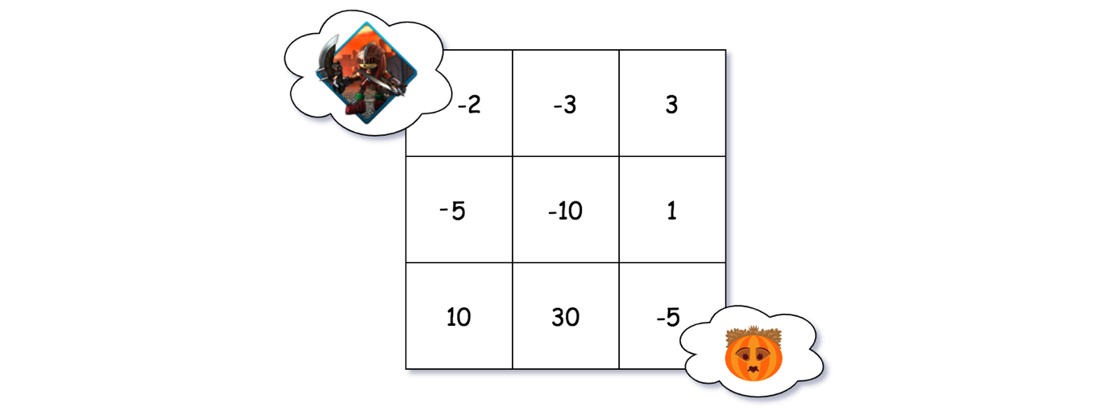

Though the **down-right** corner is the final destination of the knight, we could start from the destination and deduce ***backwards*** the minimal health point that the knight would need at each step along the way.

So starting from the destination where the princess is locked down, as one can see from the following graph, the knight would need at least 6 health points to survive the damage (5 points) caused by the daemon.

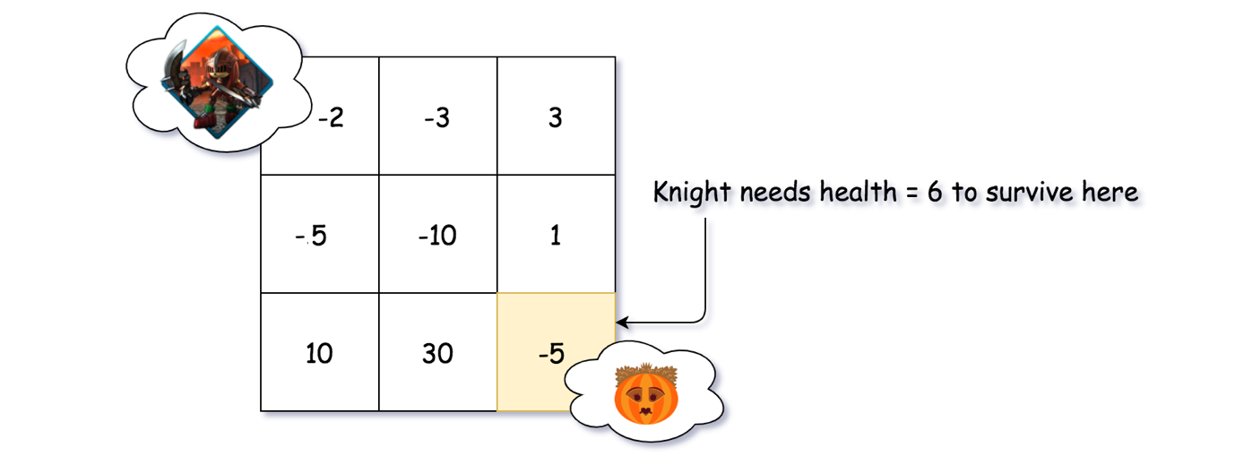

Let us now take one step back. Before reaching the destination, there are two possible positions that the knight might situate, i.e. the one right above the destination so that the knight would take a down step, and the one to the left of the destination so that the knight would take a right step.

Let us look at the cell (denoted as cell U) right above the destination, as shown in the following graph. As we know now, the knight should possess at least 6 health points upon reaching the destination. Since at the cell U we have a magic org which would increase the health of knight by 1 point, the knight would just need to possess 5 health points at the arrival of cell U.

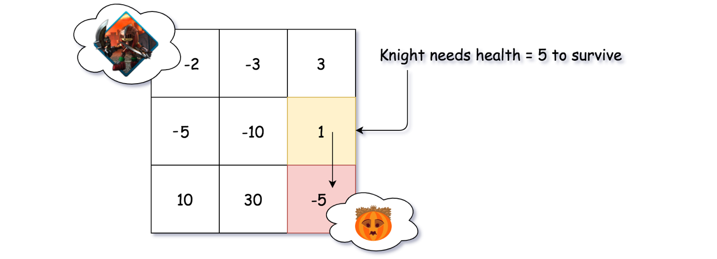

As another alternative to reach the destination, the knight might situate at the cell (denoted as cell L) to the left side of the destination, as shown in the following graph. In this case, similarly the knight would encounter a magic orb which would give him a 30-points boost on health. With this boost of health, it would be more than enough for the knight to survive the final daemon in the destination. As a result, the knight just needs to possess the minimal 1 health point upon entering the cell L.

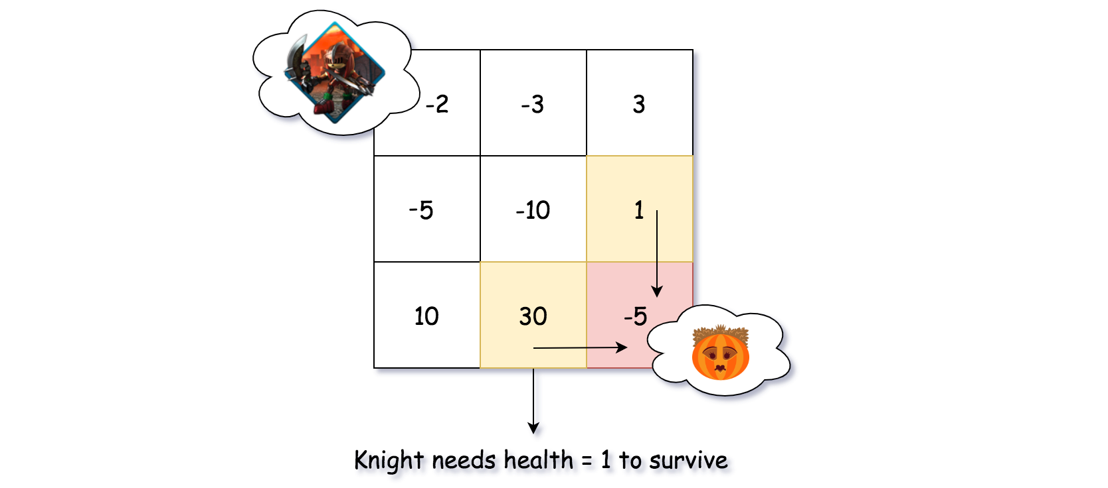

Now that we have calculated the minimal health points that the knight would need before reaching the destination from two of the possible directions, we can carry on to one more step further from the destination. Let us look at the cell (denoted as cell UL) located at the up-left corner from the destination.

Following the same logic as we have seen in the above steps, we could obtain two values for this cell, which represent the minimal health points that the knight would need for each of the directions that he takes. As one can see from the following graph, at the cell UL, if the knight takes a right step next, he would need at least 5 + 10 = 155+10=15 health points, in order to rescue the princess at the end. If he takes a down step next, he would need at least 1 + 10 = 111+10=11 health points.

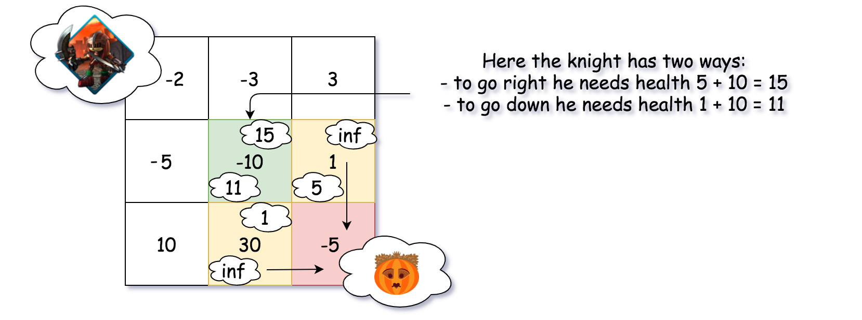

With all the 3 examples above, we conclude with the following graph where each cell is marked with two minimal health points respectively for each direction that the knight might take, except the destination cell. As one can see, starting from the up-left corner of the grid, the knight would only need 7 health points to rescue the princess.

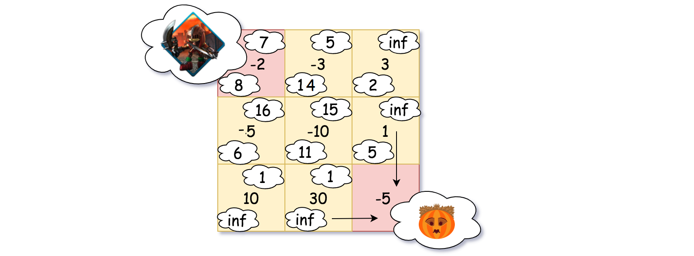

**Algorithm**

Given the above intuition, let us see how we can model it with the general code pattern of dynamic programming algorithm.

First, we define a matrix dp[row][col], where the element dp[row][col] indicates the minimal health points that the knight would need, starting from the corresponding dungeon cell dungeon[row][col], in order to reach the destination.

In the following graph, we show what the dp matrix looks like, for the examples that we listed in the intuition section.

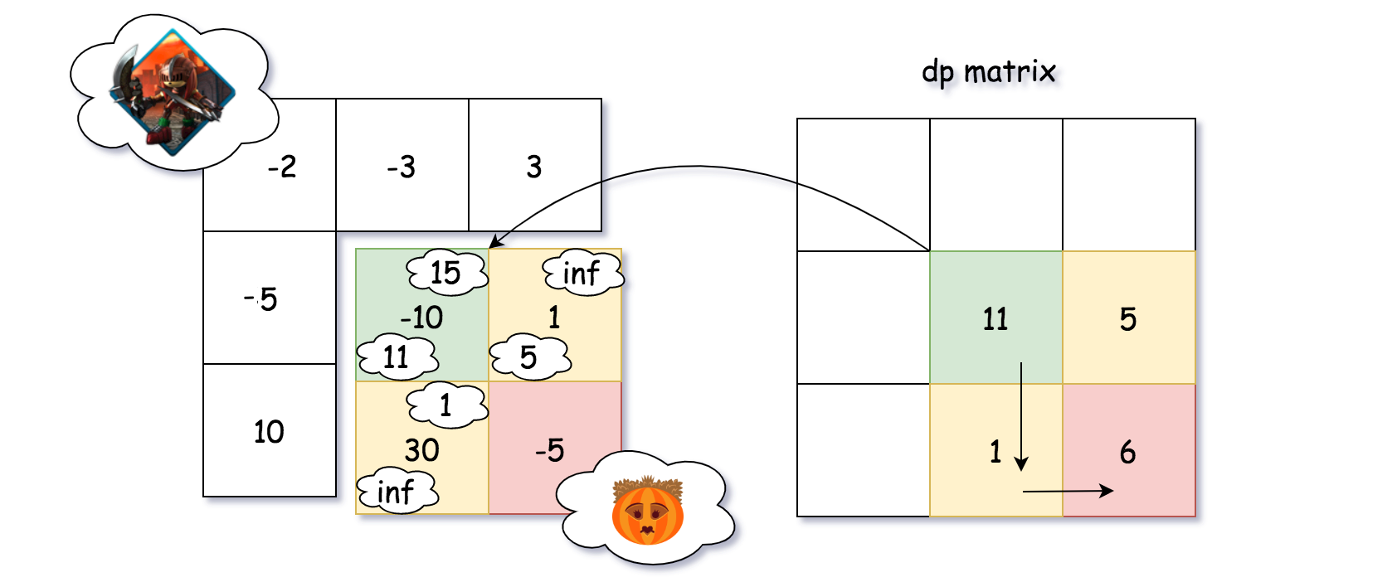

The main idea of the algorithm is clear: we need to calculate the values in the dp matrix. And the last value we calculate for the matrix would be the desired solution for the problem.

In order to calculate the values of dp matrix, we start from the down-right corner of the dungeon, and walk following the orders of **from-right-to-left** and **from-down-to-up**. Along with each cell in the dungeon, we calculate the corresponding value of dp[row][col] in the matrix.

The value of dp[row][col] is determined by the following conditions:

* If possible, by taking the right step from the current dungeon cell, the knight might need right_health health points.
* If possible, by taking the down step from the current dungeon cell, the knight would might down_health health points.
* If either of the above two alternatives exists, we then take the minimal value of them as the value for dp[row][col].
* If none of the above alternatives exists, i.e. we are at the destination cell, there are two sub-cases:
  + If the current cell is of magic orb, then 1 health point would suffice.
  + If the current cell is of daemon, then the knight should possess one health point plus the damage points that would be caused by the daemon.

|  |
| --- |
| class Solution {  int inf = Integer.MAX_VALUE;  int[][] dp;  int rows, cols;  public int getMinHealth(int currCell, int nextRow, int nextCol) {  if (nextRow >= this.rows || nextCol >= this.cols)  return inf;  int nextCell = this.dp[nextRow][nextCol];  // hero needs at least 1 point to survive  return Math.max(1, nextCell - currCell);  }  public int calculateMinimumHP(int[][] dungeon) {  this.rows = dungeon.length;  this.cols = dungeon[0].length;  this.dp = new int[rows][cols];  for (int[] arr : this.dp) {  Arrays.fill(arr, this.inf);  }  int currCell, rightHealth, downHealth, nextHealth, minHealth;  for (int row = this.rows - 1; row >= 0; --row) {  for (int col = this.cols - 1; col >= 0; --col) {  currCell = dungeon[row][col];  rightHealth = getMinHealth(currCell, row, col + 1);  downHealth = getMinHealth(currCell, row + 1, col);  nextHealth = Math.min(rightHealth, downHealth);  if (nextHealth != inf) {  minHealth = nextHealth;  } else {  minHealth = currCell >= 0 ? 1 : 1 - currCell;  }  this.dp[row][col] = minHealth;  }  }  return this.dp[0][0];  }  } |

**Complexity**

* Time Complexity: \mathcal{O}(M \cdot N)O(*M*⋅*N*) where M \cdot N*M*⋅*N* is the size of the dungeon. We iterate through the entire dungeon once and only once.
* Space Complexity: \mathcal{O}(M \cdot N)O(*M*⋅*N*) where M \cdot N*M*⋅*N* is the size of the dungeon. In the algorithm, we keep a dp matrix that is of the same size as the dungeon.

#### **Approach 2: Dynamic Programming with Circular Queue**

**Intuition**

In the above dynamic programming algorithm, there is not much we can do to optimize the time complexity, other than reducing the costy condition checks with some tricks on the initial values of the dp matrix.

On the other hand, we could reduce the space complexity of the algorithm from \mathcal{O}(M \cdot N)O(*M*⋅*N*) to \mathcal{O}(N)O(*N*) where N*N* is the number of columns.

First of all, let us flatten the dp matrix into 1D array, i.e. dp[row][col] = dp[row * N + col].

As one might notice in the above process, in order to calculate each dp[i], we would refer to at most two previously calculated dp values, i.e. dp[i-1] and dp[i-N]. Therefore, once we calculate the value for dp[i], we could discard all the previous values that are beyond the range of N.

The above characteristics of the dp array might remind you the container named **CircularQueue** which could serve as a sliding window to scan a long list.

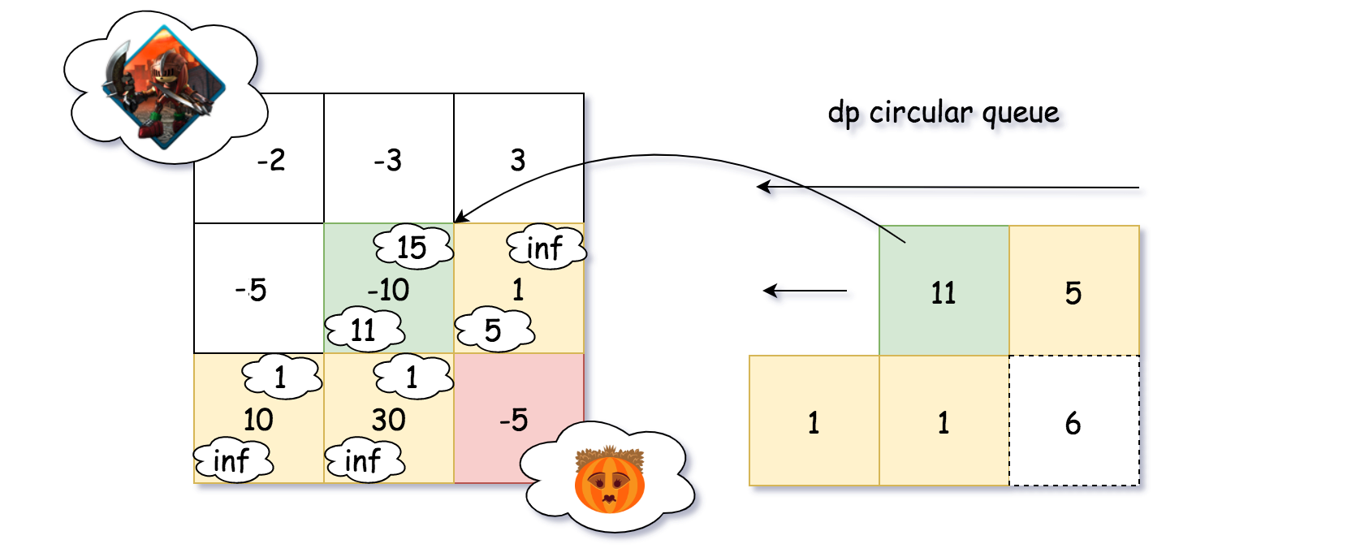

Indeed, we could use the CircularQueue to calculate the dp array, as we show in the above graph. At any moment, the size of the CircularQueue would not exceed the predefined capacity, which would be N in our case. As a result, we reduce the overall space complexity of the algorithm to \mathcal{O}(N)O(*N*).

**Algorithm**

|  |
| --- |
| class MyCircularQueue {  protected int capacity;  protected int tailIndex;  public int[] queue;  public MyCircularQueue(int capacity) {  this.queue = new int[capacity];  this.tailIndex = 0;  this.capacity = capacity;  }  public void enQueue(int value) {  this.queue[this.tailIndex] = value;  this.tailIndex = (this.tailIndex + 1) % this.capacity;  }  public int get(int index) {  return this.queue[index % this.capacity];  }  }  class Solution {  int inf = Integer.MAX_VALUE;  MyCircularQueue dp;  int rows, cols;  public int getMinHealth(int currCell, int nextRow, int nextCol) {  if (nextRow < 0 || nextCol < 0)  return inf;  int index = cols * nextRow + nextCol;  int nextCell = this.dp.get(index);  // hero needs at least 1 point to survive  return Math.max(1, nextCell - currCell);  }  public int calculateMinimumHP(int[][] dungeon) {  this.rows = dungeon.length;  this.cols = dungeon[0].length;  this.dp = new MyCircularQueue(this.cols);  int currCell, rightHealth, downHealth, nextHealth, minHealth;  for (int row = 0; row < this.rows; ++row) {  for (int col = 0; col < this.cols; ++col) {  currCell = dungeon[rows - row - 1][cols - col - 1];  rightHealth = getMinHealth(currCell, row, col - 1);  downHealth = getMinHealth(currCell, row - 1, col);  nextHealth = Math.min(rightHealth, downHealth);  if (nextHealth != inf) {  minHealth = nextHealth;  } else {  minHealth = currCell >= 0 ? 1 : 1 - currCell;  }  this.dp.enQueue(minHealth);  }  }  // retrieve the last element in the queue  return this.dp.get(this.cols - 1);  }  } |

**Complexity**

* Time Complexity: \mathcal{O}(M \cdot N)O(*M*⋅*N*) where M \cdot N*M*⋅*N* is the size of the dungeon. We iterate through the entire dungeon once and only once.
* Space Complexity: \mathcal{O}(N)O(*N*) where N*N* is the number of columns in the dungeon.

**Single Number II**

Given an integer array nums where every element appears **three times** except for one, which appears **exactly once**. Find the single element and return it.

**Example 1:**

**Input:** nums = [2,2,3,2]

**Output:** 3

**Example 2:**

**Input:** nums = [0,1,0,1,0,1,99]

**Output:** 99

**Constraints:**

* 1 <= nums.length <= 3 * 104
* -231 <= nums[i] <= 231 - 1
* Each element in nums appears exactly **three times** except for one element which appears **once**.

**Follow up:** Your algorithm should have a linear runtime complexity. Could you implement it without using extra memory?

## Solution

#### **Overview**

The problem seems to be quite simple and one could solve it in \mathcal{O}(N)O(*N*) time and \mathcal{O}(N)O(*N*) space by using an additional data structure like set or hashmap.

The real game starts at the moment when Google interviewer (the problem is quite popular at Google the last six months) asks you to solve the problem in a constant space, testing if you are OK with bitwise operators.

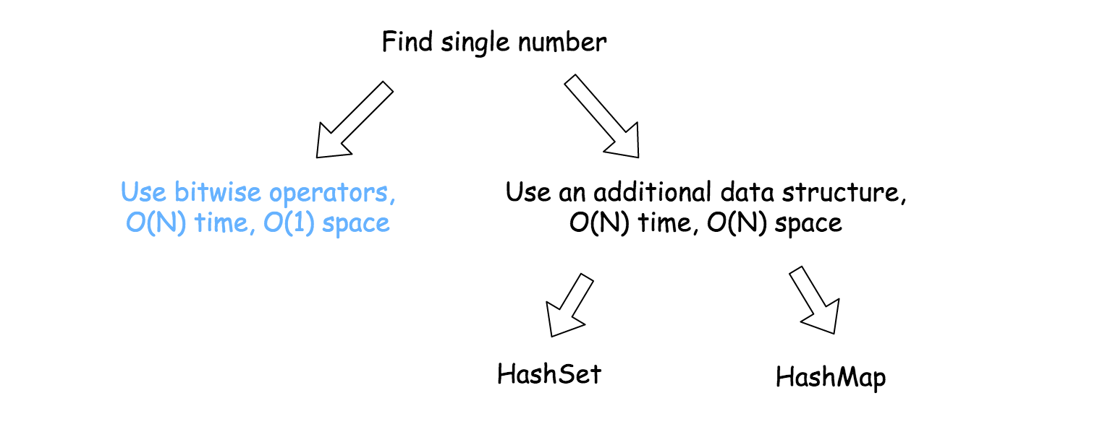

#### **Approach 1: HashSet**

The idea is to convert an input array into hashset and then to compare the tripled sum of the set with the array sum

3 \times (a + b + c) - (a + a + a + b + b + b + c) = 2 c3×(*a*+*b*+*c*)−(*a*+*a*+*a*+*b*+*b*+*b*+*c*)=2*c*

**Implementation**

|  |
| --- |
| class Solution {  public int singleNumber(int[] nums) {  Set<Long> set = new HashSet<>();  long sumSet = 0, sumArray = 0;  for(int n : nums) {  sumArray += n;  set.add((long)n);  }  for(Long s : set) sumSet += s;  return (int)((3 * sumSet - sumArray) / 2);  }  } |

**Complexity Analysis**

* Time complexity : \mathcal{O}(N)O(*N*) to iterate over the input array.
* Space complexity : \mathcal{O}(N)O(*N*) to keep the set of N/3*N*/3 elements.

#### **Approach 2: HashMap**

Let's iterate over the input array to count the frequency of each number, and then return an element with a frequency 1.

**Implementation**

|  |
| --- |
| class Solution {  public int singleNumber(int[] nums) {  HashMap<Integer, Integer> hashmap = new HashMap<>();  for (int num : nums)  hashmap.put(num, hashmap.getOrDefault(num, 0) + 1);  for (int k : hashmap.keySet())  if (hashmap.get(k) == 1) return k;  return -1;  }  } |

**Complexity Analysis**

* Time complexity : \mathcal{O}(N)O(*N*) to iterate over the input array.
* Space complexity : \mathcal{O}(N)O(*N*) to keep the hashmap of N/3*N*/3 elements.

#### **Approach 3: Bitwise Operators : NOT, AND and XOR**

**Intuition**

Now let's discuss \mathcal{O}(1)O(1) space solution by using three [bitwise operators](https://wiki.python.org/moin/BitwiseOperators)

\sim x \qquad \textrm{that means} \qquad \textrm{bitwise NOT}∼*x*that meansbitwise NOT

x \& y \qquad \textrm{that means} \qquad \textrm{bitwise AND}*x*&*y*that meansbitwise AND

x \oplus y \qquad \textrm{that means} \qquad \textrm{bitwise XOR}*x*⊕*y*that meansbitwise XOR

**XOR**

Let's start from XOR operator which could be used to detect the bit which appears odd number of times: 1, 3, 5, etc.

XOR of zero and a bit results in that bit

0 \oplus x = x0⊕*x*=*x*

XOR of two equal bits (even if they are zeros) results in a zero

x \oplus x = 0*x*⊕*x*=0

and so on and so forth, i.e. one could see the bit in a bitmask only if it appears odd number of times.

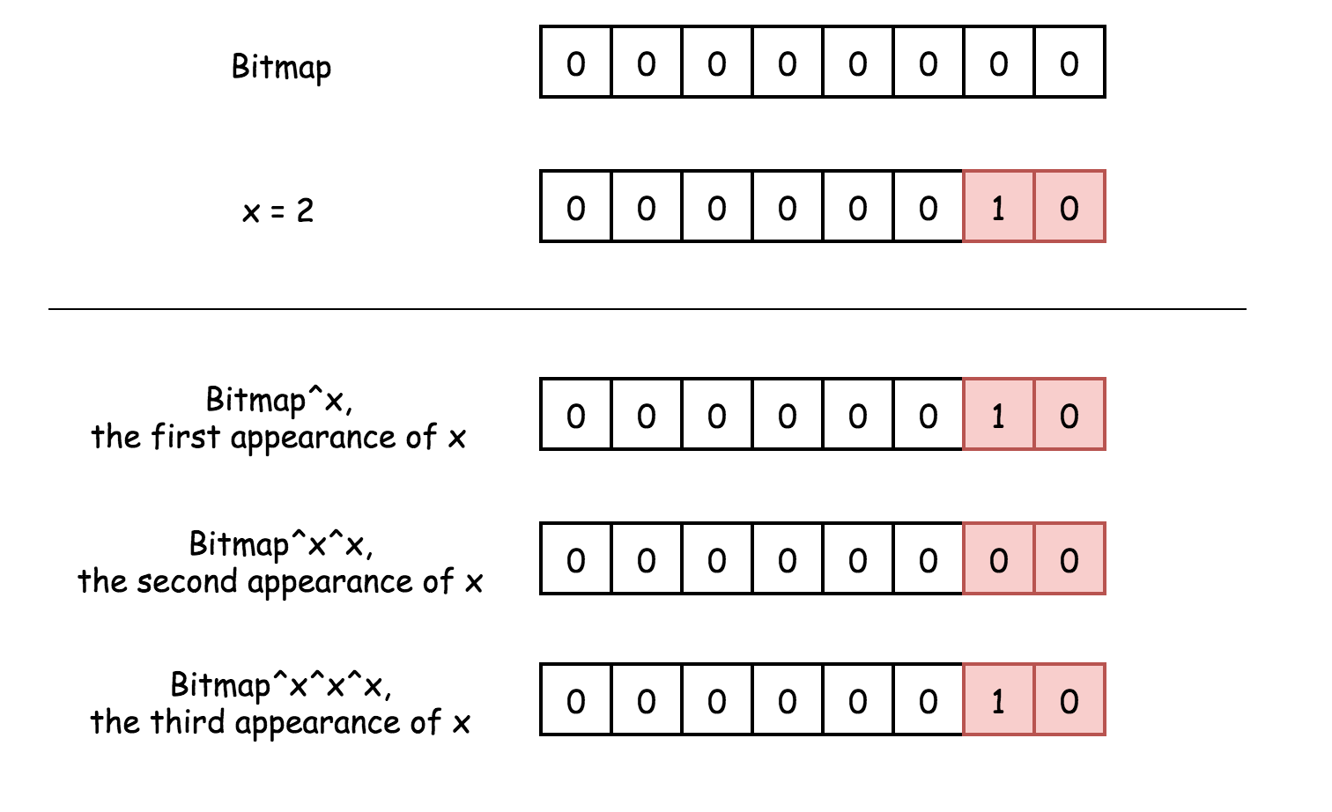

That's already great, so one could detect the bit which appears once, and the bit which appears three times. The problem is to distinguish between these two situations.

**AND and NOT**

To separate number that appears once from a number that appears three times let's use two bitmasks instead of one: seen_once and seen_twice.

The idea is to

* change seen_once only if seen_twice is unchanged
* change seen_twice only if seen_once is unchanged

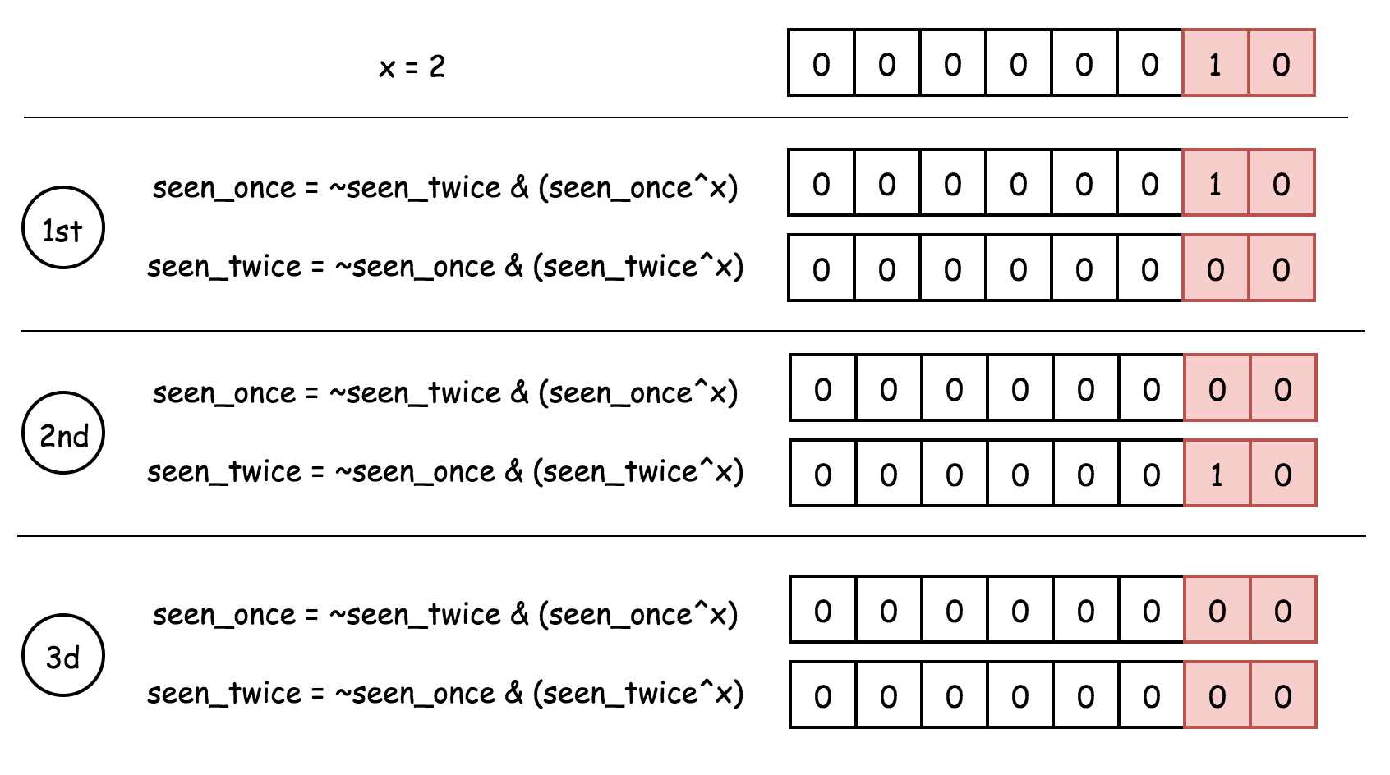

This way bitmask seen_once will keep only the number which appears once and not the numbers which appear three times.

**Implementation**

|  |
| --- |
| class Solution {  public int singleNumber(int[] nums) {  int seenOnce = 0, seenTwice = 0;  for (int num : nums) {  // first appearence:  // add num to seen_once  // don't add to seen_twice because of presence in seen_once  // second appearance:  // remove num from seen_once  // add num to seen_twice  // third appearance:  // don't add to seen_once because of presence in seen_twice  // remove num from seen_twice  seenOnce = ~seenTwice & (seenOnce ^ num);  seenTwice = ~seenOnce & (seenTwice ^ num);  }  return seenOnce;  }  } |

**Complexity Analysis**

* Time complexity : \mathcal{O}(N)O(*N*) to iterate over the input array.
* Space complexity : \mathcal{O}(1)O(1) since no additional data structures are allocated.

**Unique Binary Search Trees**

Given an integer n, return the number of structurally unique ***BST'***s (binary search trees) which has exactly n nodes of unique values from 1 to n.

**Example 1:**

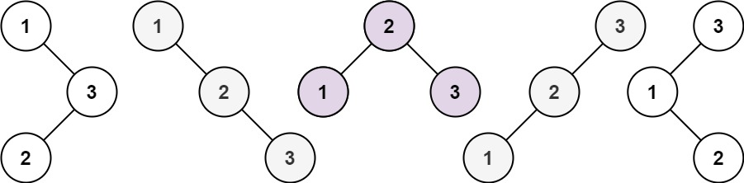

**Input:** n = 3

**Output:** 5

**Example 2:**

**Input:** n = 1

**Output:** 1

**Constraints:**

* 1 <= n <= 19

## Solution

#### **Approach 1: Dynamic Programming**

**Intuition**

The problem can be solved in a dynamic programming way.

Given a sorted sequence 1 ... n, to construct a Binary Search Tree (BST) out of the sequence, we could enumerate each number i in the sequence, and use the number as the root, then, the subsequence 1 ... (i-1) on its left side would lay on the left branch of the root, and similarly the right subsequence (i+1) ... n lay on the right branch of the root. We then can construct the subtree from the subsequence recursively. Through the above approach, we could be assured that the BST that we construct are all unique, since they start from unique roots.

As we can see, the problem can be reduced into problems with smaller sizes, instead of recursively (also repeatedly) solve the subproblems, we can store the solution of subproblems and reuse them later, i.e. the dynamic programming way.

**Algorithm**

The problem is to calculate the number of unique BST. To do so, we can define two functions:

1. G(n)*G*(*n*): the number of unique BST for a sequence of length n.
2. F(i, n)*F*(*i*,*n*): the number of unique BST, where the number i is served as the root of BST (1 \leq i \leq n1≤*i*≤*n*).

As we can see,

G(n)*G*(*n*) is actually the desired function we need in order to solve the problem.

Later we would see that *G(n)G(n)* can be deduced from *F(i, n)F(i,n)*, which at the end, would recursively refers to *G(n)G(n)*.

Following the idea from the Intuition section above, we can see that the total number of unique BST G(n)*G*(*n*), is the sum of BST F(i, n)*F*(*i*,*n*) enumerating each number i (1 <= i <= n) as a root. Hence,

G(n) = \sum_{i=1}^{n} F(i, n) \qquad \qquad (1)*G*(*n*)=∑*i*=1*n*​*F*(*i*,*n*)(1)

Particularly, for the base cases, there is only one combination to construct a BST out of a sequence of length 1 (only a root) or nothing (empty tree). i.e.

G(0) = 1, \qquad G(1) = 1*G*(0)=1,*G*(1)=1

Given a sequence 1 ... n, we pick a number i out of the sequence as the root, then the number of unique BST with the specified root defined as F(i, n)*F*(*i*,*n*), is the **cartesian product** of the number of BST for its left and right subtrees, as illustrated below:

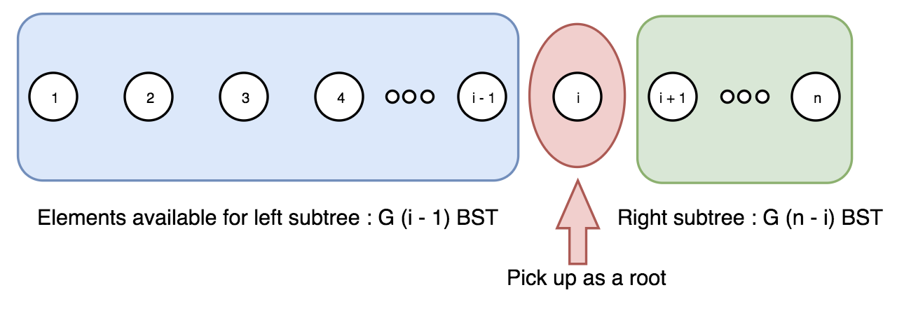

For example, F(3, 7)*F*(3,7), the number of unique BST tree with the number 3 as its root. To construct an unique BST out of the entire sequence [1, 2, 3, 4, 5, 6, 7] with 3 as the root, which is to say, we need to construct a subtree out of its left subsequence [1, 2] and another subtree out of the right subsequence [4, 5, 6, 7], and then combine them together (i.e. cartesian product). Now the tricky part is that we could consider the number of unique BST out of sequence [1,2] as G(2)*G*(2), and the number of of unique BST out of sequence [4, 5, 6, 7] as G(4)*G*(4). For G(n)*G*(*n*), it does not matter the content of the sequence, but the length of the sequence. Therefore, F(3,7) = G(2) \cdot G(4)*F*(3,7)=*G*(2)⋅*G*(4). To generalise from the example, we could derive the following formula:

F(i, n) = G(i-1) \cdot G(n-i) \qquad \qquad (2)*F*(*i*,*n*)=*G*(*i*−1)⋅*G*(*n*−*i*)(2)

By combining the formulas (1), (2), we obtain a recursive formula for G(n)*G*(*n*), i.e.

G(n) = \sum_{i=1}^{n}G(i-1) \cdot G(n-i) \qquad \qquad (3)*G*(*n*)=∑*i*=1*n*​*G*(*i*−1)⋅*G*(*n*−*i*)(3)

To calculate the result of function, we start with the lower number, since the value of G(n)*G*(*n*) depends on the values of G(0) … G(n-1)*G*(0)…*G*(*n*−1).

With the above explanation and formulas, one can easily implement an algorithm to calculate the G(n)*G*(*n*). Here are some examples:

|  |
| --- |
| public class Solution {  public int numTrees(int n) {  int[] G = new int[n + 1];  G[0] = 1;  G[1] = 1;  for (int i = 2; i <= n; ++i) {  for (int j = 1; j <= i; ++j) {  G[i] += G[j - 1] * G[i - j];  }  }  return G[n];  }  } |

**Complexity Analysis**

* Time complexity : the main computation of the algorithm is done at the statement with G[i]. So the time complexity is essentially the number of iterations for the statement, which is \sum_{i=2}^{n} i = \frac{(2+n)(n-1)}{2}∑*i*=2*n*​*i*=2(2+*n*)(*n*−1)​, to be exact, therefore the time complexity is O(N^2)*O*(*N*2)
* Space complexity : The space complexity of the above algorithm is mainly the storage to keep all the intermediate solutions, therefore O(N)*O*(*N*).

#### **Approach 2: Mathematical Deduction**

**Intuition**

Actually, as it turns out, the sequence of G(n)*G*(*n*) function results is known as [Catalan number](https://en.wikipedia.org/wiki/Catalan_number) C_n*Cn*​. And one of the more convenient forms for calculation is defined as follows:

C_0 = 1, \qquad C_{n+1} = \frac{2(2n+1)}{n+2}C_n \qquad \qquad (4)*C*0​=1,*Cn*+1​=*n*+22(2*n*+1)​*Cn*​(4)

We skip the proof here, which one can find following the above reference.

**Algorithm**

Given the formula (3), it becomes rather easy to calculate G_n*Gn*​ which is actually C_n*Cn*​. Here are some examples:

|  |
| --- |
| class Solution {  public int numTrees(int n) {  // Note: we should use long here instead of int, otherwise overflow  long C = 1;  for (int i = 0; i < n; ++i) {  C = C * 2 * (2 * i + 1) / (i + 2);  }  return (int) C;  }  } |

**Complexity Analysis**

* Time complexity : O(N)*O*(*N*), as one can see, there is one single loop in the algorithm.
* Space complexity : O(1)*O*(1), we use only one variable to store all the intermediate results and the final one.

**Sum Root to Leaf Numbers**

**Solution**

You are given the root of a binary tree containing digits from 0 to 9 only.

Each root-to-leaf path in the tree represents a number.

* For example, the root-to-leaf path 1 -> 2 -> 3 represents the number 123.

Return the total sum of all root-to-leaf numbers.

A **leaf** node is a node with no children.

**Example 1:**

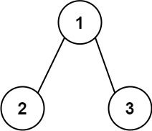

**Input:** root = [1,2,3]

**Output:** 25

**Explanation:**

The root-to-leaf path 1->2 represents the number 12.

The root-to-leaf path 1->3 represents the number 13.

Therefore, sum = 12 + 13 = 25.

**Example 2:**

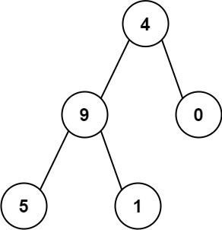

**Input:** root = [4,9,0,5,1]

**Output:** 1026

**Explanation:**

The root-to-leaf path 4->9->5 represents the number 495.

The root-to-leaf path 4->9->1 represents the number 491.

The root-to-leaf path 4->0 represents the number 40.

Therefore, sum = 495 + 491 + 40 = 1026.

**Constraints:**

* The number of nodes in the tree is in the range [1, 1000].
* 0 <= Node.val <= 9
* The depth of the tree will not exceed 10.

## Solution

#### **Overview**

**Prerequisites**

There are three DFS ways to traverse the tree: preorder, postorder and inorder. Please check two minutes picture explanation, if you don't remember them quite well: [here is Python version](https://leetcode.com/problems/binary-tree-inorder-traversal/discuss/283746/all-dfs-traversals-preorder-inorder-postorder-in-python-in-1-line) and [here is Java version](https://leetcode.com/problems/binary-tree-inorder-traversal/discuss/328601/all-dfs-traversals-preorder-postorder-inorder-in-java-in-5-lines).

**Optimal Strategy to Solve the Problem**

Root-to-left traversal is so-called DFS preorder traversal. To implement it, one has to follow straightforward strategy Root->Left->Right.

Since one has to visit all nodes, the best possible time complexity here is linear. Hence all interest here is to improve the space complexity.

There are 3 ways to implement preorder traversal: iterative, recursive and Morris.

Iterative and recursive approaches here do the job in one pass, but they both need up to \mathcal{O}(H)O(*H*) space to keep the stack, where H*H* is a tree height.

Morris approach is two-pass approach, but it's a constant-space one.

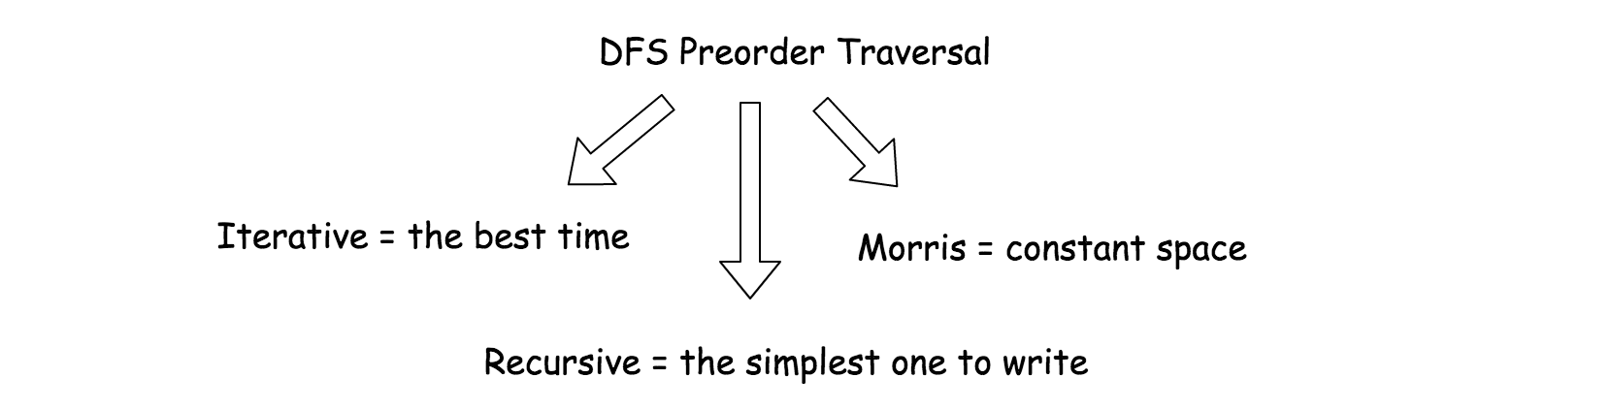

#### **Approach 1: Iterative Preorder Traversal.**

**Intuition**

Here we implement standard iterative preorder traversal with the stack:

* Push root into stack.
* While stack is not empty:
  + Pop out a node from stack and update the current number.
  + If the node is a leaf, update root-to-leaf sum.
  + Push right and left child nodes into stack.
* Return root-to-leaf sum.



**Implementation**

Note, that [Javadocs recommends to use ArrayDeque, and not Stack as a stack implementation](https://docs.oracle.com/javase/8/docs/api/java/util/ArrayDeque.html).

|  |
| --- |
| class Solution {  public int sumNumbers(TreeNode root) {  int rootToLeaf = 0, currNumber = 0;  Deque<Pair<TreeNode, Integer>> stack = new ArrayDeque();  stack.push(new Pair(root, 0));  while (!stack.isEmpty()) {  Pair<TreeNode, Integer> p = stack.pop();  root = p.getKey();  currNumber = p.getValue();  if (root != null) {  currNumber = currNumber * 10 + root.val;  // if it's a leaf, update root-to-leaf sum  if (root.left == null && root.right == null) {  rootToLeaf += currNumber;  } else {  stack.push(new Pair(root.right, currNumber));  stack.push(new Pair(root.left, currNumber));  }  }  }  return rootToLeaf;  }  } |

**Complexity Analysis**

* Time complexity: \mathcal{O}(N)O(*N*) since one has to visit each node.
* Space complexity: up to \mathcal{O}(H)O(*H*) to keep the stack, where H*H* is a tree height.

#### **Approach 2: Recursive Preorder Traversal.**

Iterative approach 1 could be converted into recursive one.

Recursive preorder traversal is extremely simple: follow Root->Left->Right direction, i.e. do all the business with the node (= update the current number and root-to-leaf sum), and then do the recursive calls for the left and right child nodes.

P.S. Here is the difference between preorder and the other DFS recursive traversals. On the following figure the nodes are numerated in the order you visit them, please follow 1-2-3-4-5 to compare different DFS strategies implemented as recursion.

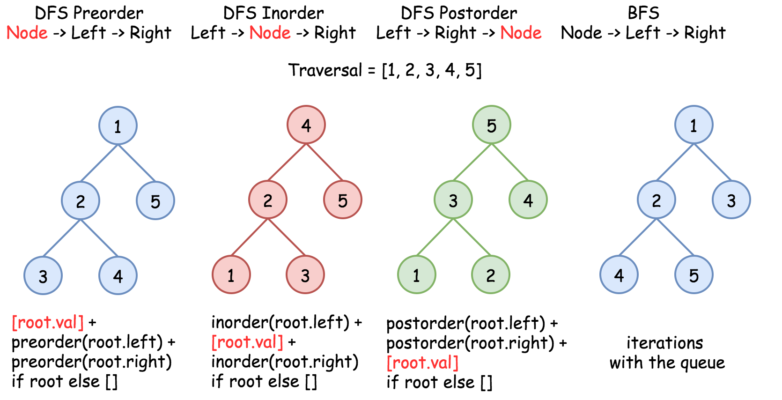

**Implementation**

|  |
| --- |
| class Solution {  int rootToLeaf = 0;  public void preorder(TreeNode r, int currNumber) {  if (r != null) {  currNumber = currNumber * 10 + r.val;  // if it's a leaf, update root-to-leaf sum  if (r.left == null && r.right == null) {  rootToLeaf += currNumber;  }  preorder(r.left, currNumber);  preorder(r.right, currNumber) ;  }  }  public int sumNumbers(TreeNode root) {  preorder(root, 0);  return rootToLeaf;  }  } |

**Complexity Analysis**

* Time complexity: \mathcal{O}(N)O(*N*) since one has to visit each node.
* Space complexity: up to \mathcal{O}(H)O(*H*) to keep the recursion stack, where H*H* is a tree height.

#### **Approach 3: Morris Preorder Traversal.**

We discussed already iterative and recursive preorder traversals, which both have great time complexity though use up to \mathcal{O}(H)O(*H*) to keep the stack. We could trade in performance to save space.

The idea of Morris preorder traversal is simple: to use no space but to traverse the tree.

How that could be even possible? At each node one has to decide where to go: to the left or tj the right, traverse the left subtree or traverse the right subtree. How one could know that the left subtree is already done if no additional memory is allowed?

The idea of [Morris](https://www.sciencedirect.com/science/article/pii/0020019079900681) algorithm is to set the temporary link between the node and its [predecessor](https://leetcode.com/articles/delete-node-in-a-bst/): predecessor.right = root. So one starts from the node, computes its predecessor and verifies if the link is present.

* There is no link? Set it and go to the left subtree.
* There is a link? Break it and go to the right subtree.

There is one small issue to deal with : what if there is no left child, i.e. there is no left subtree? Then go straightforward to the right subtree.

**Implementation**



|  |
| --- |
| class Solution {  public int sumNumbers(TreeNode root) {  int rootToLeaf = 0, currNumber = 0;  int steps;  TreeNode predecessor;  while (root != null) {  // If there is a left child,  // then compute the predecessor.  // If there is no link predecessor.right = root --> set it.  // If there is a link predecessor.right = root --> break it.  if (root.left != null) {  // Predecessor node is one step to the left  // and then to the right till you can.  predecessor = root.left;  steps = 1;  while (predecessor.right != null && predecessor.right != root) {  predecessor = predecessor.right;  ++steps;  }  // Set link predecessor.right = root  // and go to explore the left subtree  if (predecessor.right == null) {  currNumber = currNumber * 10 + root.val;  predecessor.right = root;  root = root.left;  }  // Break the link predecessor.right = root  // Once the link is broken,  // it's time to change subtree and go to the right  else {  // If you're on the leaf, update the sum  if (predecessor.left == null) {  rootToLeaf += currNumber;  }  // This part of tree is explored, backtrack  for(int i = 0; i < steps; ++i) {  currNumber /= 10;  }  predecessor.right = null;  root = root.right;  }  }  // If there is no left child  // then just go right.  else {  currNumber = currNumber * 10 + root.val;  // if you're on the leaf, update the sum  if (root.right == null) {  rootToLeaf += currNumber;  }  root = root.right;  }  }  return rootToLeaf;  }  } |

**Complexity Analysis**

* Time complexity: \mathcal{O}(N)O(*N*).
* Space complexity: \mathcal{O}(1)O(1).